

**UNIVERSITI TEKNOLOGI MALAYSIA**

**OBJECT ORIENTED PROGRAMMING**

**(SECJ2154)**

**SEMESTER 1, SESSION 2023/2024**

**GROUP PROJECT**

**BOOK STORE INVENTORY MANAGEMENT SYSTEM**

**SECTION 01**

**LECTURER:**

**MADAM LIZAWATI BINTI MI YUSUF**

| **NAME** | **MATRIC NUMBER** |
| --- | --- |
| SARVEISH A/L BALASUNDRAM | B23CS0016 |
| TAN CHEE SEN | B23CS0072 |
| CHONG WEI YANG | A23CS5027 |
| LIEW YONG ZHENG | A23CS5008 |

**Table Of Contents**

**SECTION A: PROJECT DESCRIPTION** **3**

1. Problem Statement and Project Overview 3

2. Objective and Scope 5

3. Project Workflow 6

4. OO Concepts 22

**SECTION B: UML CLASS DIAGRAM** **37**

1. Name Class 54

2. User Class 55

3. Menu Class 57

4. Report Class 57

5. Admin Class58

6. Customer Class60

7. BookSupplier Class62

8. Book Class63

9. InventorySystem Class66

10. OrderManagement Class67

**SECTION C: SOURCE CODE AND USER MANUAL** **71**

1. User manual 71

A. Admin User Manual 75

B. Customer User Manual 85

C. Book SupplierUser Manual 89

2. Source Code 93

**SECTION D: TASK DISTRIBUTION………………………………………………………………..150**

**SECTION E: CONCLUSION…………………………………………………………………………151**

# SECTION A: PROJECT DESCRIPTION

## Problem Statement and Project Overview

Although online applications and platforms have been widely embraced for book purchases and monitoring product inventory levels, small-town or rural bookshops mostly depend on conventional, face-to-face interactions to sell and manage their stock. One such bookstore is Kamal Book Store.

Mr Kamal is facing a lot of difficulties in uplifting his bookstore sales and keeping track of his book store’s stores' management. This is because Mr. Kamal still uses manual filing to keep track of book records, book stock quantity and many more. He felt very stressed due to the large amount of work that he needed to put in order to manage the book records, customers' details, and his bookstore as a whole. Moreover, he is also facing problems in keeping track of his restocking schedule for his products to the book supplier as he is encountering dilemmas including inventory discrepancies, out-of-stock, and challenges in accurately forecasting demand, resulting in delays or lack of accurate information from suppliers, supplying the wrong quantity and wrong type of books, indirectly impacting customer demand and satisfaction. So, he decided to implement an effective bookstore management system that would help him ease his work and improve his bookstore's sales.

Our team has planned to develop a system named Kamal BookStore Inventory Management System. This system is an efficient and comprehensive programme used to facilitate the day-to-day operations of the bookstore. This system is designed to be used by the admin (Mr. Kamal), the book supplier and the customers of his bookstore. The system mainly focuses on enhancing seamless book inventory management and secured authentication for the user types, the overall shopping experience for the customers and seamless management of restocking books by the supplier.

From an admin perspective, the demand for extra human resources to handle book records and stock quantity is significantly reduced for the administrator, Mr.Kamal. This is because the administrator is only required to concentrate on important activities like adding new books, changing information, and ensuring accurate inventory records by automating time-consuming chores due to the system's effective features. For the bookstore and Mr Ali, this increase in efficiency means significant time and resource savings. Moreover, the system also offers a secured authentication, which ensures a secure sign-in process for the admin by limiting functionalities and features for other user roles, which are customers and suppliers. The system also provides Mr. Kamal with reports that give him important information about the functioning of the bookstore, including a list of the top ten best-selling books, total profit earned, and much more. As a result, it is possible to make good decisions on book promotion and inventory. In addition, Mr Kamal can effectively stock up by using the system for placing orders with suppliers so as to ensure a suitable level of inventory in order to sustain his bookshop's profitability.

From a customer perspective, the system will improve the whole user experience by offering an easy-to-use interface and a smooth book ordering procedure whenever they use the system. The system's user experience starts with a simple registration or sign-in process that gives users access to various features and an extensive range of book catalogues. Regarding purchasing a book from the bookstore, the system offers them an easy-to-understand book addition to their cart, and they can view their book cart before the ordering procedure is performed completely.

Lastly, from the book supplier's perspective, they can access the system by logging in to the system. They can view the pending admin orders towards them with in-detail information. Later on, they can provide approval status of either approve or reject to the admin's order request by even searching the order quickly and in an easy manner.

In conclusion, this system offers Mr Kamal's bookshop operations by providing customers with an easy-to-use platform to buy books from the store, an elegant book-ordering management process for both customers to the bookstore as well as admin to the book supplier, and an administrator-friendly approach to book management.

## Objective and Scope

The main objectives of the system are:-

1. To offer a secure authentication to access the system by providing user registration and sign-in processes.
2. To provide an automated system with features for adding, editing, and removing book entries that help manage book inventory.
3. To increase efficiency and reduce data errors, resulting in improved accuracy, faster decision-making, and a more responsive approach to inventory control.
4. To offer suppliers to make faster decisions, respond promptly to admin’s book supply requests, and participate in a more seamlessly integrated ordering process.
5. To offer the customers a seamless book ordering and purchasing experience.

Scope of the system are :-

1. The system only supports only one book supplier.
2. The system only supports one administrator to access the system, Mr. Kamal, as it doesn’t allow new registration for admin roles.
3. The system doesn’t offer a payment system for the customer to pay directly for their order through the system.
4. The system provides a simple yet effective reporting to the administrator.
5. The system offers no user types with sorting options to view the book catalogue.
6. The system is only recommended for desktops and laptops as it is not mobile-friendly.

## Project Workflow

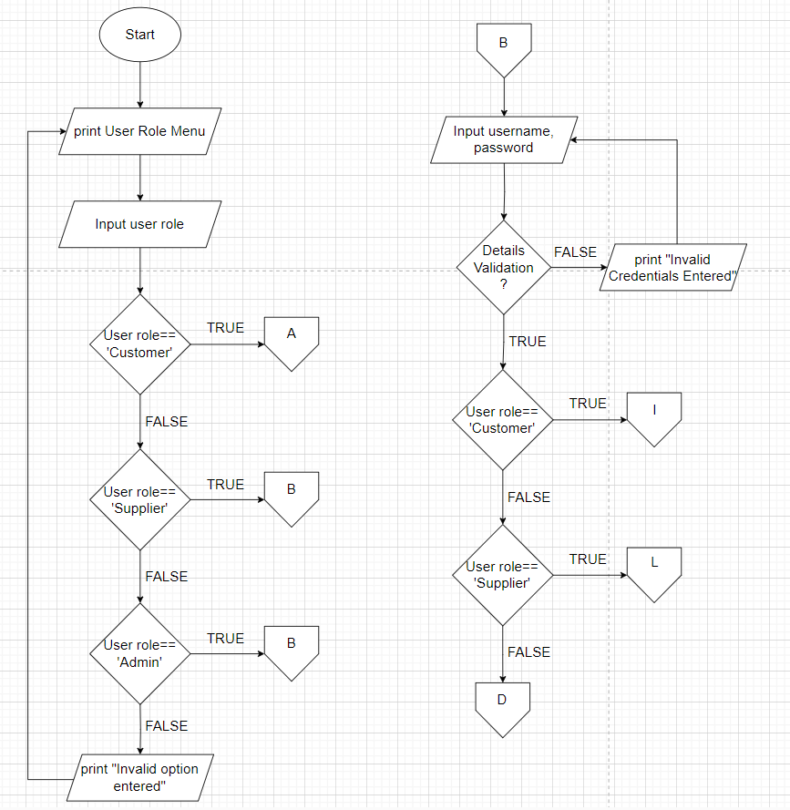

**Figure 1.1.1:** login() - select user role **Figure 1.1.2:** login() - all user login

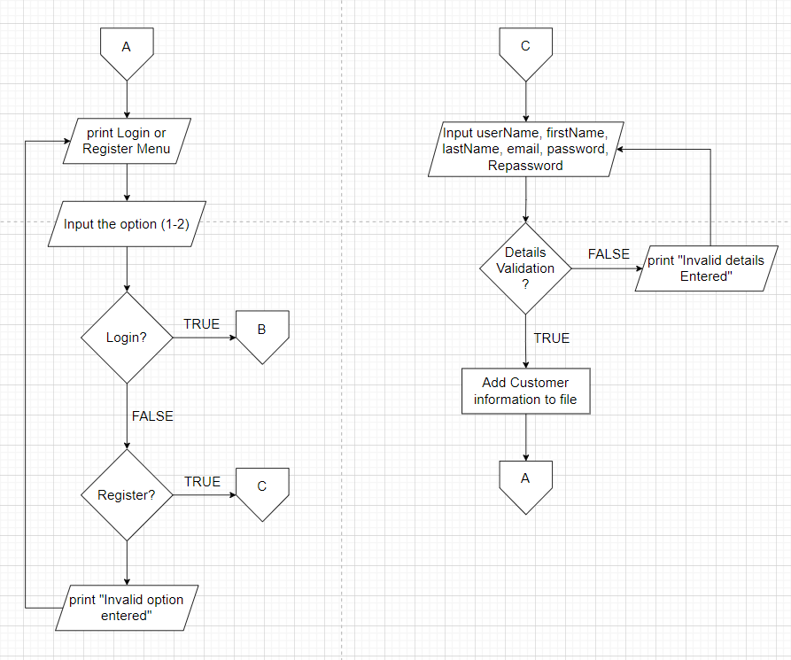

**Figure 1.1.3:** login() - customer **Figure 1.1.4:** registration() - customer register

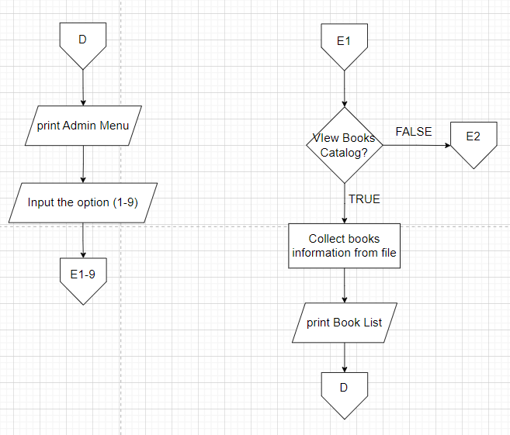

**Figure 1.1.5:** viewMenu() - admin **Figure 1.1.6:** viewAllBooks() - admin

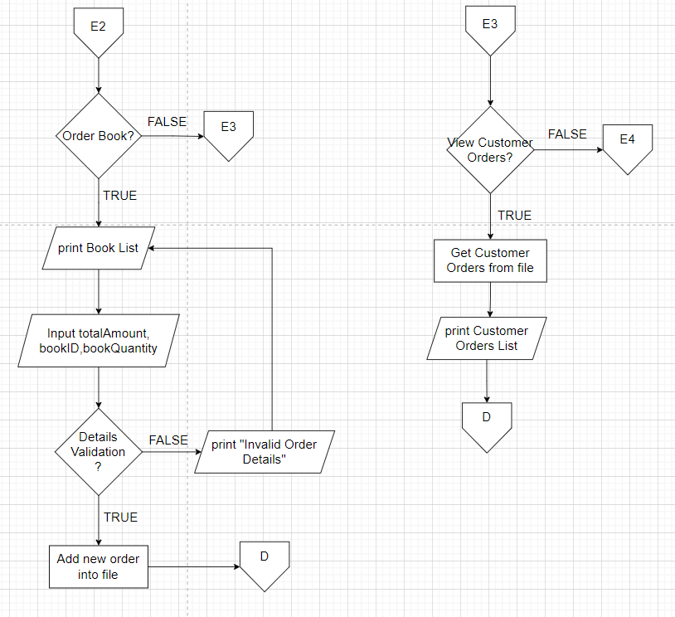

**Figure 1.1.7:** orderBooks() - admin **Figure 1.1.8:** viewAllOrders() - Customer Orders

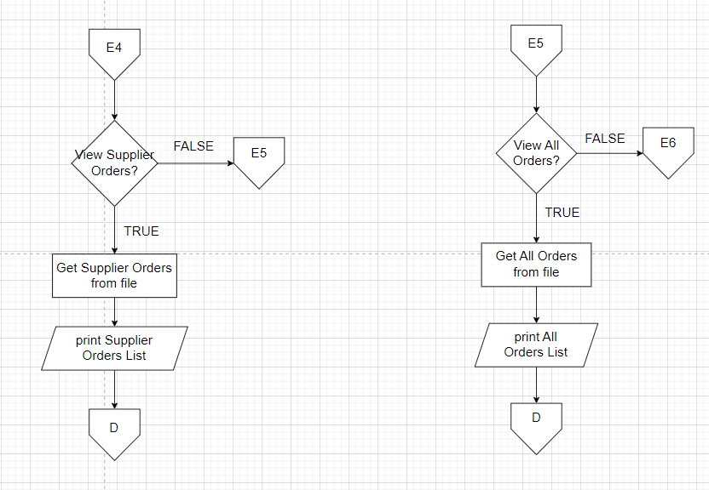

**Figure 1.1.9:** viewAllOrders()-Supplier Orders **Figure 1.1.10:** viewAllOrders()-All Orders

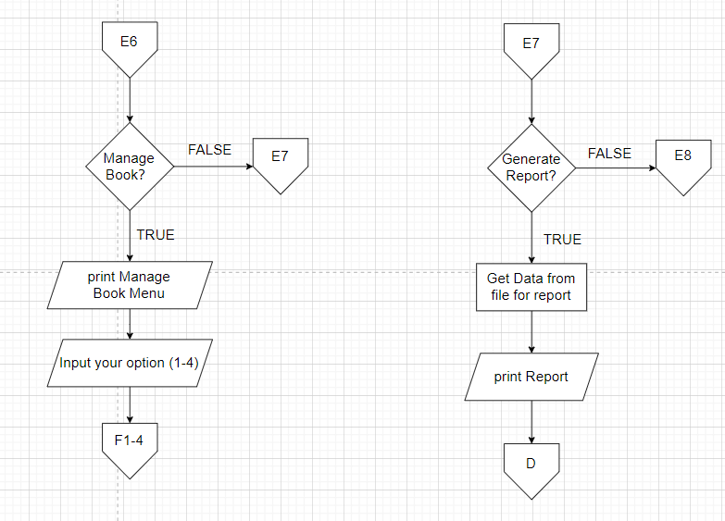

**Figure 1.1.11:** manageMenu() - admin **Figure 1.1.12:** generateSalesReport() - admin

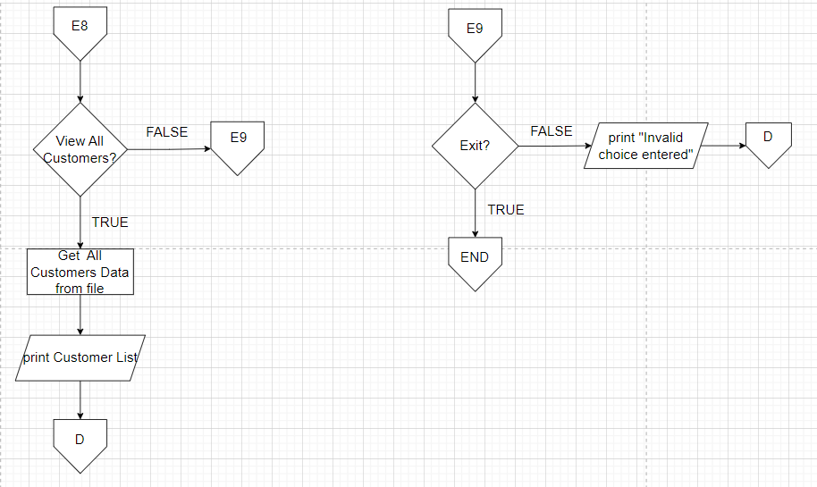

**Figure 1.1.13:** viewAllCustomer() - admin **Figure 1.1.14:** Exit - admin

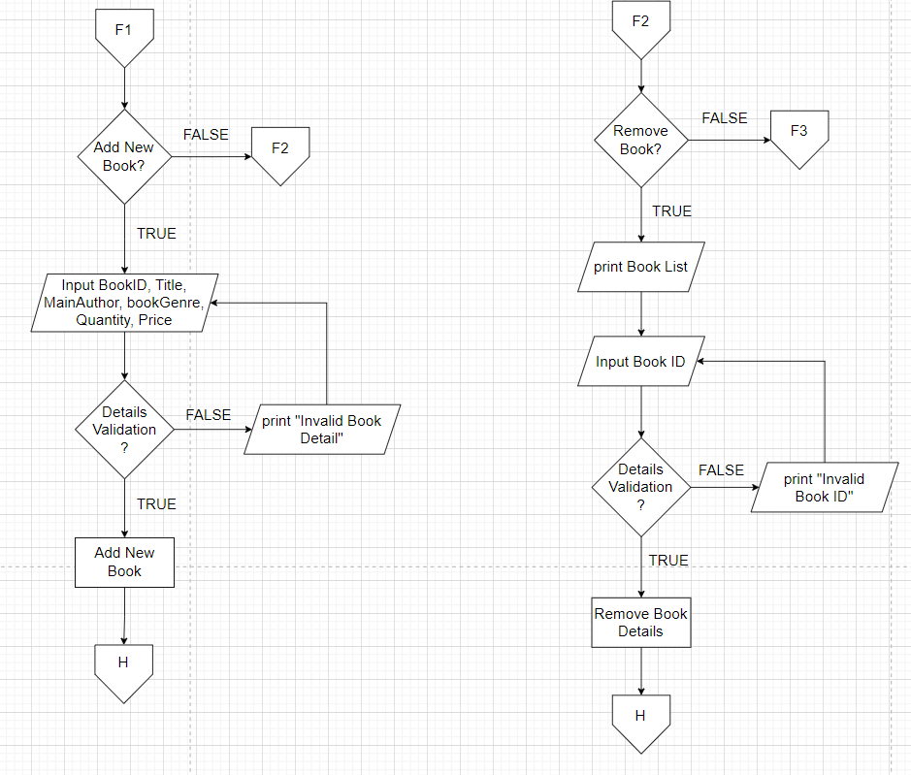

**Figure 1.1.15:** addBooksInfoFile()- admin **Figure 1.1.16:** removeBookFromFile()- admin

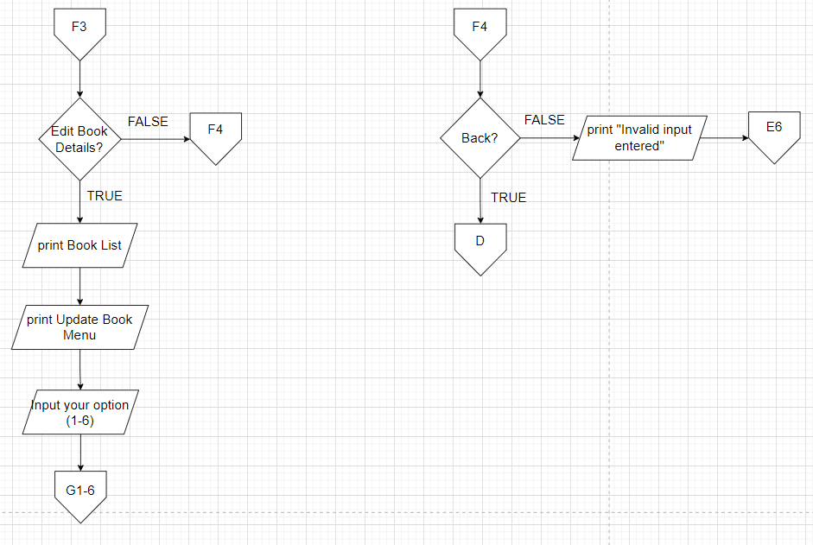

**Figure 1.1.17:** editBookDetails() - admin **Figure 1.1.18:** Back - admin

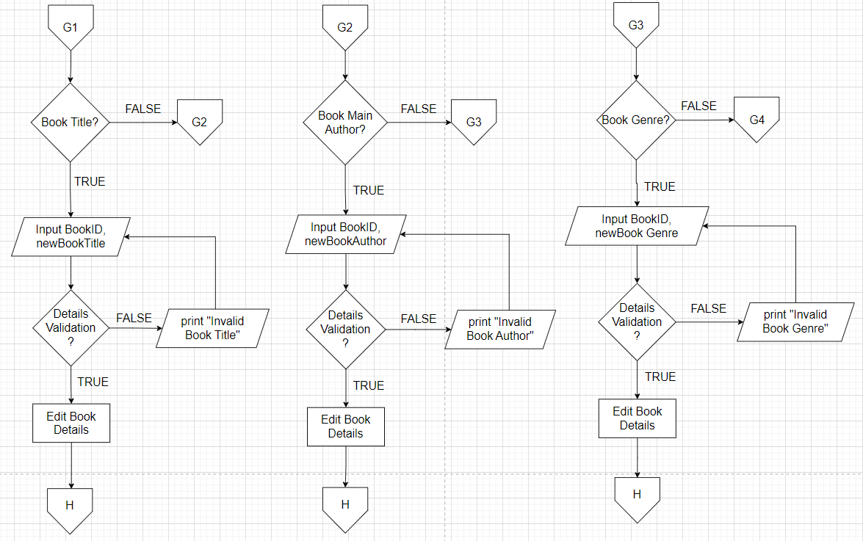

**Figure 1.1.19:** editBookDetails() - Title, MainAuthor, Genre (admin)

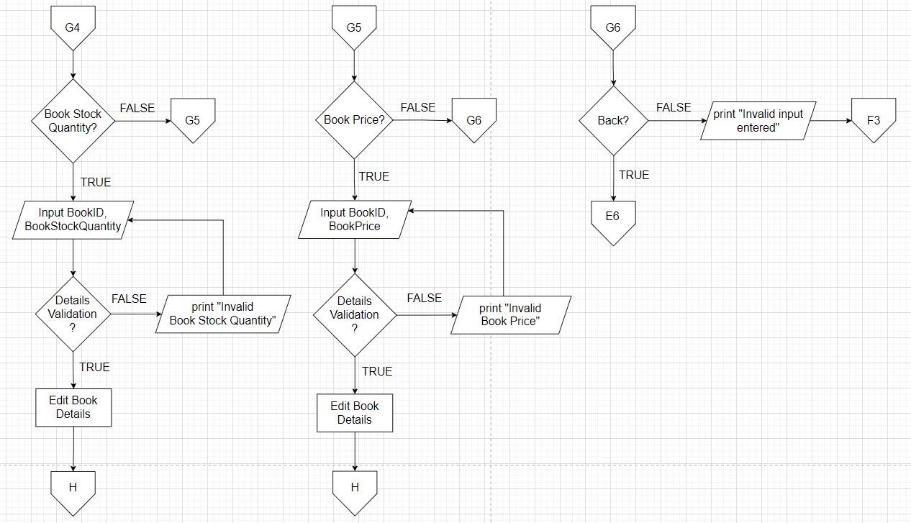

**Figure 1.1.20:** editBookDetails() - QuantityinStock, BookPrice, Back (admin)

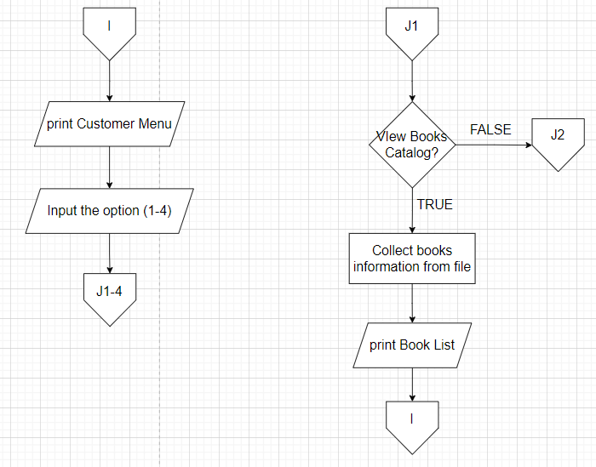

**Figure 1.1.21:** viewMenu() - Customer **Figure 1.1.22:** displayBooks() - Customer

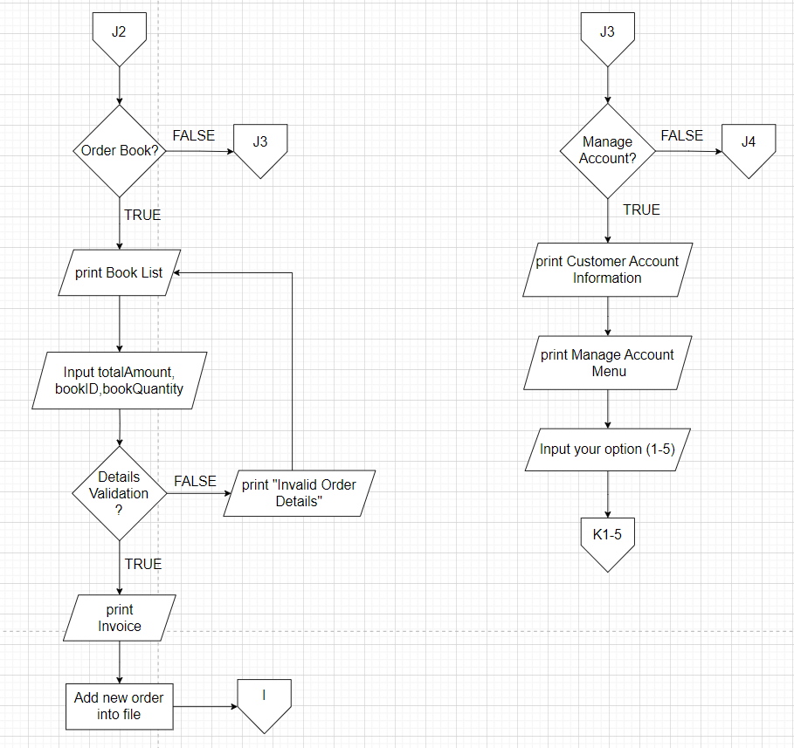

**Figure 1.1.23:** orderNewBooks()-Customer **Figure 1.1.24:** updateCustomerAcc()-Customer

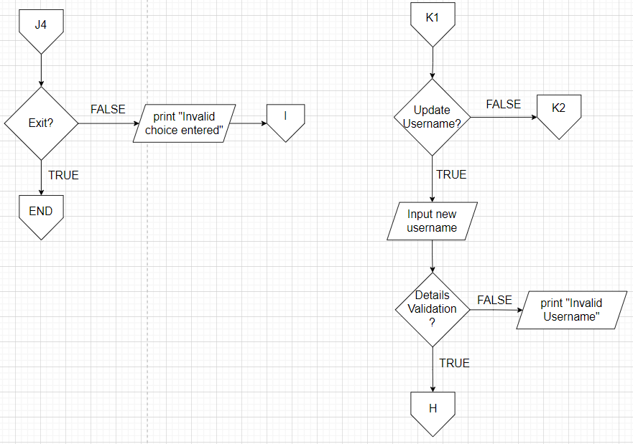

**Figure 1.1.25:** Exit - Customer .**Figure 1.1.26:** updateCustomerAcc() - username

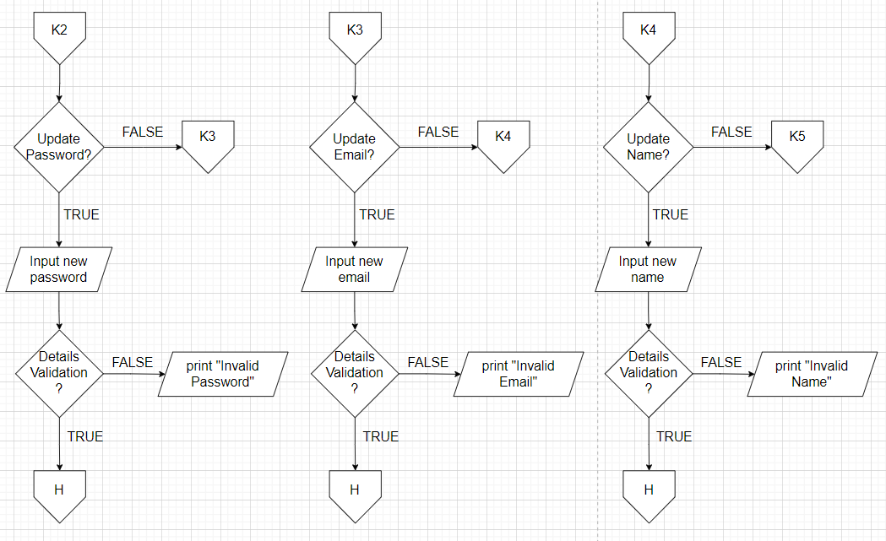

**Figure 1.1.27:** updateCustomerAcc() - password, email, name Customer

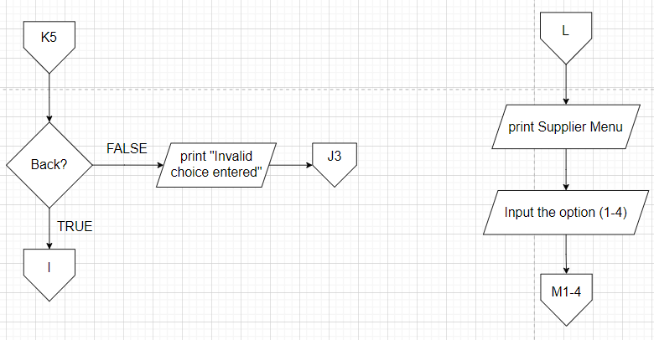

**Figure 1.1.28:** Back - Customer **Figure 1.1.29:** viewMenu() - Supplier

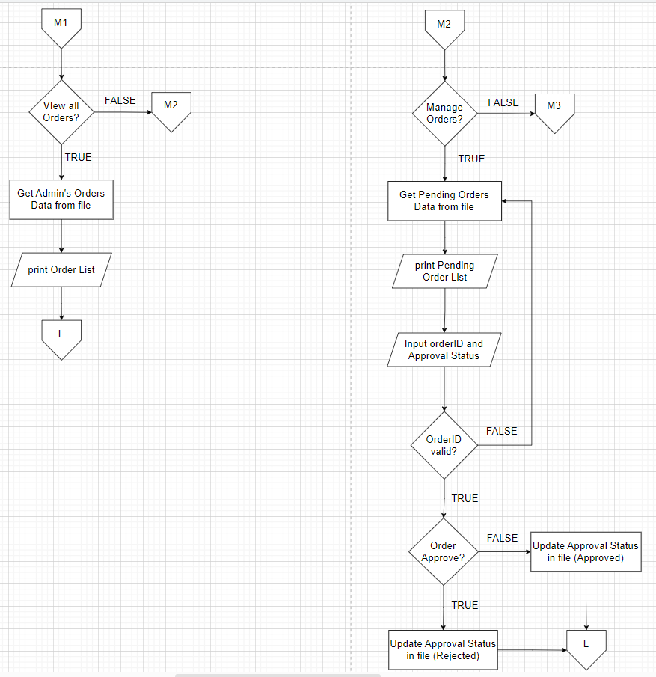

**Figure 1.1.30:** viewAllOrders() - Supplier **Figure 1.1.31:** updateOrderStatus() - Supplier

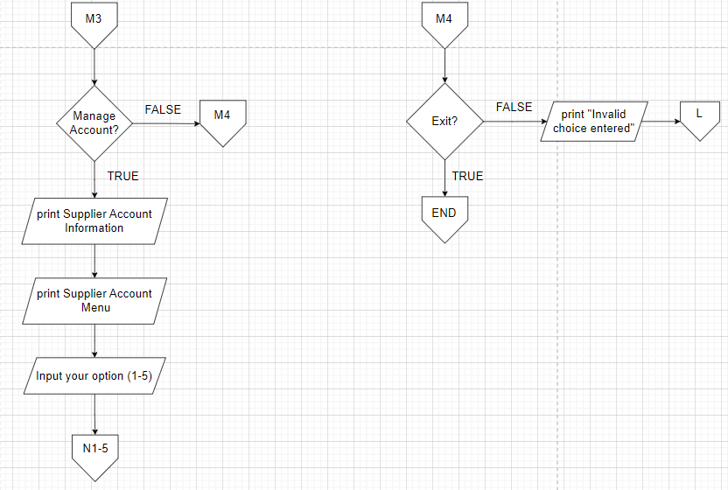

**Figure 1.1.32:** manageAccount() - Supplier **Figure 1.1.33:** Exit - Supplier

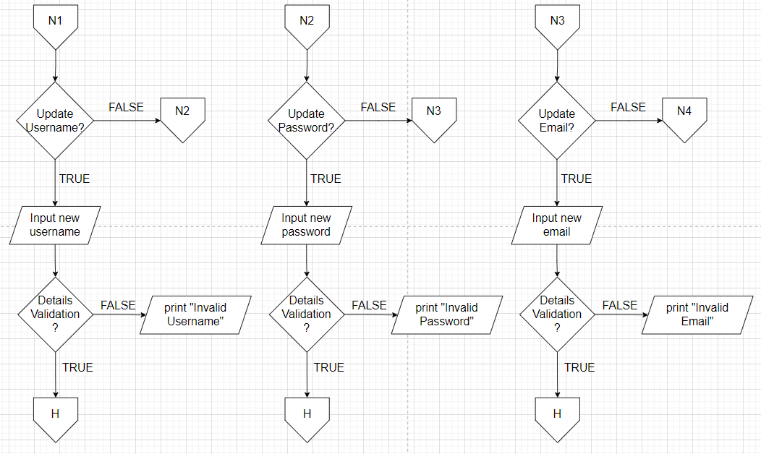

**Figure 1.1.34:** manageAccount() - username, password, email Supplier

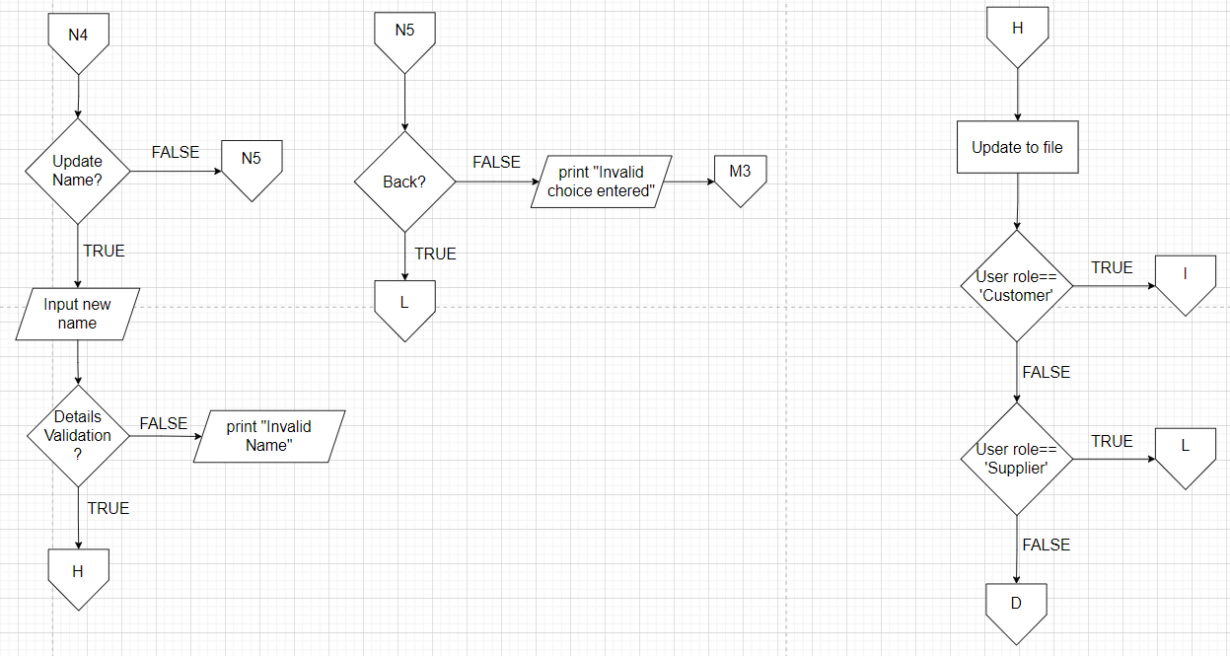

**Figure 1.1.35:** manageAccount() - name, Back Supplier **Figure 1.1.36:** update xxx() - All role

## OO Concepts

1. **Encapsulation and data hiding**

* Encapsulation involves bundling attributes and methods within a class, controlling access to the data through methods while hiding the internal implementation details. In the inventory system, classes encapsulate data related to books, orders, and user information. Public methods enable controlled access to this data, maintaining data integrity and security.

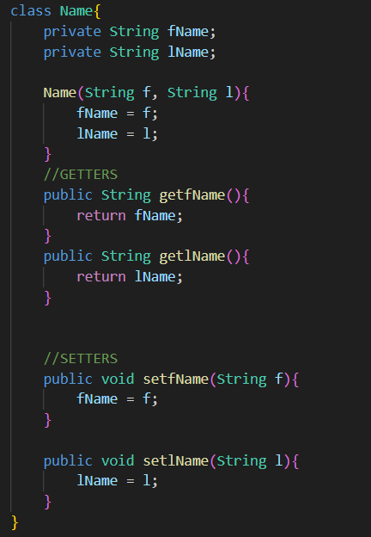

**Figure 1.2.1**: Illustrates an example of data encapsulation and hiding that have been implemented in the system under Name class.

1. **Inheritance**

* It is used to create a hierarchy in which classes declared as subclasses inherit properties and behaviour from superclasses. It established an “is-a” relationship between classes.
* Figure 2.0 shows the User class, which represents the parent class in the system. Meanwhile, Figure 2.1 Admin, Figure 2.2 Customer and Figure 2.3 BookSupplier classes are subclasses for the parent class. These subclasses inherit the methods and variables of their parent class, which are declared as public or protected as their access modifiers.

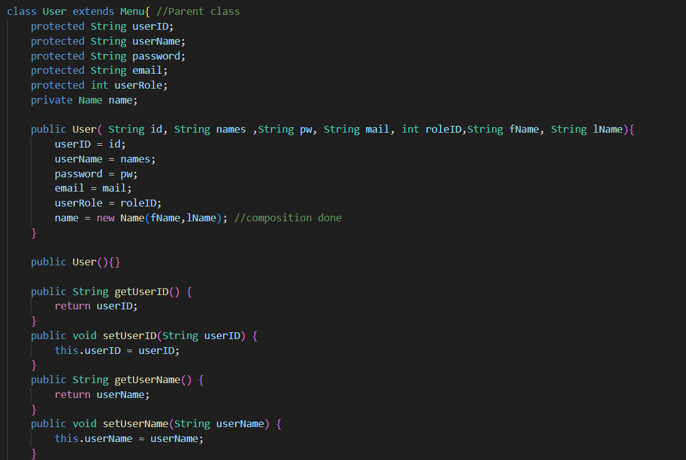

**Figure 1.2.2: User parent class**

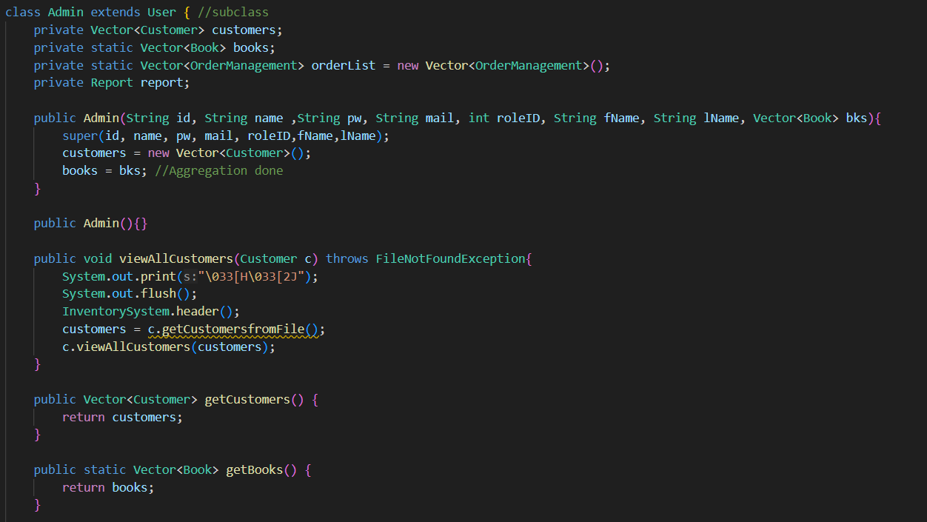

**Figure 1.2.3: Admin subclass**

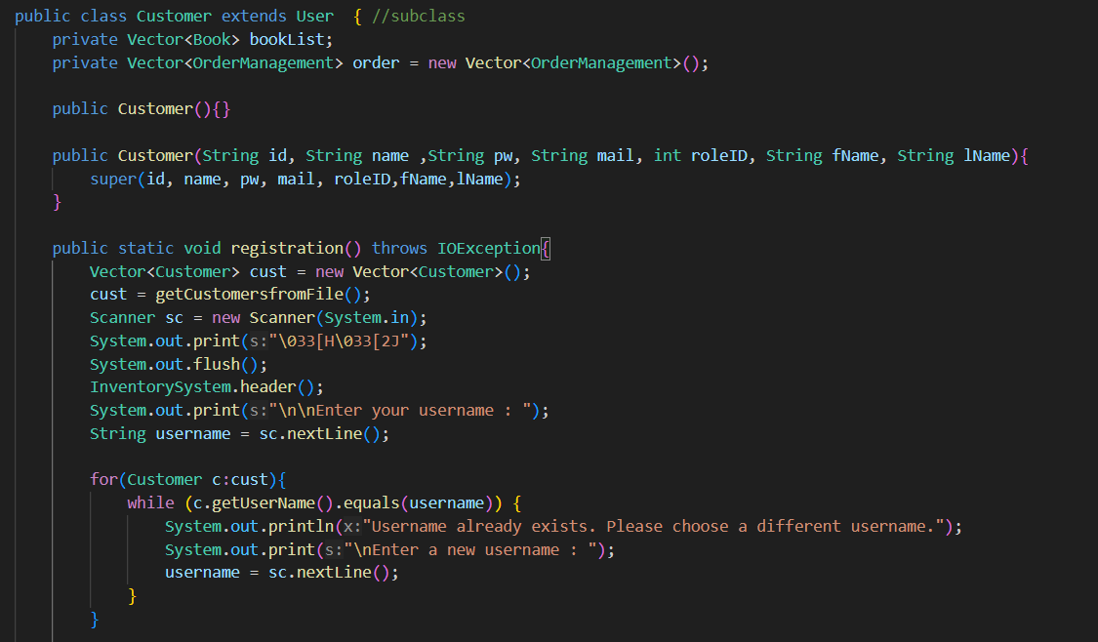

**Figure 1.2.4: Customer subclass**

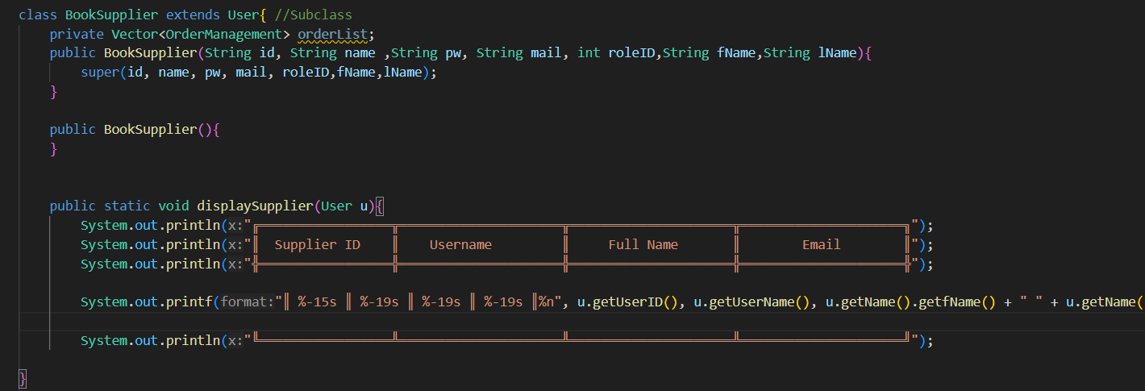

**Figure 1.2.5: BookSupplier subclass**

1. Composition

* A strong relationship in which one class contains objects of another class as part of its structure. Composition is a way to design classes where one class contains an object of another class, establishing a "has-a" relationship.
* Figure 3.2 shows the User class and its composition relationship with a name class in Figure 3.1. The User class has a Name object in its structure, according to this composition which demonstrates how the User class integrates and depends on the attributes and functions of the Name object. This implies that the User class has a Name object, which leads to an interconnection of those two classes.



**Figure 1.2.6: Name Class**

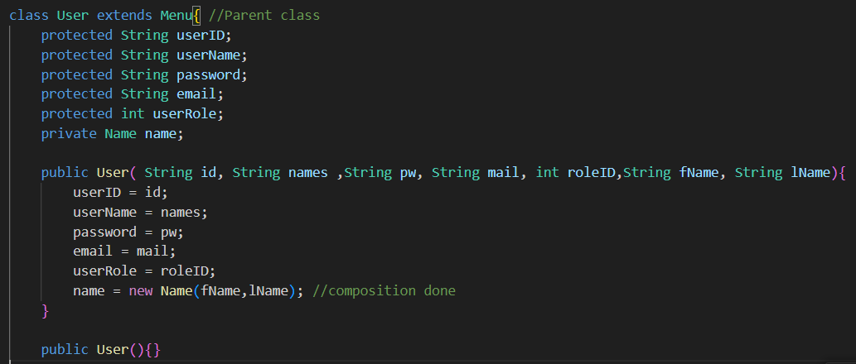

**Figure 1.2.7: User Class**

1. Aggregation

* A loose relationship in which one class is associated with another class but does not own its objects.
* An aggregate relationship, which includes a static Vector<Book> called books, is shown in Figure 4.2 of the Administration class. The Admin class constructor receives a Book class vector as an argument, indicating that the Admin class is merging the Book objects. We have developed the getter and setter methods for a book vector to show that we can retrieve and modify any combination of books. Figure 4.1 shows the Book class implementation.

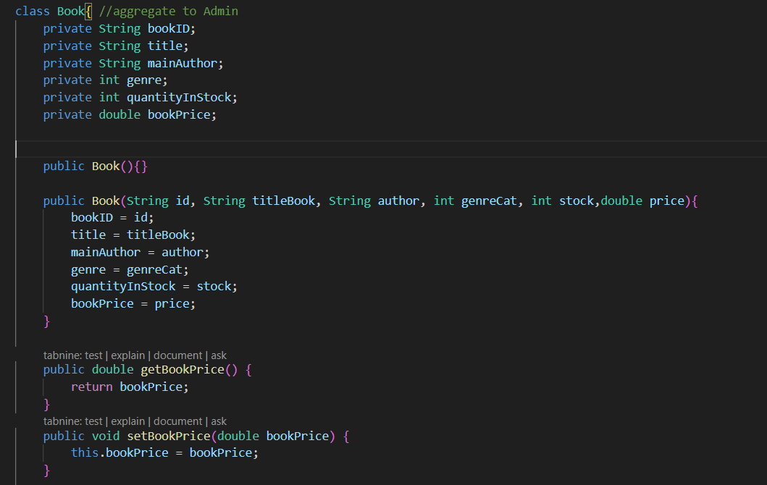

**Figure 1.2.8: Book Class**

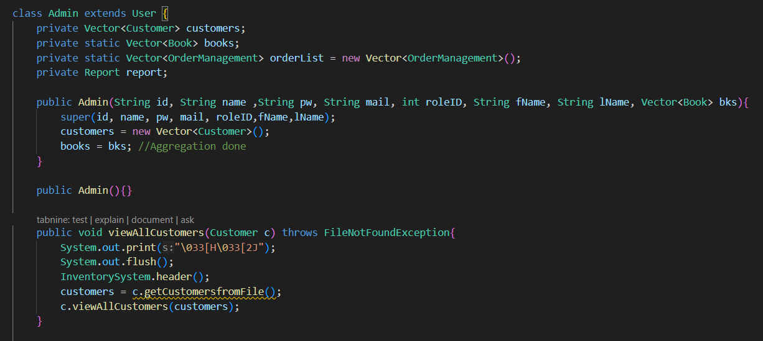

**Figure 1.2.9: Admin Class**

1. Polymorphism:

* The ability to treat different classes as instances of the same class through inheritance and method overriding.
* The Menu class in Figure 5.0 declares an abstract method called viewMenu(). The method viewMenu() is implemented with polymorphism features. The Admin class and User class in Figure 5.1 and 5.2 inherits from the Menu class and demonstrates polymorphism by offering a distinct implementation for the viewMenu() method. The method's implementation in both classes overrides the abstract method declared in the base class, showcasing the flexibility and adaptability of polymorphism within the structure of inheritance and method overriding.



**Figure 1.2.10: Menu Class**

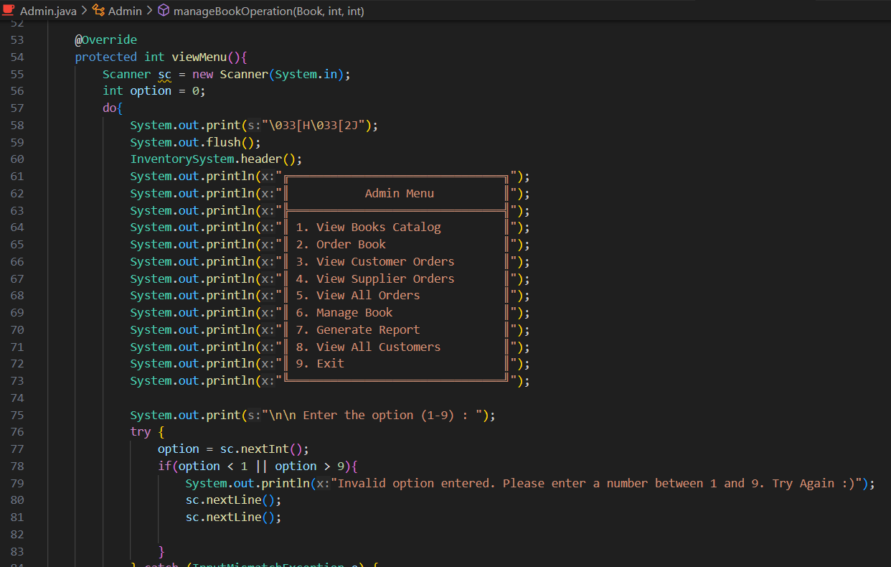

**Figure 1.2.11: viewMenu() method in Admin class**

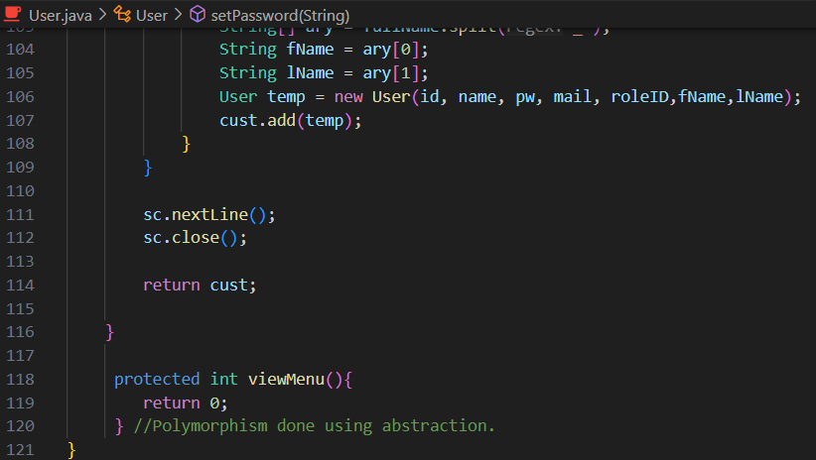

**Figure 1.2.12: Viewmenu method**

1. Exception handling:

* It is used to manage exceptions that may occur during program execution and ensure that errors or unexpected situations are properly handled. In an inventory system, this might involve handling scenarios such as incorrect user input during order processing or data entry about products.
* In order to effectively manage certain exceptions, the viewMenu(), generateReport(), and validation() methods have been integrated with "try" and "catch" blocks as shown in Figures 6.0, 6.1 and 6.2 respectively. Exceptions such as FileNotFoundException and InputMismatchException are used to provide special information about the type of exception that occurred. Moreover, this feature is used to update and include error messages that provide more information in order to improve clarity and facilitate the process of understanding and resolving issues.

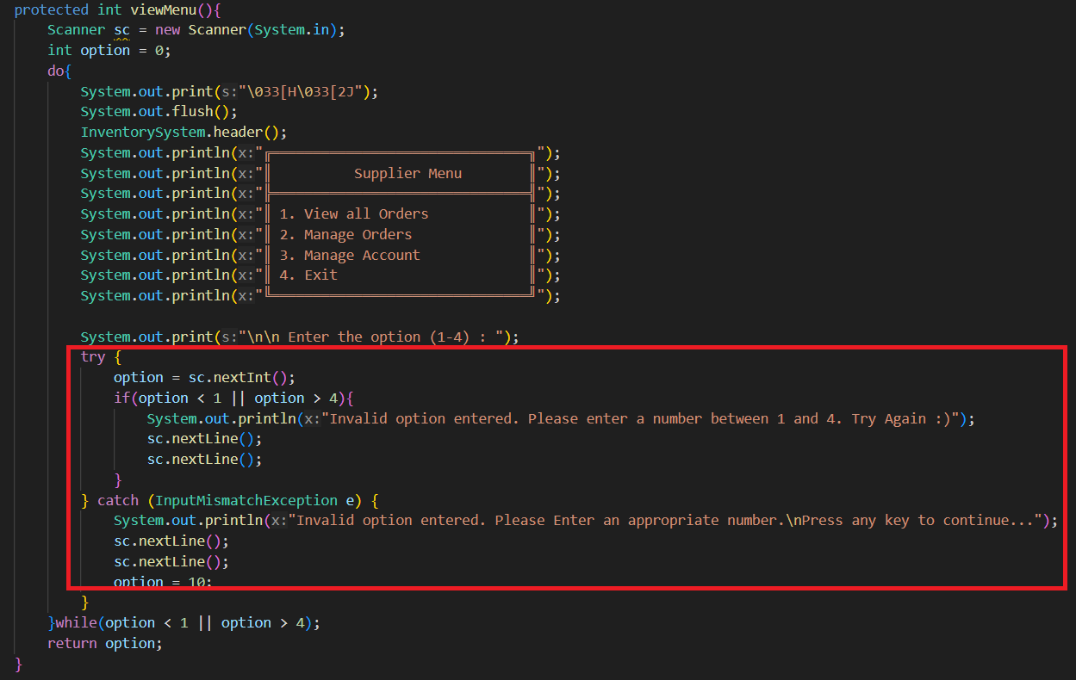

**Figure 1.2.13: viewMenu() method with InputMismatchException try-catch block.**

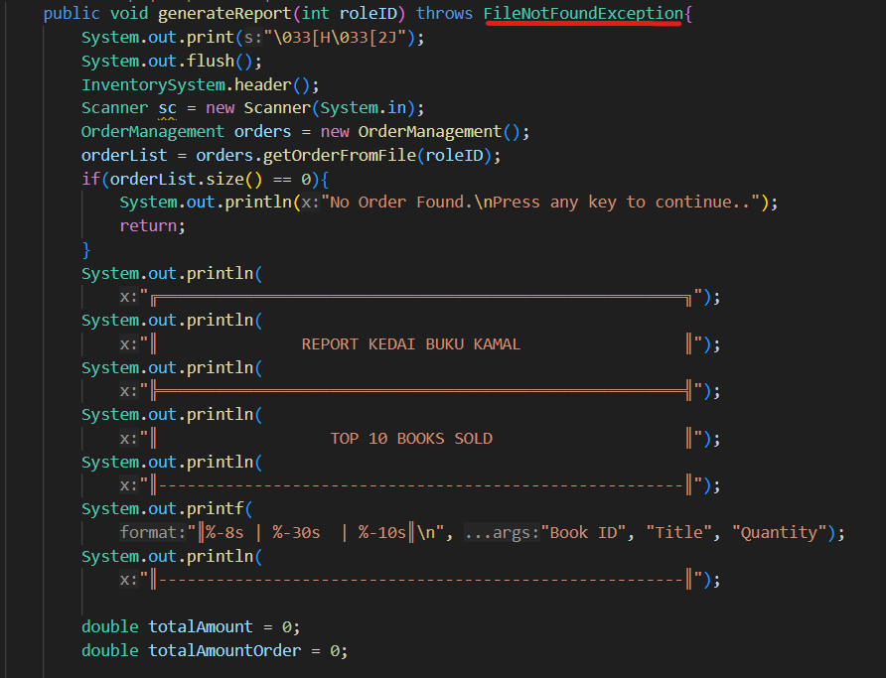

**Figure 1.2.14: generateReport() method with FileNotFoundException.**

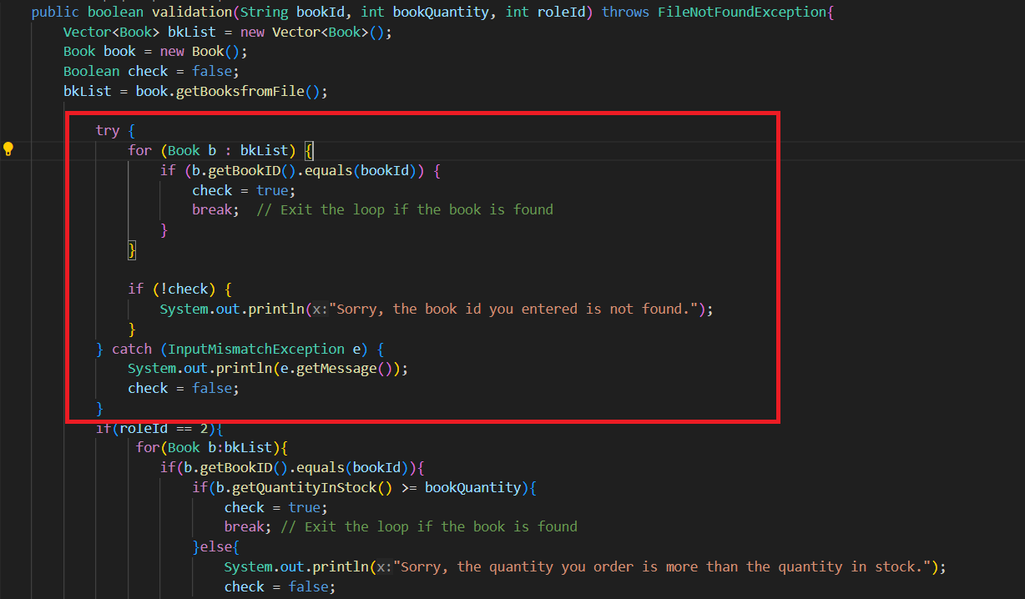

**Figure 1.2.15: validation() method with InputMismatchException try-catch block.**

1. Association

* An association can be one-to-one, one-to-many, or many-to-many. The Admin class has associations with the Report and OrderManagement classes. Figure 7.0 shows the Admin class implementing association by declaring orderList variable that represents OrderManagement class and report variable that represents Report class within the class.
* The generateSalesReport() method represents an association between the Admin class with the Report class, where an Admin can generate sales reports using a Report object in Figure 7.1. Meanwhile, the orderBooks() method represents an association between Admin class and OrderManagement class, where an Admin can add orders to its orderList variable using an OrderManagement object in Figure 7.1.

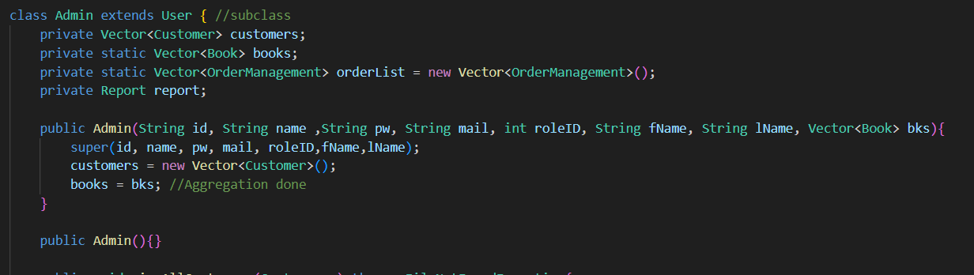

**Figure 1.2.16: Implementation of declaring variables that represents Report and OrderManagement class.**

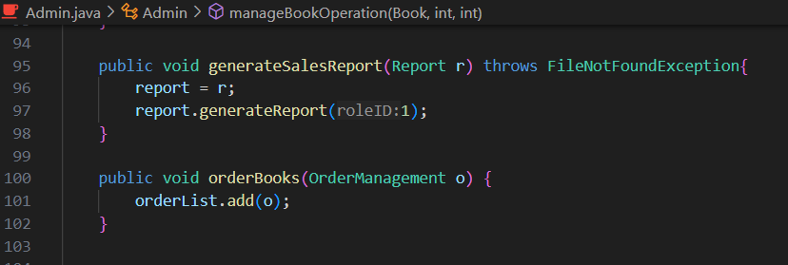

**Figure 1.2.17: Functions that are used to create association between Admin and Report Class using generateSalesReport() and association between Admin and OrderManagement class using orderBooks().**

1. **File Operation (Add, Delete, Edit, View)**

* Figure 8.0 until Figure 8.3 shows how the system implements file operation concept to perform new book addition into file, removing a certain book detail from file, reading all the details from the file and modifying certain book details and updating it into the file.
* For example, figure 8.1 shows addBooksIntoFile() method that adds new book details entered by the user into the booksDatabase.txt text file.   
  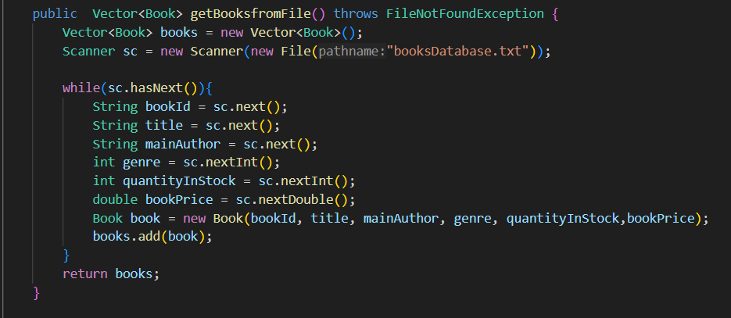

**Figure 1.2.18: getBooksfromFile() method**

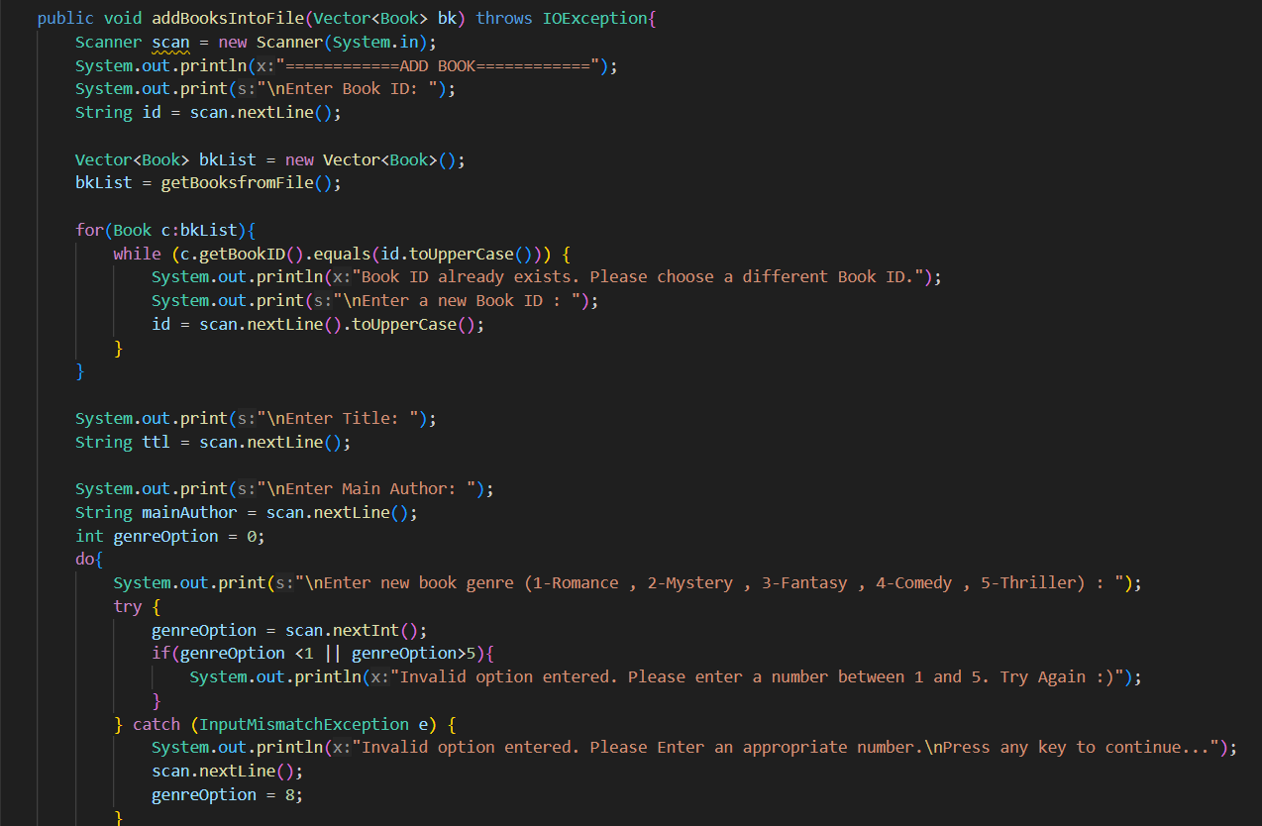

**Figure 1.2.19: addBooksIntoFile() method**

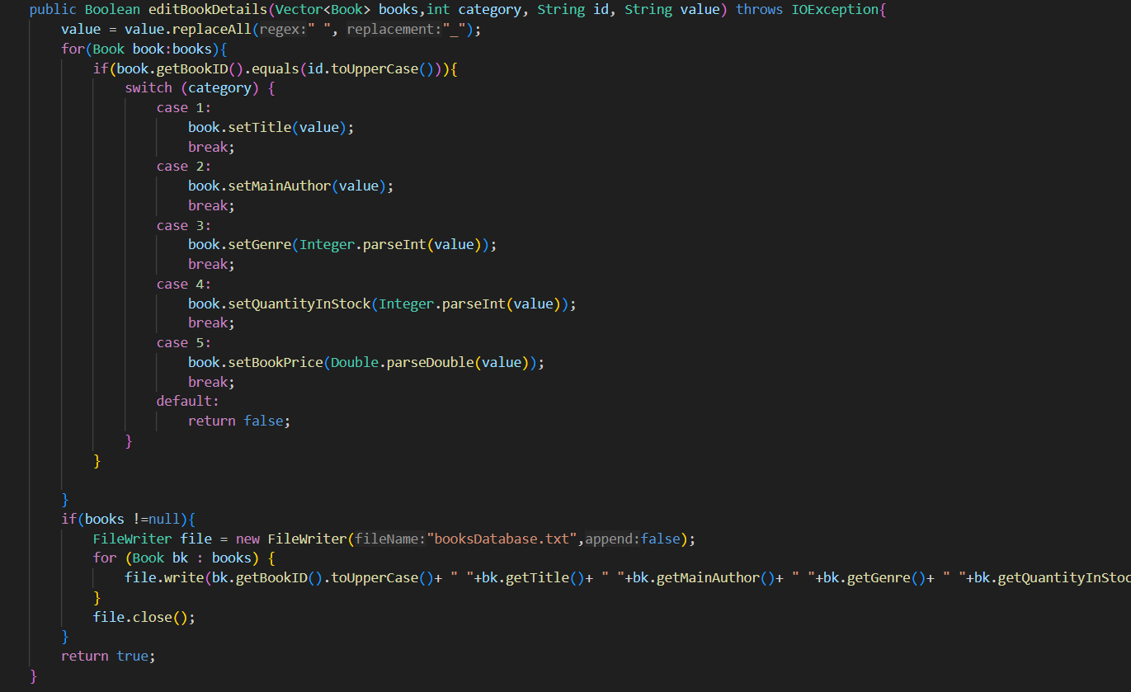

**Figure 1.2.20: editBookDetails() method**

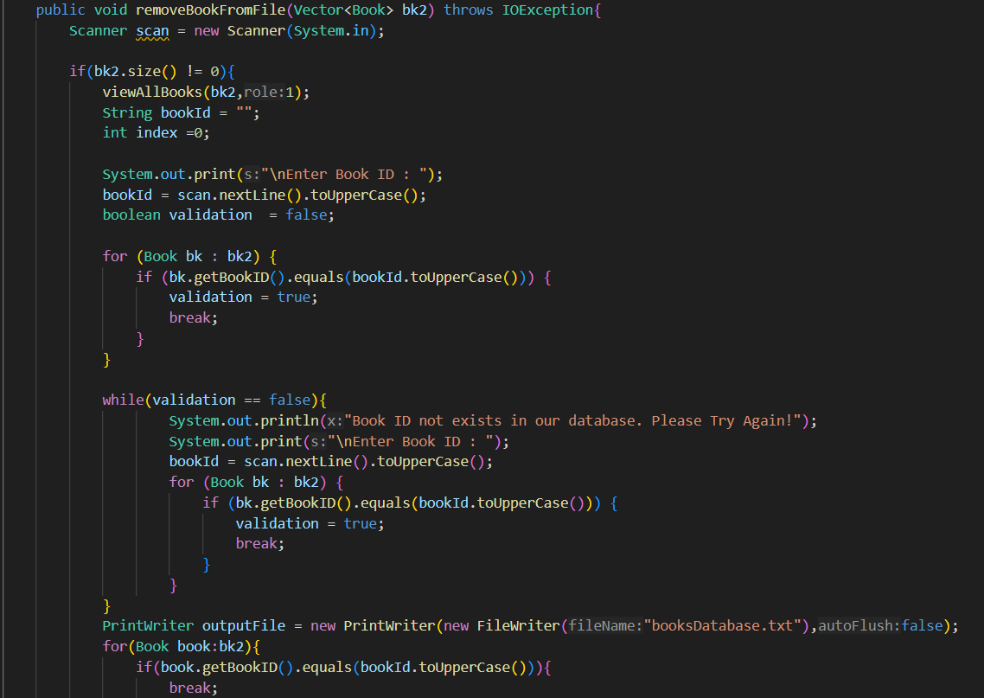

**Figure 1.2.21: removeBookFromFile() method**

# SECTION B: UML CLASS DIAGRAM

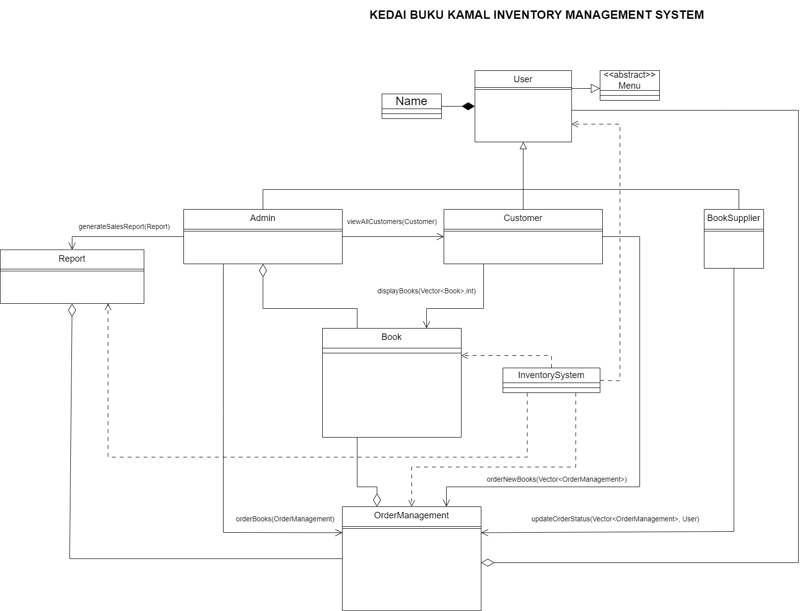

**Figure 2.1 : UML class Figure (class with no data)**

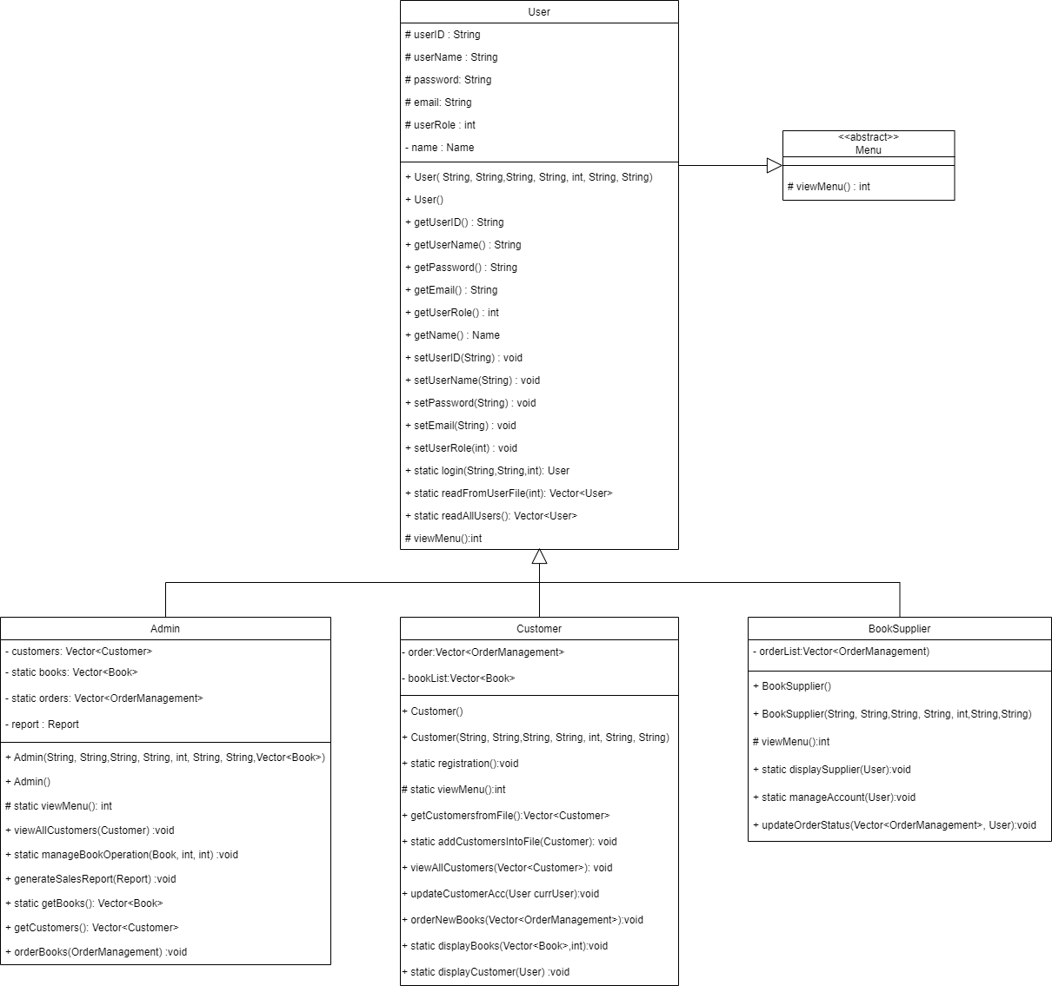

**Figure 2.2: 3 subclass to user**

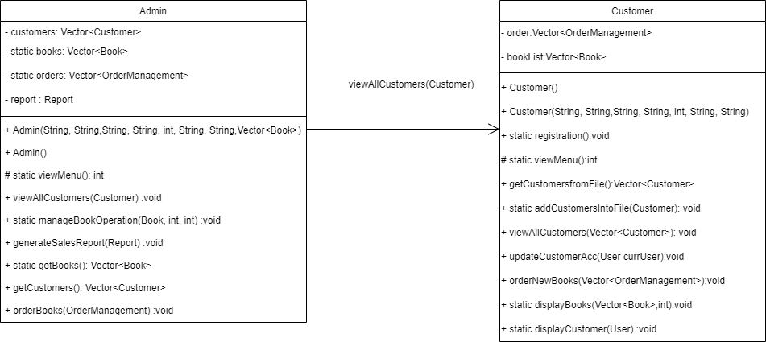

**Figure 2.3 : Admin to customer**

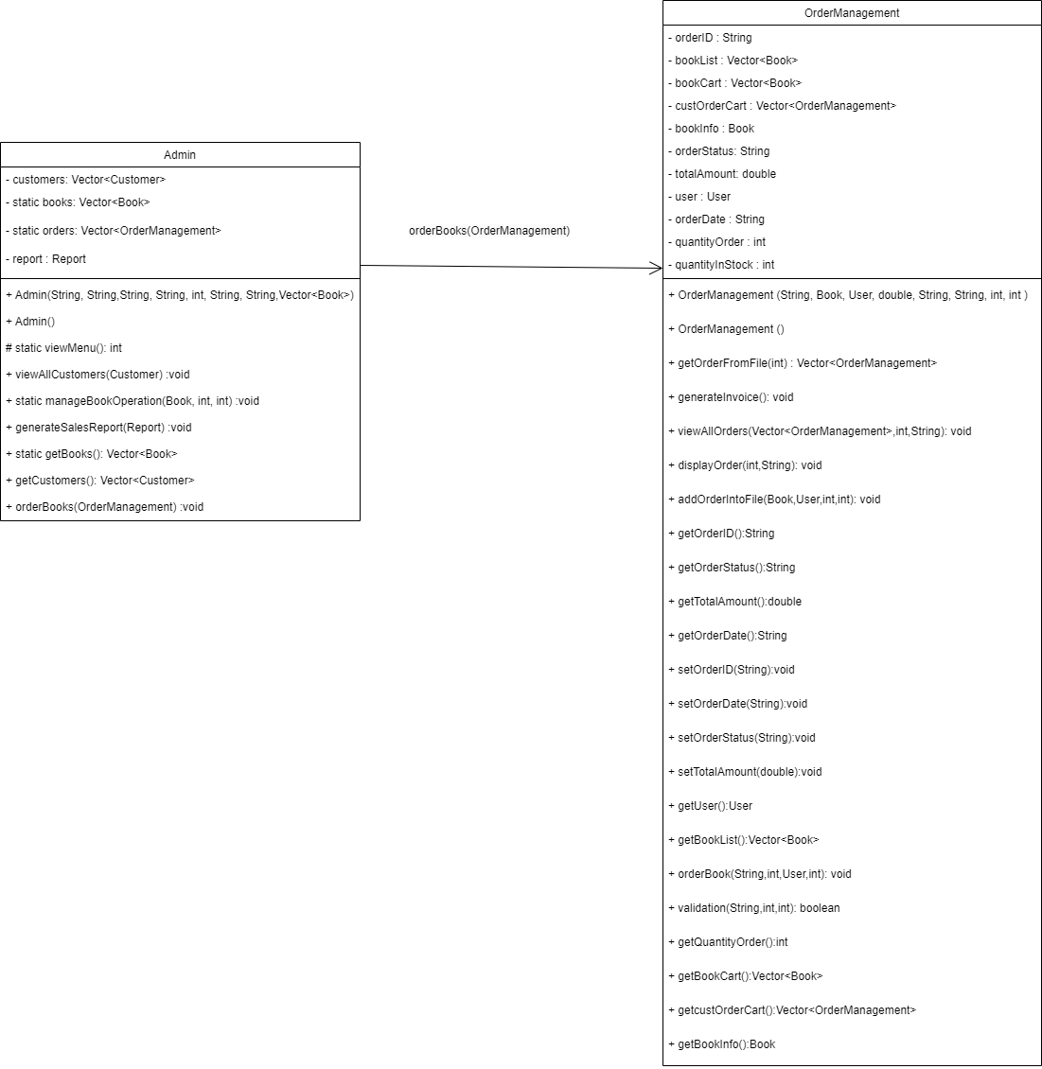

**Figure 2.4 : Admin to orderManagement**

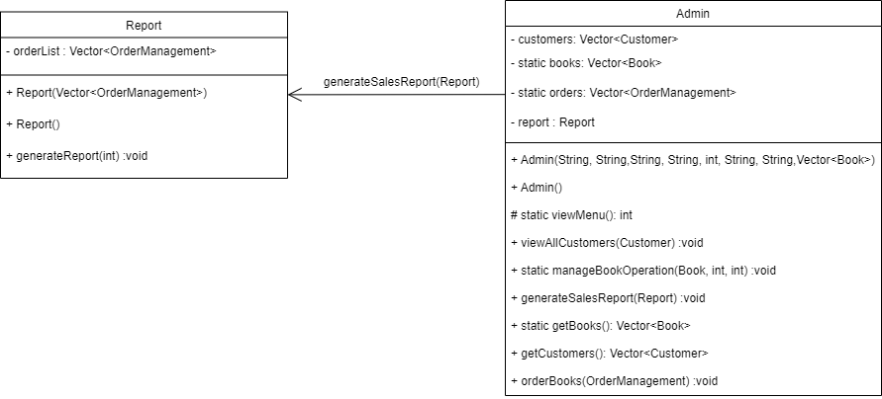

**Figure 2.5 : Admin to report**

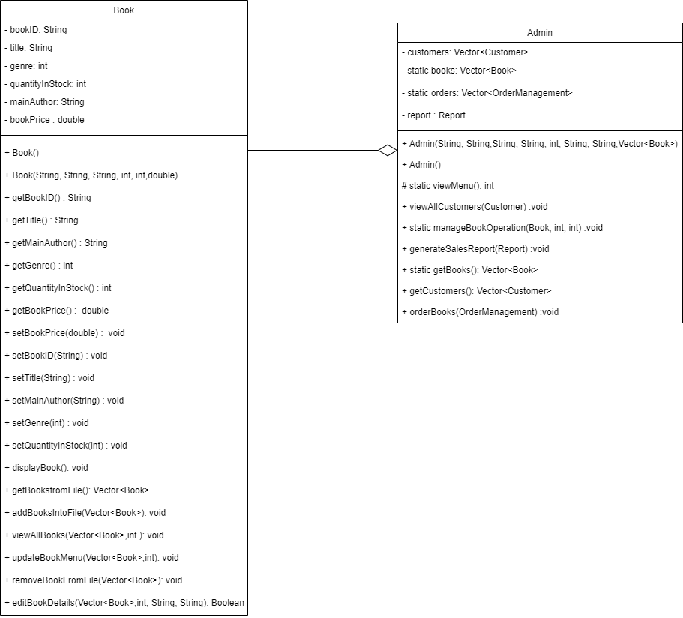

**Figure 2.6 : Book to admin**

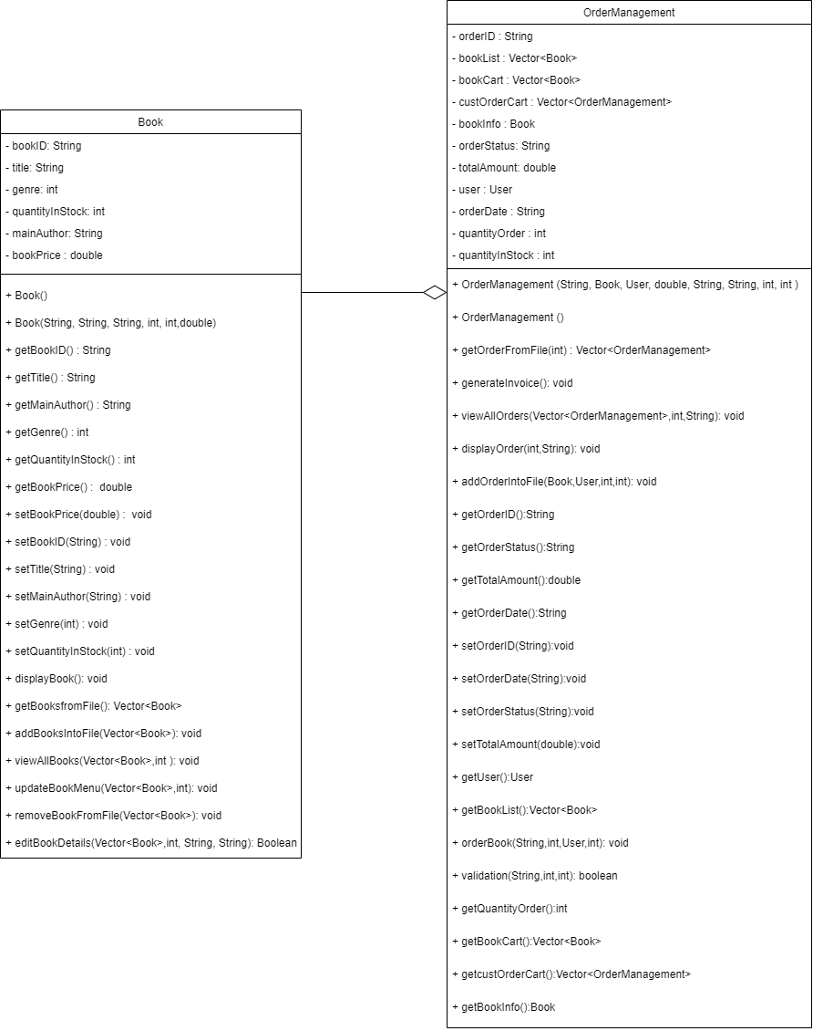

**Figure 2.7 : Book to orderManagement**

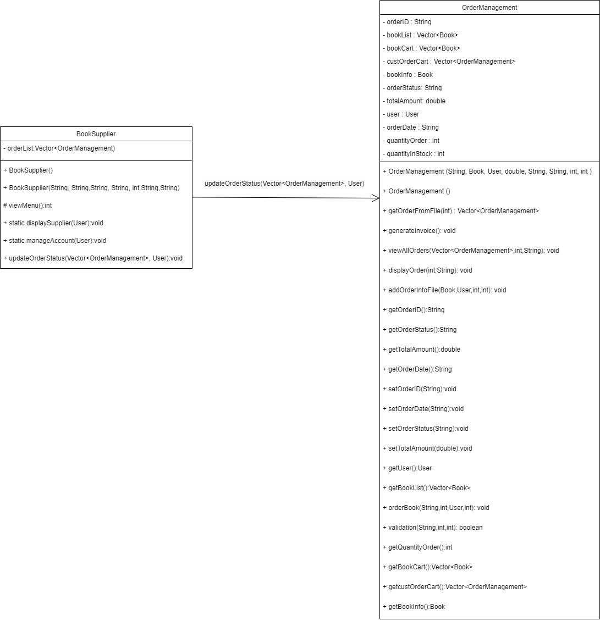

**Figure 2.8 : BookSupplier to orderManagement**

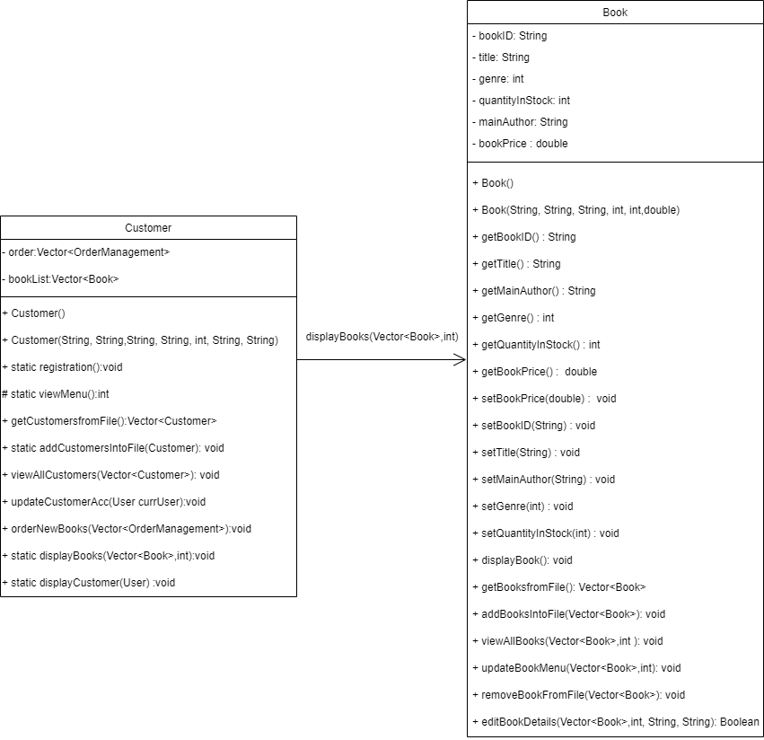

**Figure 2.9 : Customer to book**

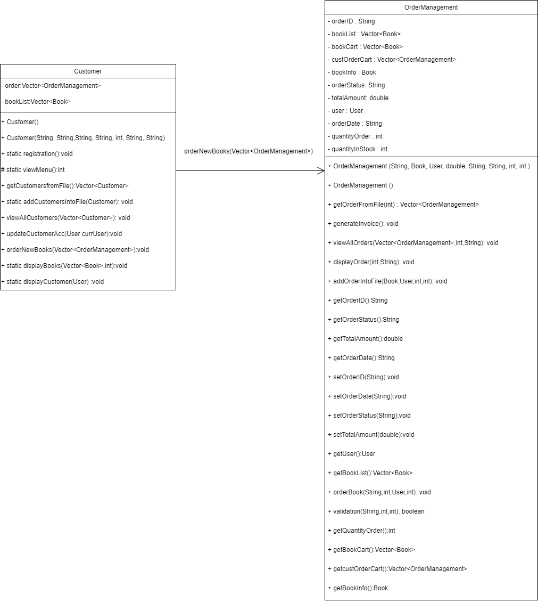

**Figure 2.10 : Customer to orderManagement**

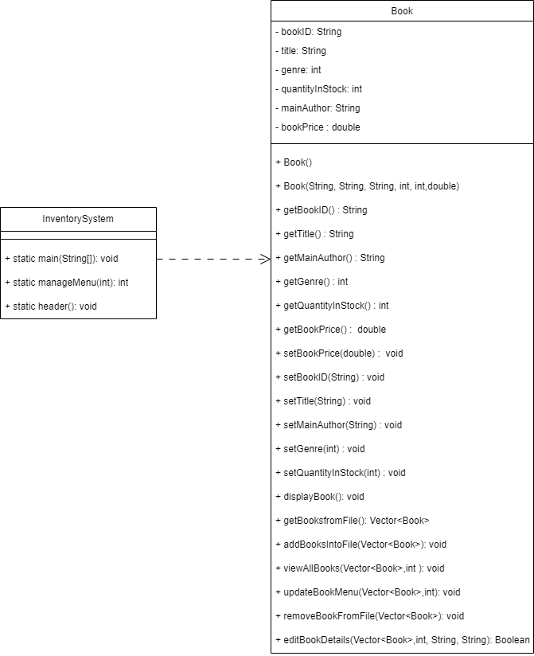

**Figure 2.11 : InventorySystem to book**

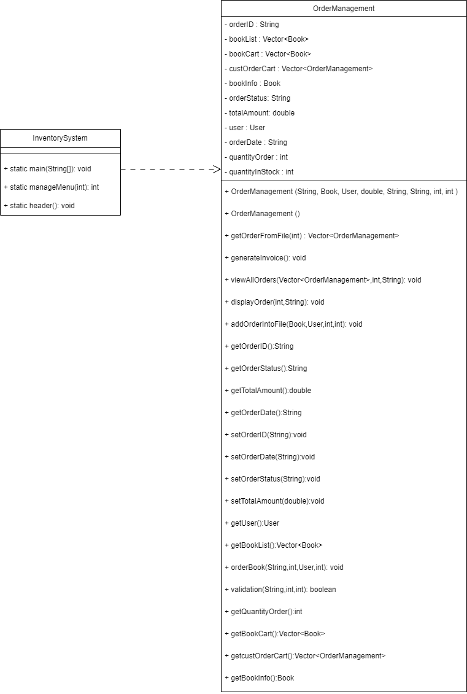

**Figure 2.12 : InventorySystem to orderManagement**

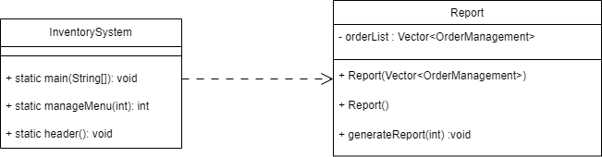

**Figure 2.13 : InventorySystem to report**

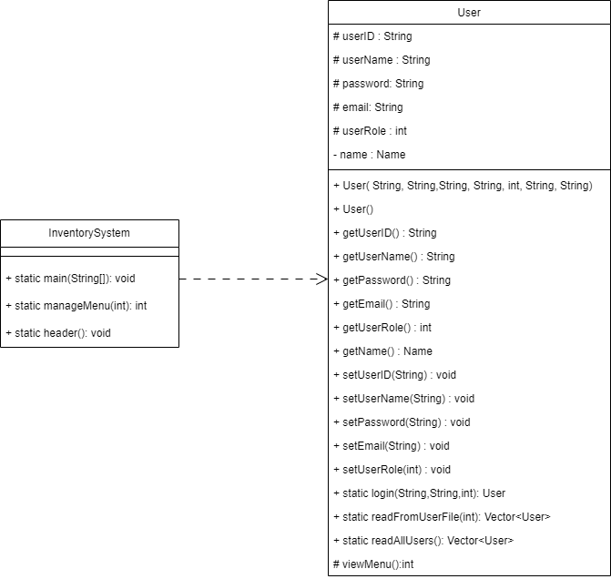

**Figure 2.14 : InventorySystem to user**

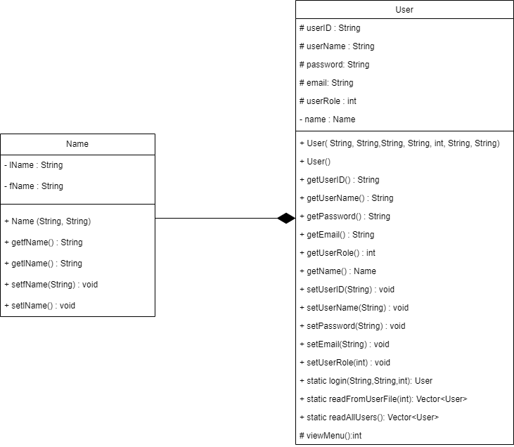

**Figure 2.15 : Name to user**

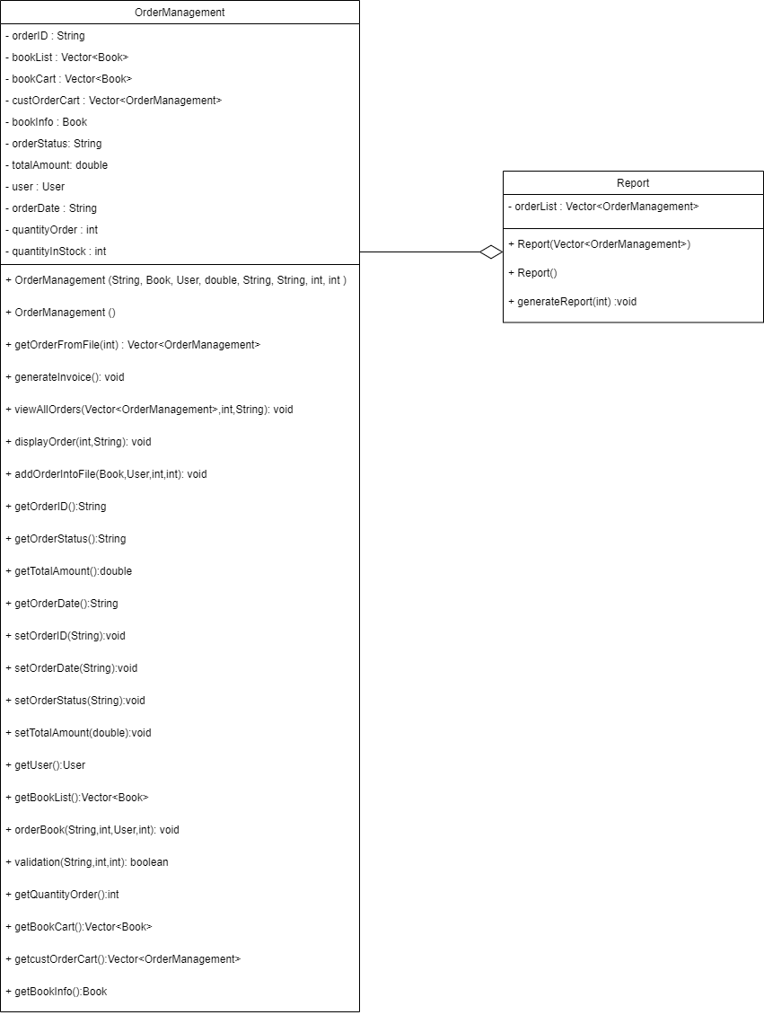

**Figure 2.16 : OrderManagement to report**

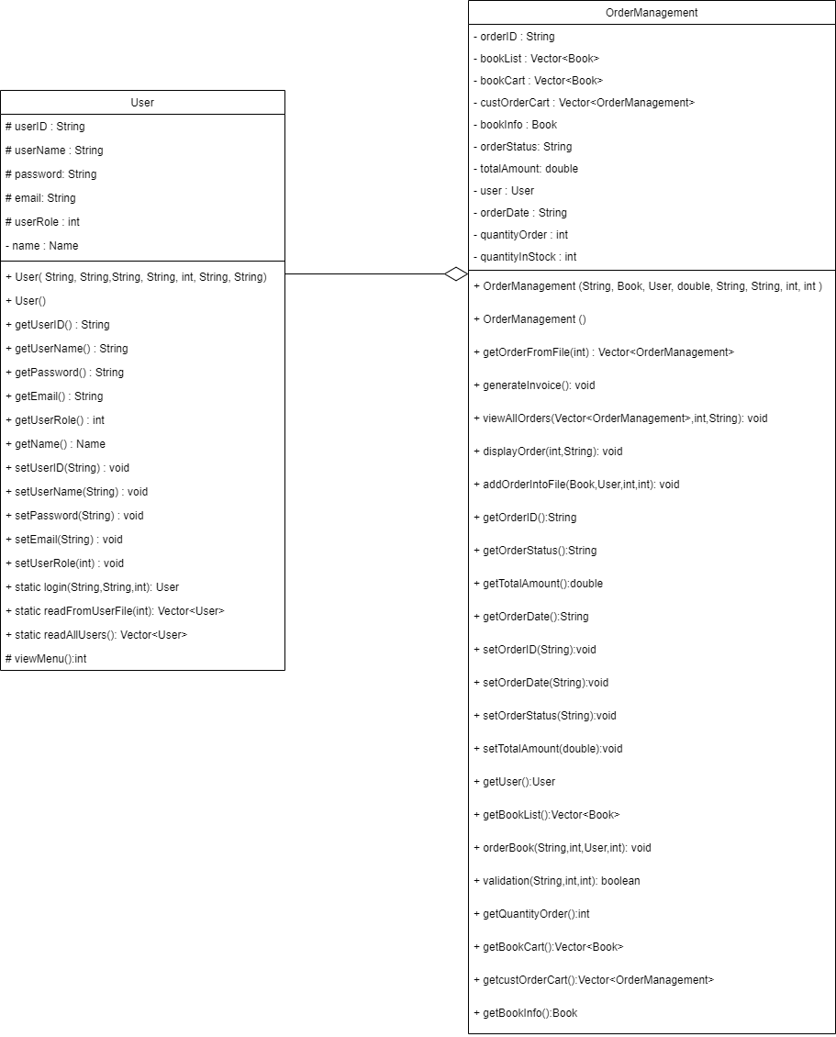

**Figure 2.17 : User to orderManagement**

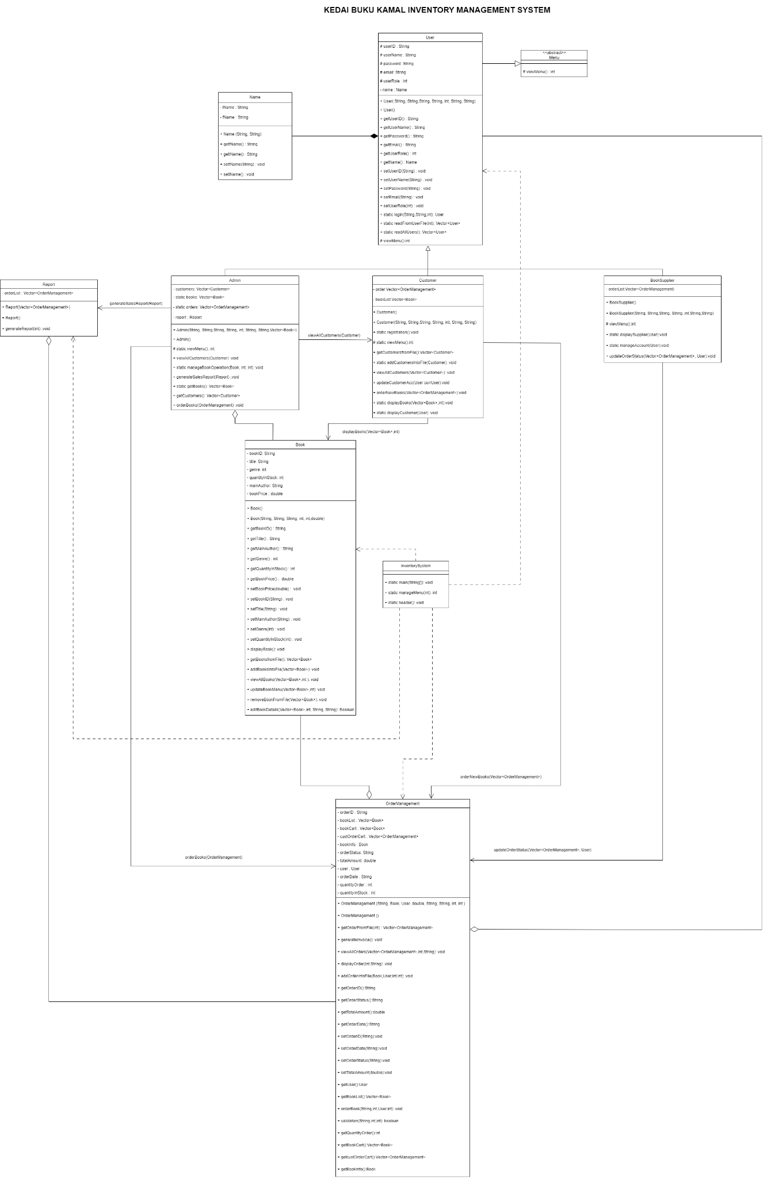

**Figure 2.18 : UML class Figure**

## NAME CLASS

| **Attributes** | **Data Type** | **Description** |
| --- | --- | --- |
| fName | String | A variable to store first name. |
| lName | String | A variable to store last name. |
| **Methods** | **Return / void** | **Description** |
| Name(String, string) | void | A function used to find name. |
| getfName() | return String | A function used to get first name. |
| getlName() | return String | A function used to get last name. |
| setfName(String) | void | A function used to set first name. |
| setlName() | void | A function used to set last name. |

## USER CLASS

| **Attributes** | **Data Type** | **Description** |
| --- | --- | --- |
| userID | String | A variable to store userID. |
| userName | String | A variable to store userName. |
| password | String | A variable to store password. |
| email | String | A variable to store email. |
| userRole | int | A variable to store userRole. |
| name | Name | A variable to store name. |
| **Method** | **Return / void** | **Description** |
| User(String, String, String, String, int, String, String) | - | Constructor for initializing User with specified parameters. |
| User() | - | Default constructor for creating an empty User object. |
| getUser(String) | return String | A function used to get user. |
| getUserName(String) | return String | A function used to get user name. |
| getPassword(String) | return String | A function used to get password. |
| getEmail(String) | return String | A function used to get email. |
| getUserRole(int) | return int | A function used to get user role. |
| getName(Name) | return name | A function used to get name. |
| getUserID(String) | return String | A function used to get userID. |
| static login(String, String, int) | return Boolean | Static method for user login. |
| static readFormUserFile(int) | return Vector<User> | Static method to read user data from a file based on user ID. |
| static readAllUsers() | return Vector<User> | Static method to read all user data from a file. |
| viewMenu() | return int | Method to view the user menu and return the selected option. |

## MENU CLASS

| **Method** | **Return / void** | **Description** |
| --- | --- | --- |
| viewMenu() | return int | A function used to view menu. |

## REPORT CLASS

| **Attributes** | **Data Type** | **Description** |
| --- | --- | --- |
| orderList | Vector<OrderManagement> | A vector containing instances of OrderManagement |
| **Method** | **Return / void** | **Description** |
| Report(Vector<OrderManagement>) | - | Constructor that takes a vector of OrderManagement to initialize the Report. |
| Report | - | Default constructor for creating an empty Report object. |
| generateReport() | void | A function used to generate report |
| getOrderList() | void | A function used to get order list. |

## ADMIN CLASS

| **Attributes** | **Data Type** | **Description** |
| --- | --- | --- |
| static customers | Vector<Customer> | Static vector containing instances of Customer. |
| static books | Vector<Book> | Static vector containing instances of Book. |
| static orders | Vector<OrderManagement> | Static vector containing instances of OrderManagement. |
| report | Report | An instance of the Report class |
| **Method** | **Return / void** | **Description** |
| Admin(String, String, String, int, String, String, Vector<Book>) | - | Constructor for initializing Admin with specified parameters. |
| Admin() | - | Default constructor for creating an empty Admin object. |
| static viewMenu() | return int | Static method to view menu and return the selected option. |
| viewAllCustomers(Customer) | void | Displays information about a specific Customer. |
| static manageBookOperation(Book, int, int) | void | Static method to manage book operations |
| generateSalesReport(Report) | void | Generates a sales report based on the provided Report object. |
| orderBooks(Vector<OrderManagement>) | void | Places orders for books based on a vector of OrderManagement. |

## CUSTOMER CLASS

| **Attributes** | **Data Type** | **Description** |
| --- | --- | --- |
| order | Vector<OrderManagement> | Vector containing instances of OrderManagement. |
| bookList | Vector<Book> | Vector containing instances of Book. |
| **Method** | **Return / void** | **Description** |
| Customer() | - | Default constructor for creating an empty Customer object. |
| Customer(String, String, String, String, int, String, String) | - | Constructor for initializing Customer with specified parameters. |
| static registration() | void | Static method for customer registration. |
| static viewMenu() | return int | Static method to view menu and return the selected option. |
| getCustomersFromFile() | return Vector<Customer> | Reads and returns customer data from a file. |
| static addCustomersIntoFile(Customer) | void | Static method to add a customer to the file. |
| viewAllCustomers(Vector<Customer>) | void | Displays information about all customers in a vector. |
| updateCustomerAcc(int, String, String) | Return Boolean | Updates customer account information based on parameters. |
| orderNewBooks(Vector<OrderManagement>) | void | Places new orders for books based on a vector of OrderManagement. |
| displayBooks(Vector<Book>, int) | void | Displays information about books based on a vector of Book and an integer parameter. |

## BOOKSUPPLIER CLASS

| **Attributes** | **Data Type** | **Description** |
| --- | --- | --- |
| static order | Vector<OrderManagement> | Static vector containing instances of OrderManagement. |
| **Method** | **Return / void** | **Description** |
| BookSupplier() | - | Default constructor for creating an empty BookSupplier object. |
| BookSupplier(String, String, String, String, int, String, String) | - | Constructor for initializing BookSupplier with specified parameters. |
| static viewMenu() | return int | Static method to view menu and return the selected option. |
| static displaySupplier(User) | void | Static method to display information about a specific User. |
| static manageAccount(User) | void | Static method to manage the account of a specific User. |
| updateOrderStatus(Vector<OrderManagement>) | void | Updates the status of orders based on a vector of OrderManagement. |

## BOOK CLASS

| **Attributes** | **Data Type** | **Description** |
| --- | --- | --- |
| bookID | String | A variable to store bookID. |
| title | String | A variable to store title. |
| mainAuthor | String | A variable to store mainAuthor. |
| genre | int | A variable to store genre. |
| quantityInStock | int | A variable to store quantityInStock. |
| **Method** | **Return / void** | **Description** |
| Book() | - | Default constructor for creating an empty Book object. |
| Book(String, String, String, int, int) | - | Constructor for initializing Book with specified parameters. |
| getBookID() | return String | A function used to get bookID. |
| getTitle() | return String | A function used to get title. |
| getMainAuthor() | return String | A function used to get main author. |
| getGenre() | return int | A function used to get genre. |
| getQuantityInStock() | return int | A function used to get quantity in stock. |
| setBookID(String) | void | A function used to set bookID. |
| setTitle(String) | void | A function used to set title. |
| setMainAuthor(String) | void | A function used to set main author. |
| setGenre(int) | void | A function used to set genre. |
| setQuantityInStock(int) | void | A function used to set quantity in stock. |
| displayBook() | void | Displays information about the book. |
| getBooksFromFile() | return Vector<Book> | Reads and returns book data from a file. |
| addBooksIntoFile(Vector<Book>) | void | Adds books to the file. |
| viewAllBooks(Vector<Book>, int) | void | Displays information about all books in a vector. |
| updateBookMenu(Vector<Book>, int) | void | Updates the book menu based on a vector of Book and an integer parameter. |
| removeBookFromFile(Vector<Book>) | void | Removes books from the file based on a vector of Book. |
| editBookDetails(Vector<Book>, int, String, String) | return bool | Edits book details based on a vector of Book, an integer parameter, and new details. Returns true if successful. |

## INVENTORYSYSTEM CLASS

| **Method** | **Return / void** | **Description** |
| --- | --- | --- |
| static main(String[]) | void | Main method to start the inventory system. |
| static header() | void | Static method to display the system header. |
| static manageMenu() | return int | Static method to manage the system menu and return the selected option. |

## ORDERMANAGEMENT CLASS

| **Attributes** | **Data Type** | **Description** |
| --- | --- | --- |
| orderID | String | A variable to store orderID. |
| bookInfo | Vector<Book> | Vector containing instances of Book representing the ordered books. |
| bookCart | Vector<Book> | Vector containing instances of Book representing the items in the customer's cart. |
| custOrderCart | Vector<OrderManagement> | Vector containing instances of OrderManagement representing the customer's order cart. |
| orderStatus | String | A variable to store order status. |
| totalAmount | double | A variable to store total amount. |
| user | User | Instance of the User class representing the customer who placed the order. |
| orderDate | String | A variable to store order date. |
| quantityOrder | int | A variable to store quantity order. |
| quantityInStock | int | A variable to store quantity in stock. |
| **Method** | **Return / void** | **Description** |
| OrderManagement(String, Book, User, double, String, String, int, int) | - | Constructor for initializing OrderManagement with specified parameters. |
| OrderManagement() | - | Default constructor for creating an empty OrderManagement object. |
| getOrderFromFile(int) | Return Vector<OrderManagement> | Retrieves orders from a file based on order ID. |
| generateInvoice() | void | A function used to generate invoice. |
| viewAllOrders(Vector<OrderManagement>, int, String) | void | A function used to view all orders. |
| displayOrder(int, String) | void | A function used to display order. |
| addOrderIntoFile(Book, User, int, int) | void | Adds an order to the file based on book, user, and quantity information. |
| getOrderID() | return String | A function used to get orderID. |
| getOrderStatus() | return String | A function used to get order status |
| getTotalAmount() | return double | A function used to get total amount. |
| getOrderDate() | return String | A function used to get order date |
| getOrderStatus() | return String | A function used to get order status. |
| setOrderID(String) | void | A function used to set orderID. |
| setOrderDate(String) | void | A function used to set order date. |
| setOrderStatus(String) | void | A function used to set order status. |
| setTotalAmount() | void | A function used to set total amount. |
| getUser() | return User | A function used to get user from the order. |
| getBookList() | return Vector<Book> | A function used to get book list. |
| orderBook(String, int, User, int) | return boolean | Places a new order based on book ID, quantity, user, and order ID. |
| validation(String, int, int) | return boolean | Validates book ID, quantity, and user information for ordering. Returns true if valid. |
| getQuantityOrder() | return int | A function used to get quantity order. |
| getBookCart() | return Vector<Book> | A function used to get book cart. |
| getcustOrderCart() | return Vector<OrderManagement> | A function used to get cust order cart. |
| getBookInfo() | return Book | A function used to get book info. |

# 

# SECTION C: SOURCE CODE AND USER MANUAL

## **User manual**

1. First, this screen shows the role to be chosen by the user, if you are an administrator, enter the number 1, if you are a customer, enter the number 2, if you are a supplier, enter the number 3, as shown in **Figure 3.1**.

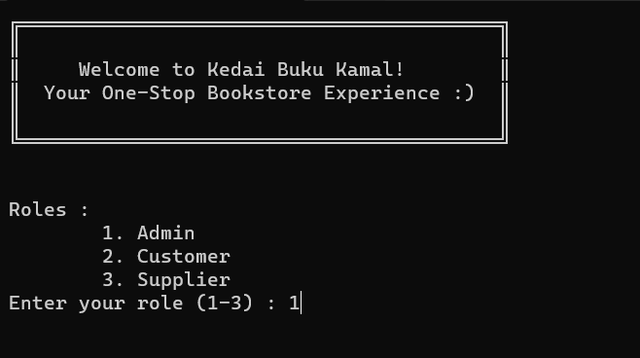

**Figure 3.1 : Role choice screen**

1. After selecting your role, you will be asked to enter your username and password, as shown in **Figure 3.2**. Please make sure you enter your username and password correctly. Otherwise the credentials will be invalid.

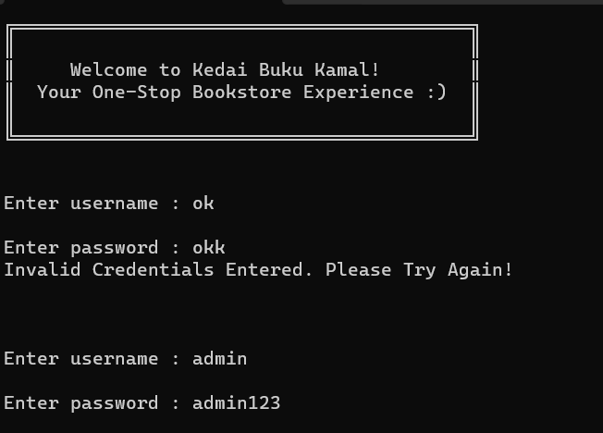

**Figure 3.2 : Enter username and password**

1. If you are a customer and do not have any account, you can select number 2 to register a new account, as shown in **Figure 3.3**. If you already have an account, you can choose number 1 to login.

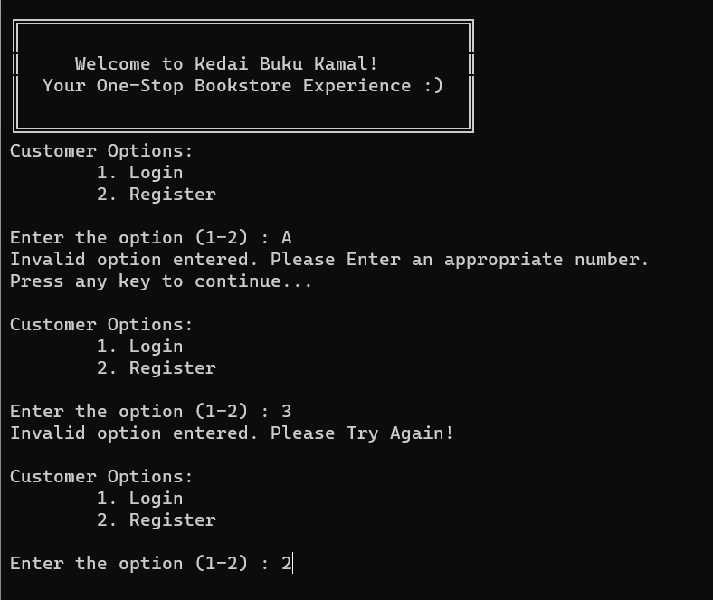

**Figure 3.3 : Customer options to login and register**

1. If you select to register an account, then it will show you this screen as shown in **Figure 3.4**  to enter your username and password to register an account.After successfully register, you can continue to login as shown in **Figure 3.5**.

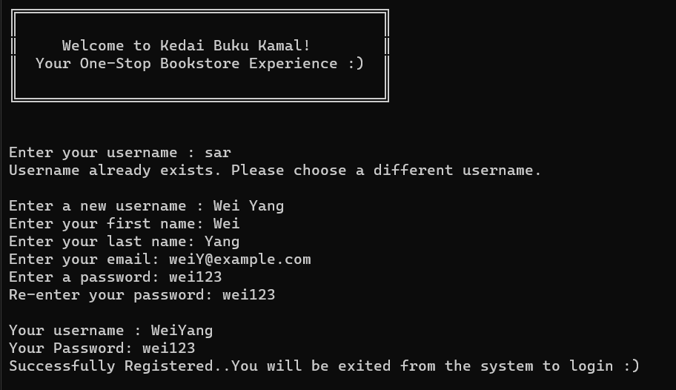

**Figure 3.4 : Enter username and password for register**

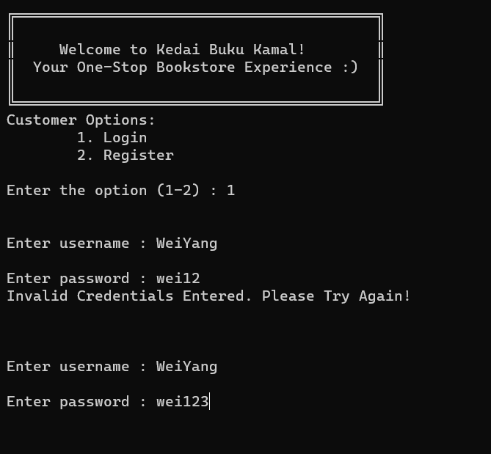

**Figure 3.5 : Enter username and password to login**

1. After successful login, if you are an administrator, the menu page will be displayed, as shown in **Figure 3.6**. If you are a customer, the menu page will be displayed, as shown in **Figure 3.7**. If you are a supplier, the menu screen will be displayed, as shown in **Figure 3.8**. Please make sure to enter the number if you want to select the menu.

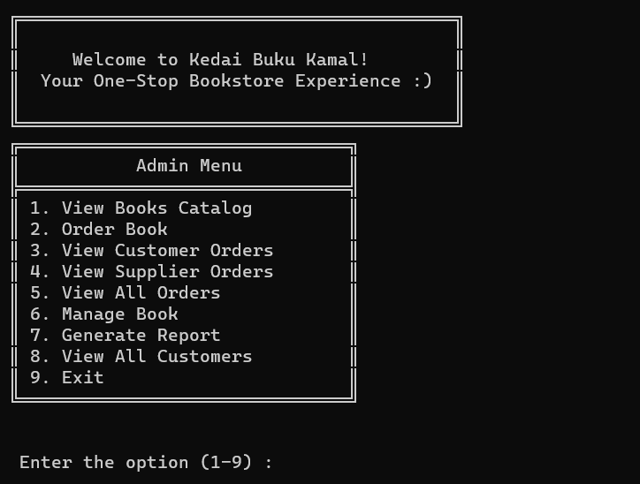

**Figure 3.6 : Admin menu screen**

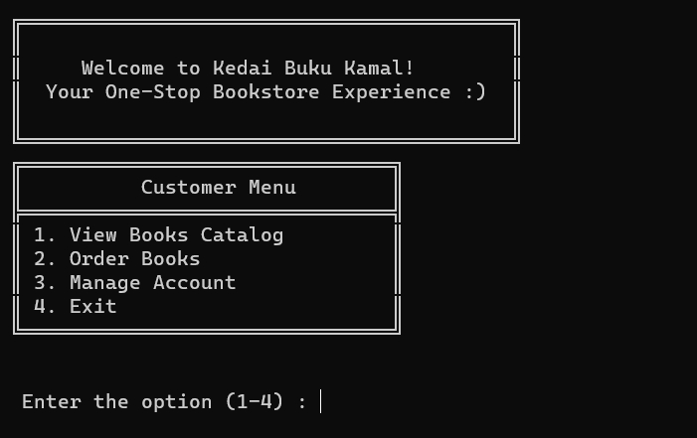

**Figure 3.7 : Customer menu screen**

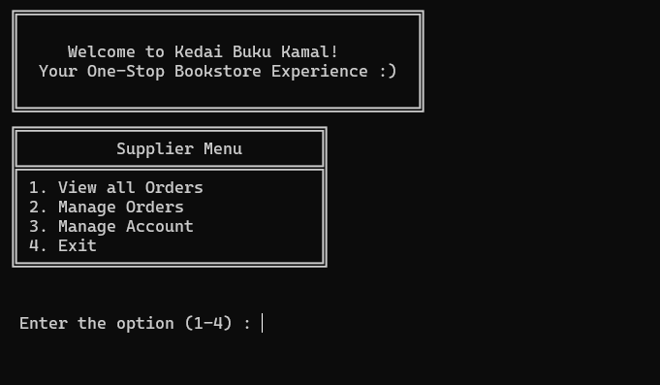

**Figure 3.8 : Supplier menu screen**

### **Admin User Manual**

1. If you select admin menu number 1, the book catalog list will be displayed, as shown in **Figure 3.9**.

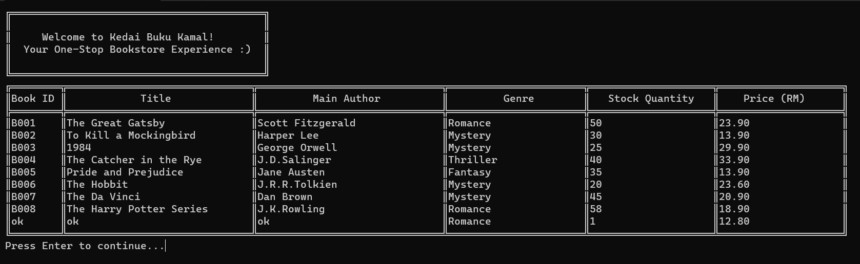

**Figure 3.9 : View books catalog**

1. If you select admin menu number 2, the order books screen will be displayed, as shown in **Figure 3.10**. Admin needs to enter a valid BookID and quantity of books that the admin wants to order. As a result, the order will be successfully sent to supplier to be approved.

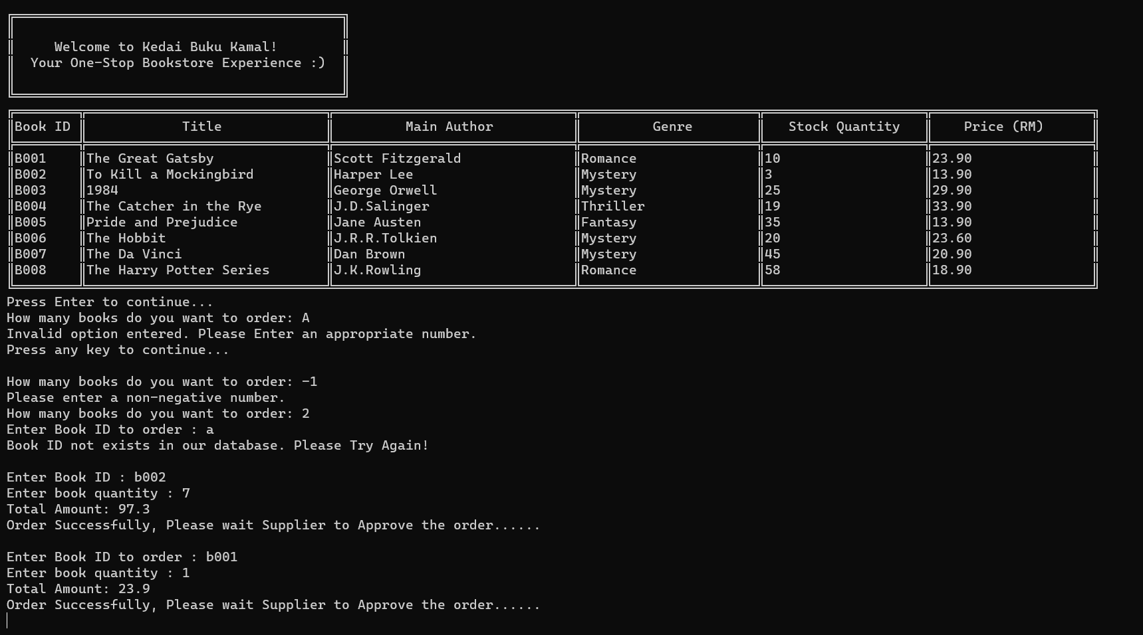

**Figure 3.10 : Orders books**

1. If you select admin menu number 3, the customer orders will be displayed, as shown in **Figure 3.11**.

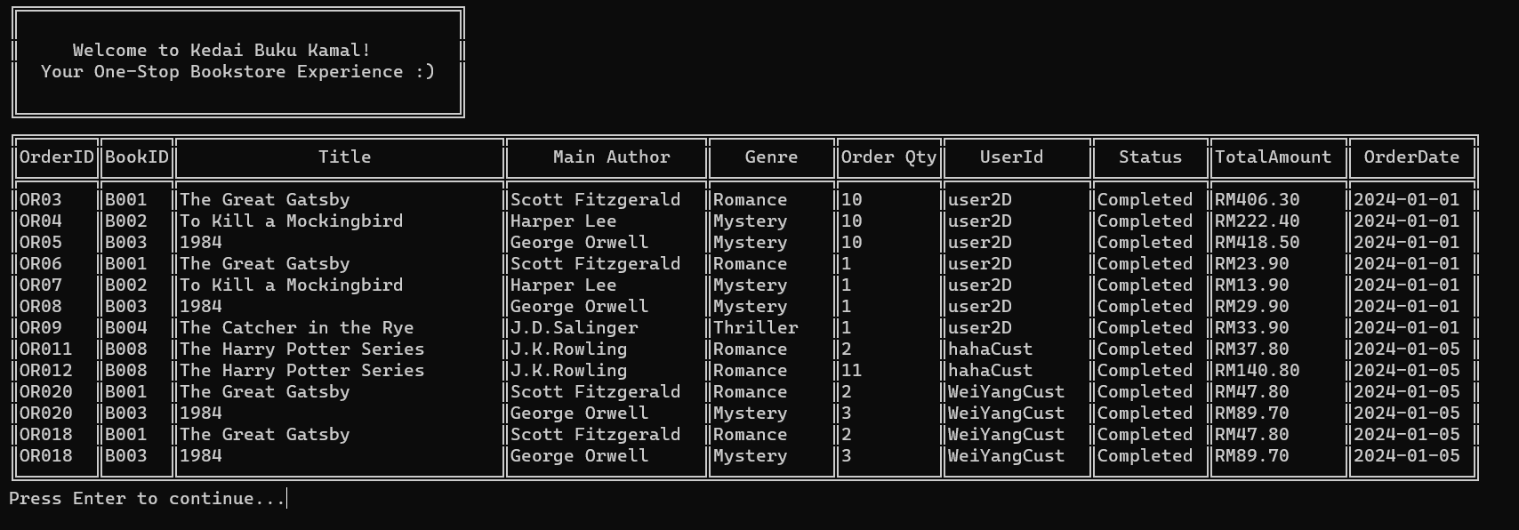

**Figure 3.11 : View customer orders**

1. If you select menu number 4, the supplier orders will be displayed, as shown in **Figure 3.12**.

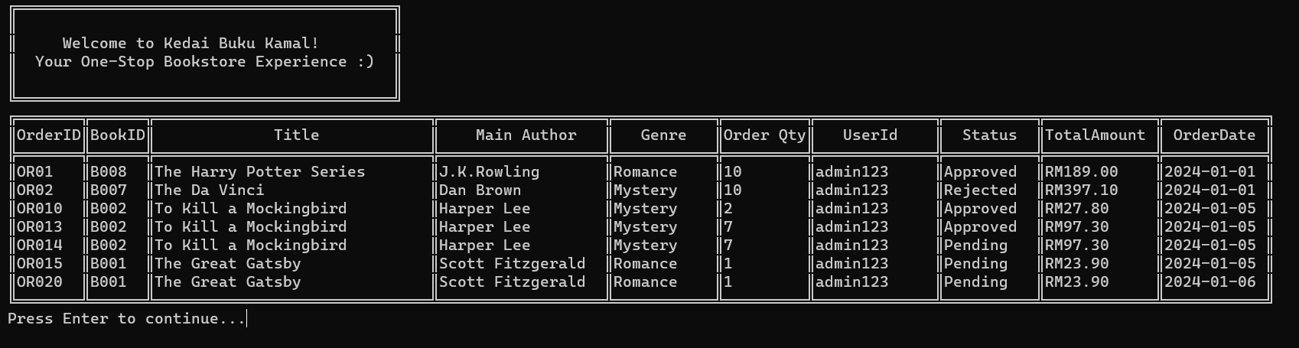

**Figure 3.12 : View supplier orders**

1. If you select menu number 5, all orders will be displayed, as shown in **Figure 3.13**.

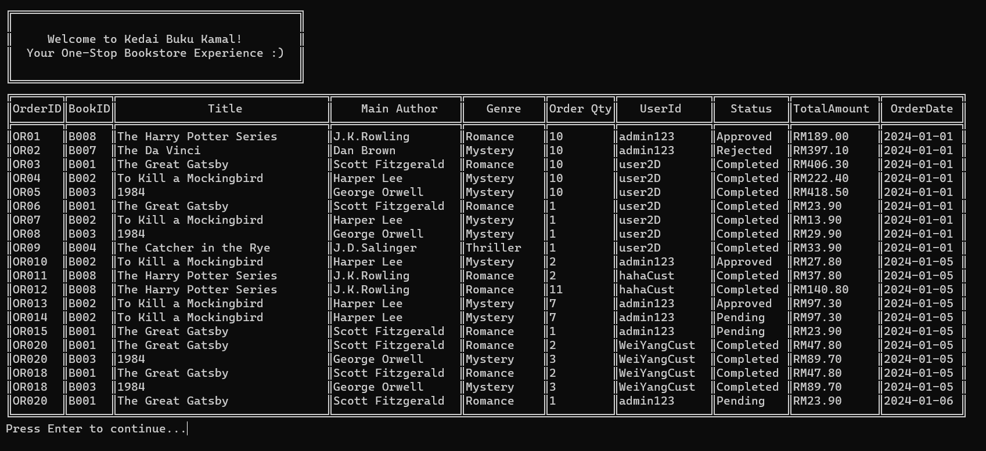

**Figure 3.13 : View all orders**

1. If you select menu number 6, the managed book menu will be displayed, as shown in **Figure 3.14**.
   1. If you want to add a new book, you need to select number 1 to add a new book, as shown in **Figure 3.15**.
   2. If you want to remove a book, you need to select number 2 to remove a book, as shown in **Figure 3.16** and **Figure 3.17**.
   3. If you want to edit a book's details, you need to select number 3 to edit a book's details, as shown in **Figure 3.18**.

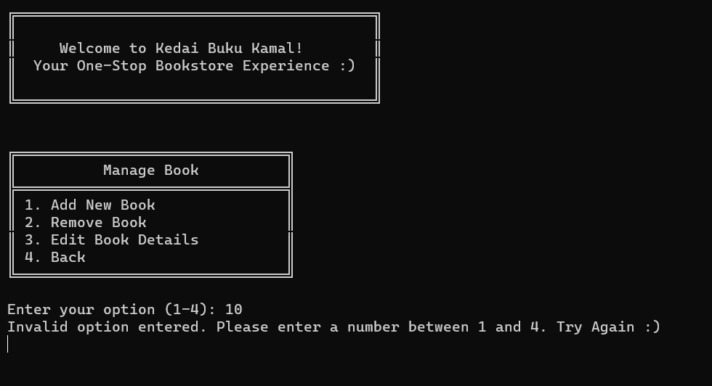

**Figure 3.14 : Manage book**

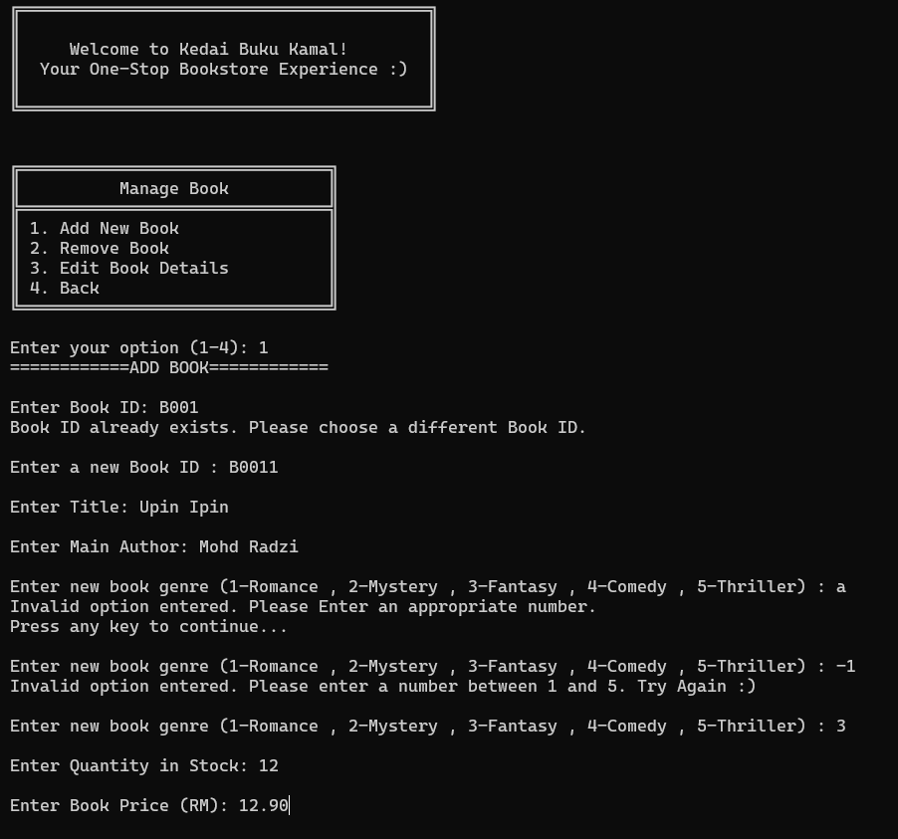

**Figure 3.15 : Manage book (add new book)**

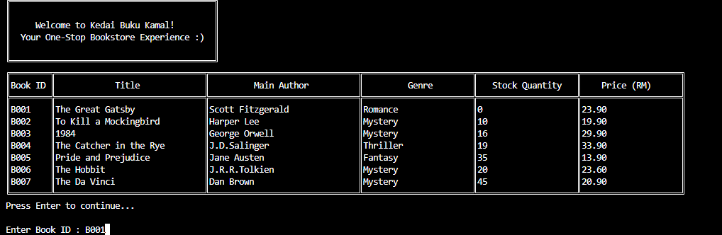

**Figure 3.16 : Manage book (before remove book)**

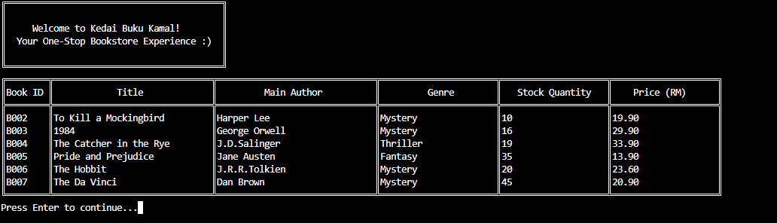

**Figure 3.17 : Manage book (after remove book)**

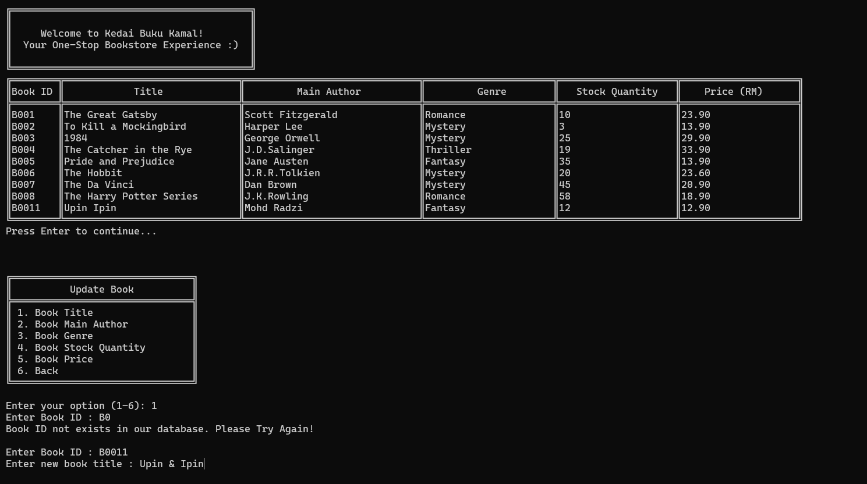

**Figure 3.18 : Manage book (edit book details)**



**Figure 3.19 : Manage book (Edit book title)**

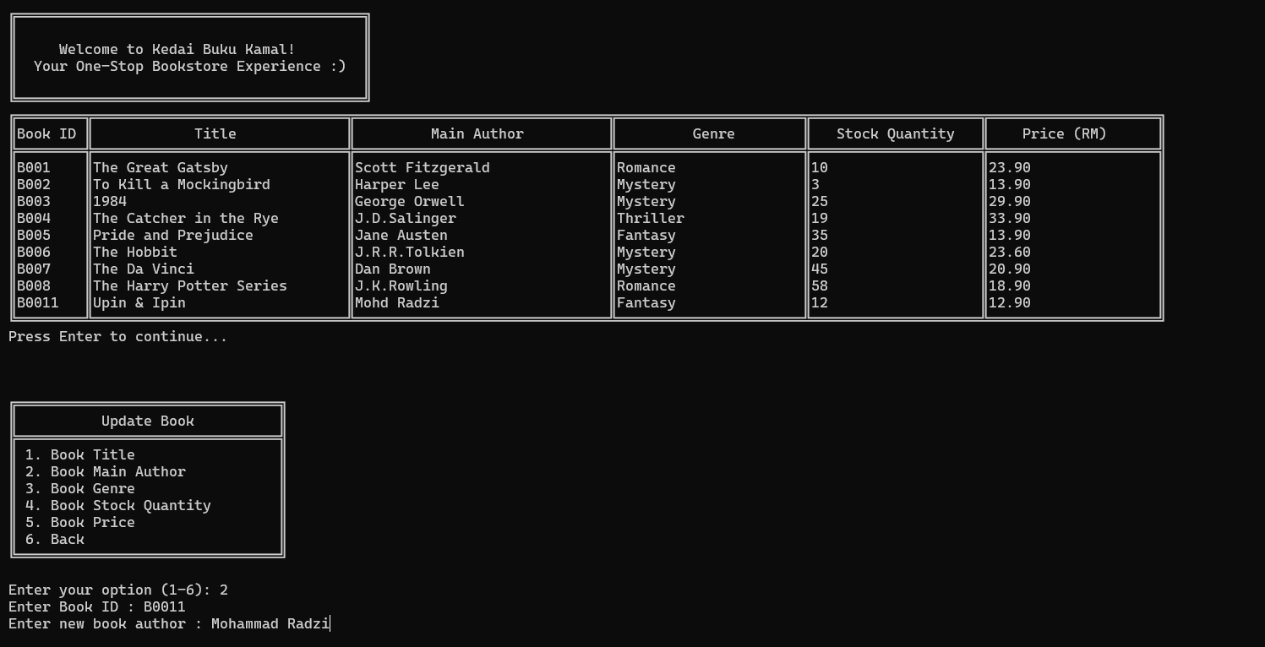

**Figure 3.20 : Manage book (Edit book main author)**

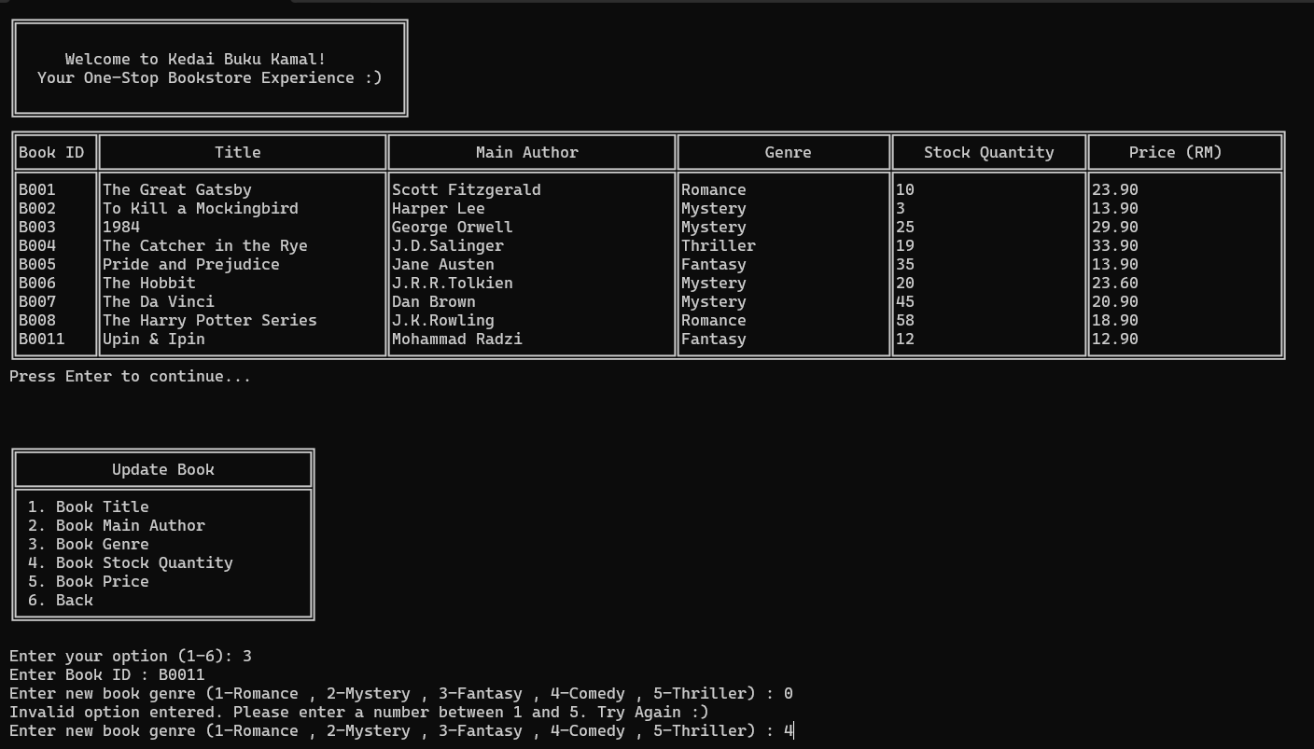

**Figure 3.21 : Manage book (Edit book genre)**

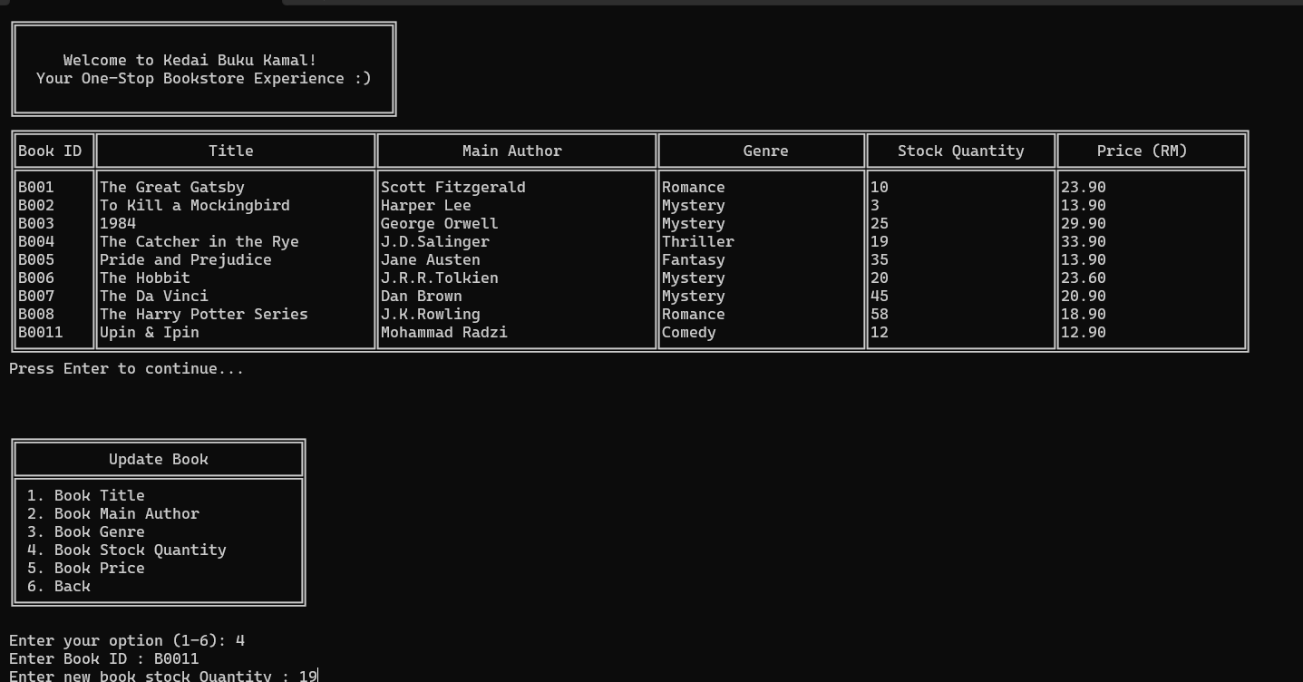

**Figure 3.22 : Manage book (Edit book stock quantity)**

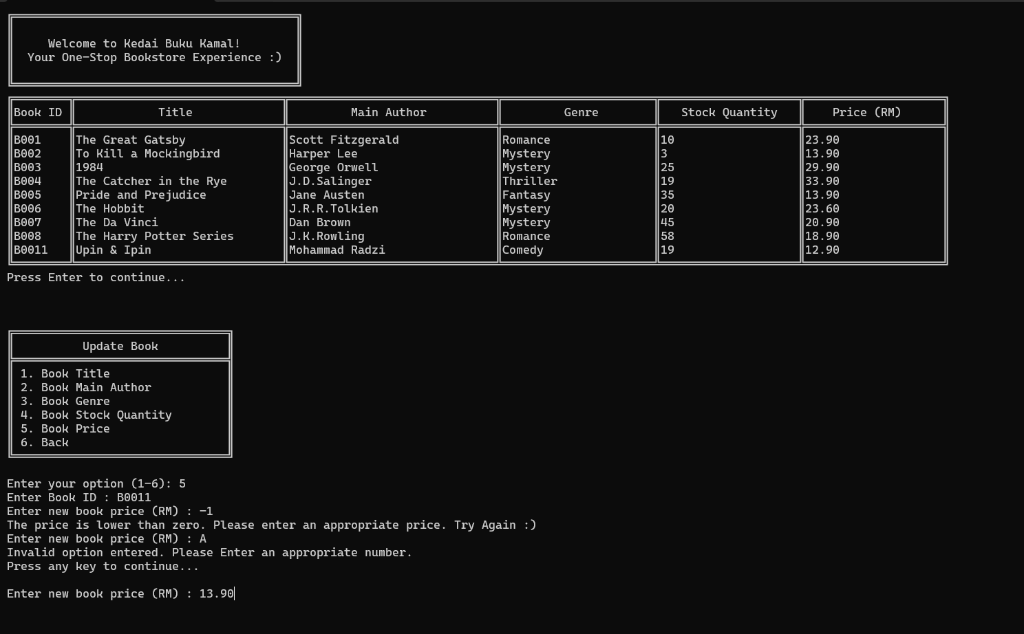

**Figure 3.23 : Manage book (Edit book price)**

1. If you select menu number 7, the manage book menu will be displayed, as shown in **Figure 3.24**.

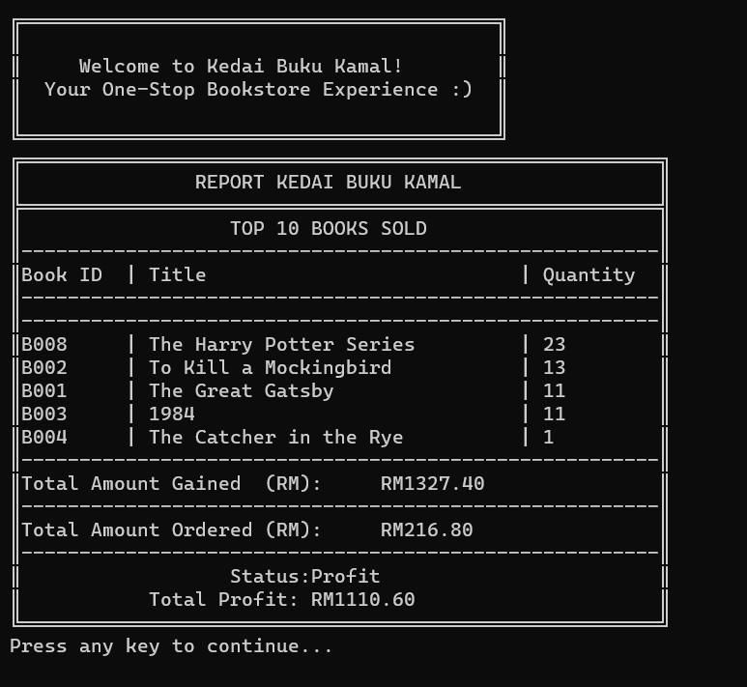

**Figure 3.24 : Generate report**

1. If you select menu number 8, the all customer will be displayed, as shown in **Figure 3.25**.

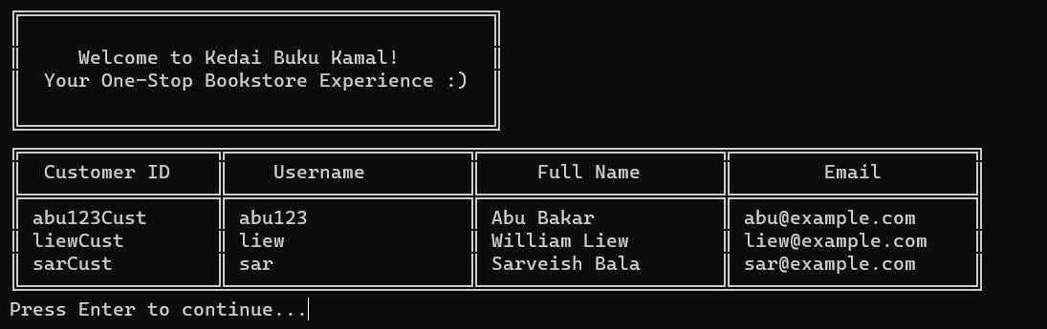

**Figure 3.25 : View all customers**

### **Customer User Manual**

1. If you select customer menu number 1, the book catalogue will be displayed, as shown in **Figure 3.26**.

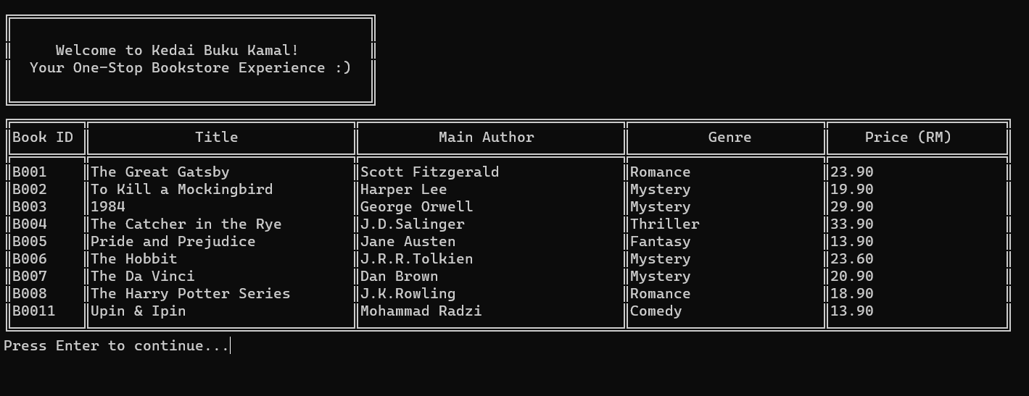

**Figure 3.26 : View books catalogue**

1. If you select customer menu number 2, the order book screen will be displayed, as shown in **Figure 3.27**.

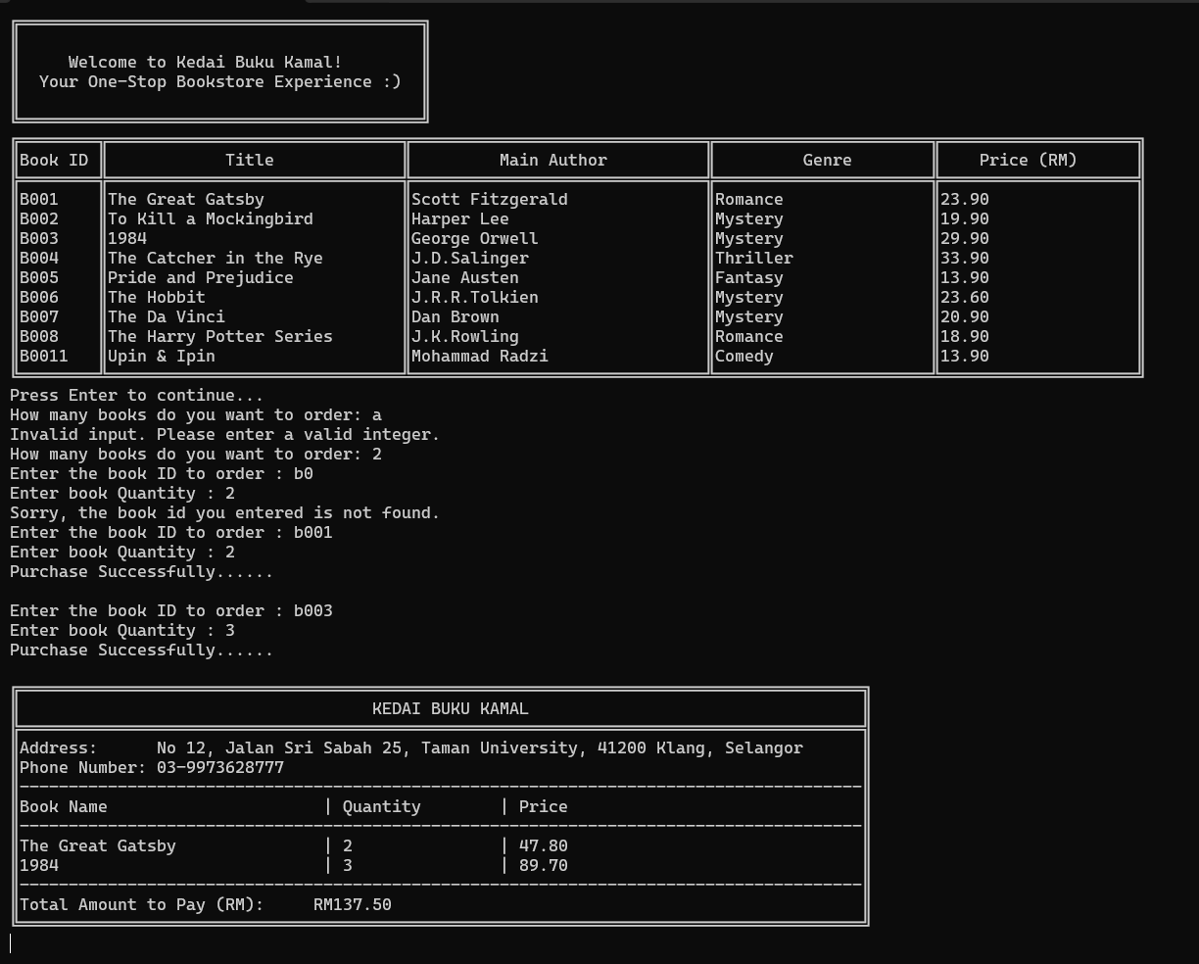

**Figure 3.27 : Order book**

1. If you select customer menu number 3, the manage account menu will be displayed, as shown in Figure **3.28**.
   1. After you select customer menu number 3, if you want to update username, you need to select number 1, as shown in **Figure 3.29**
   2. If you want to update the password, you need to select number 2, as shown in **Figure 3.30**.
   3. If you want to update the email, you need to select number 3, as shown in **Figure 3.31**.
   4. If you want to update the name, you need to select number 4, as shown in **Figure 3.32**.

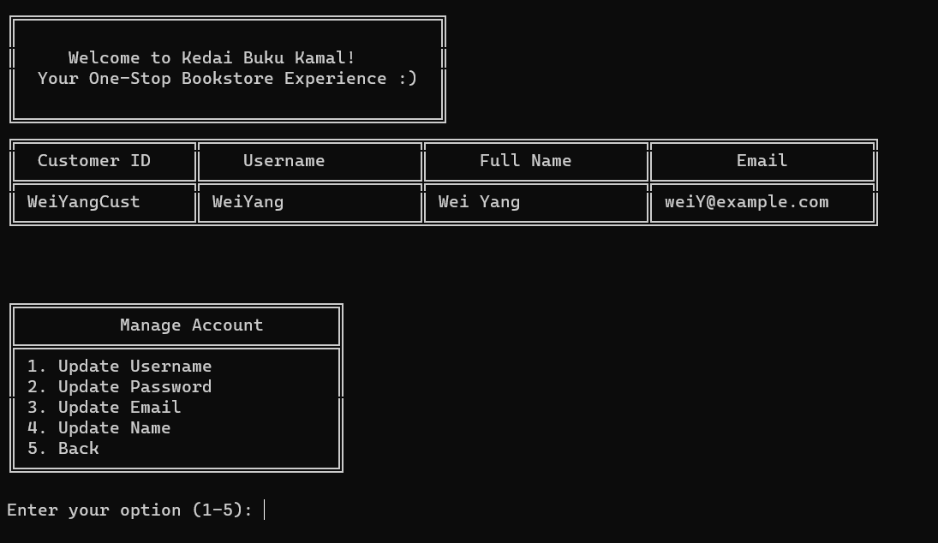

**Figure 3.28 : Manage account**

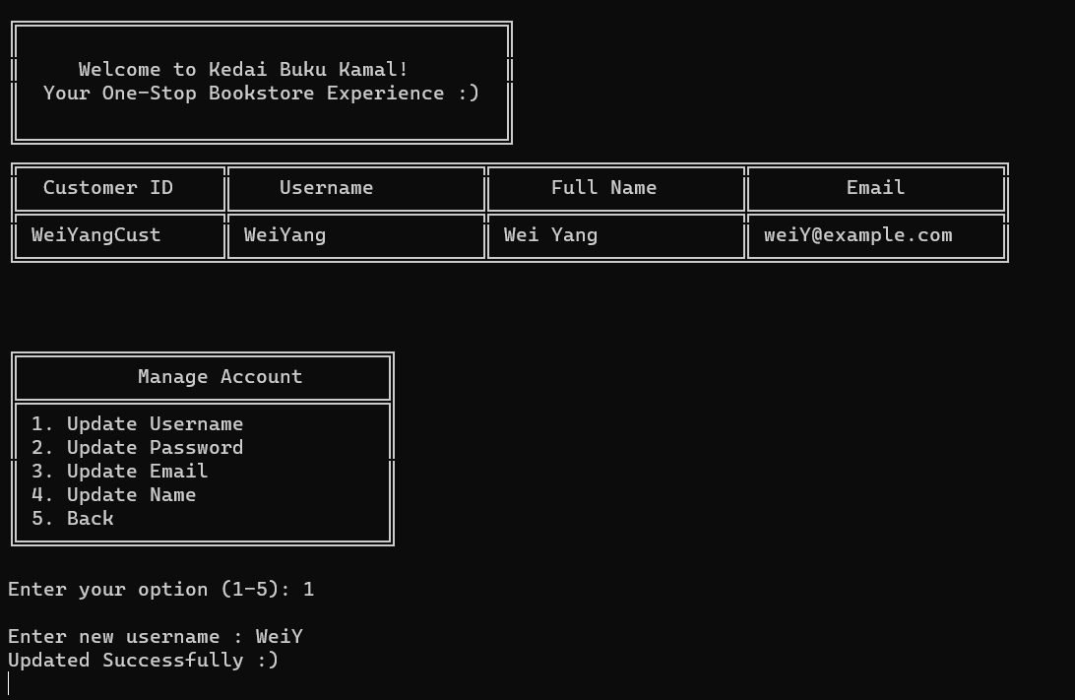

**Figure 3.29 : Update username**

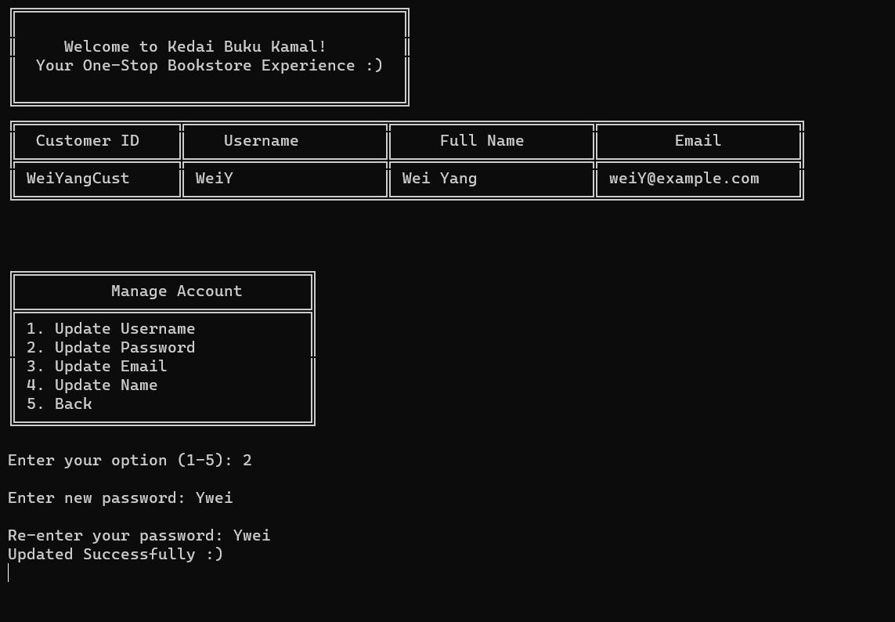

**Figure 3.30 : Update password**

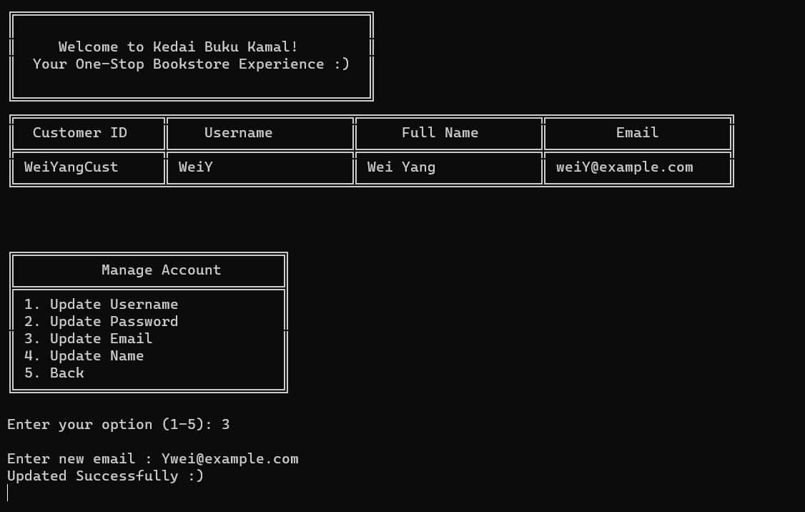

**Figure 3.31 : Update email**

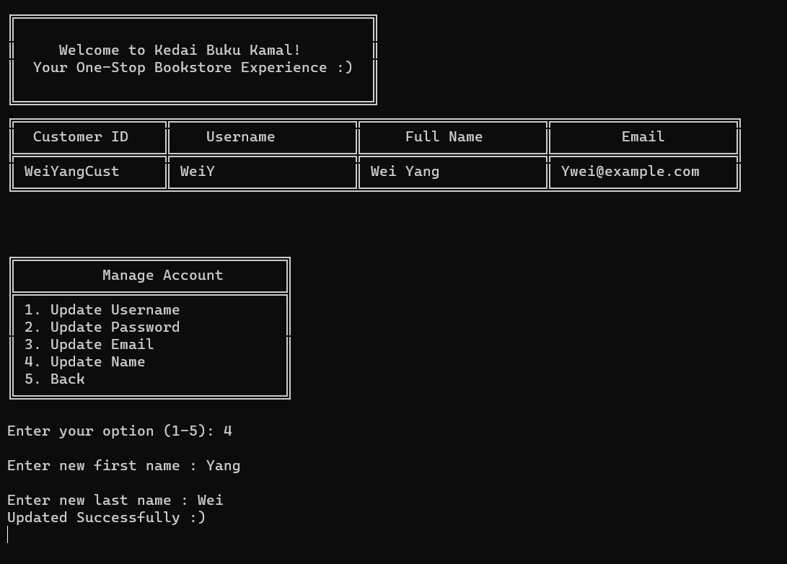

**Figure 3.32 : Update name**

### **Book SupplierUser Manual**

1. If you select supplier menu number 1, all orders will be displayed, as shown in Figure **3.33**.

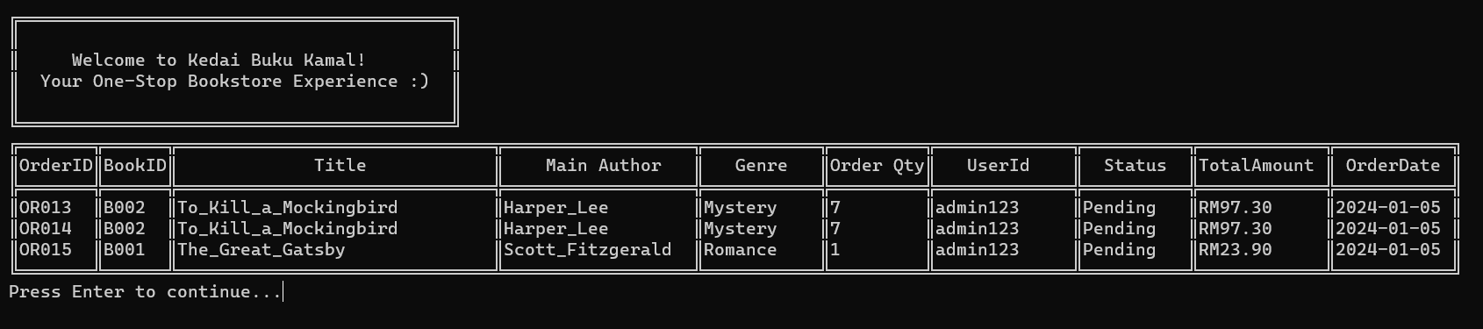

**Figure 3.33 : View all orders**

1. If you select supplier menu number 2, manage orders will be displayed, as shown in **Figure 3.34** and **Figure 3.35**.

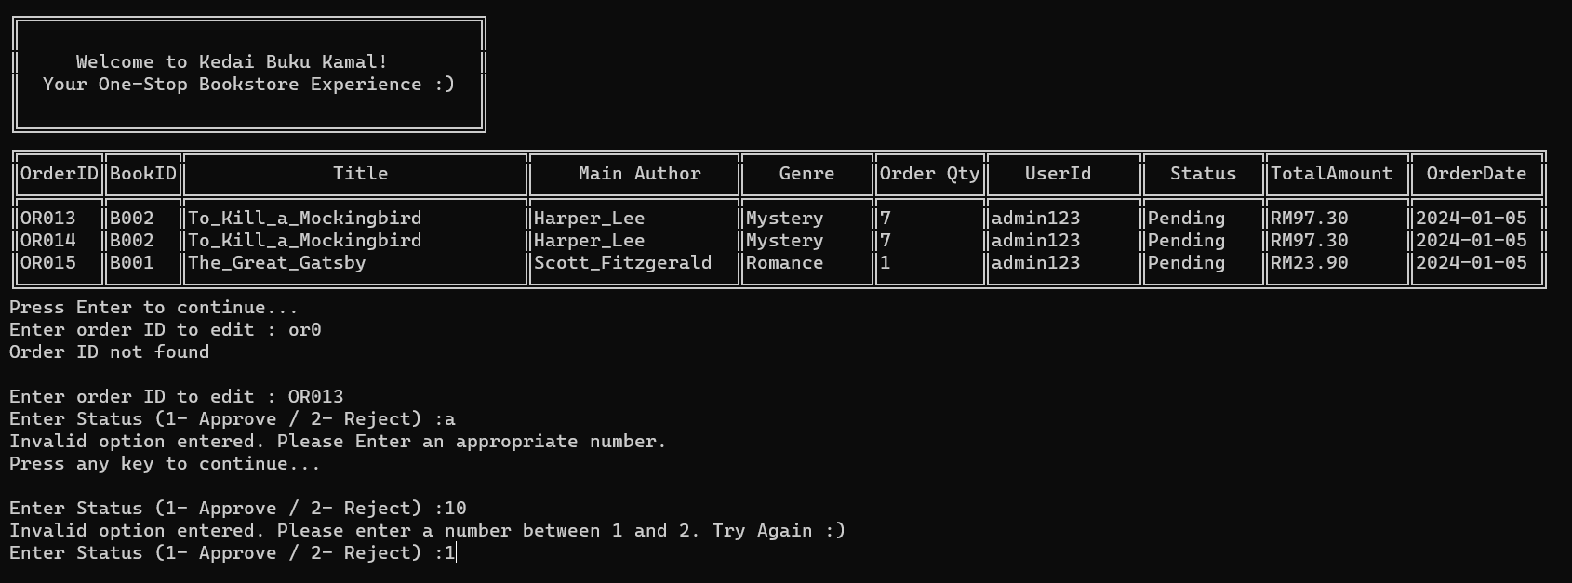

**Figure 3.34 : Manage order (before approve)**

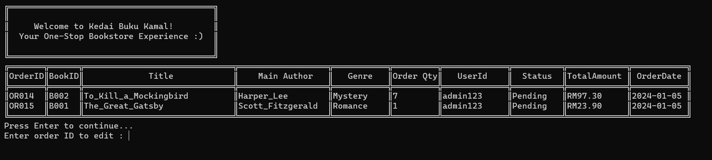

**Figure 3.35 : Manage order (After approve)**

1. If you select supplier menu number 3, the manage account menu will be displayed, as shown in **Figure 3.36**.
   1. After you select supplier menu number 1, if you want to update username, you need to select number 1, as shown in **Figure 3.37**.
   2. If you want to update the password, you need to select number 2, as shown in **Figure 3.38**.
   3. If you want to update the email, you need to select number 3, as shown in **Figure 3.39**.
   4. If you want to update the name, you need to select number 4, as shown in **Figure 3.40**.

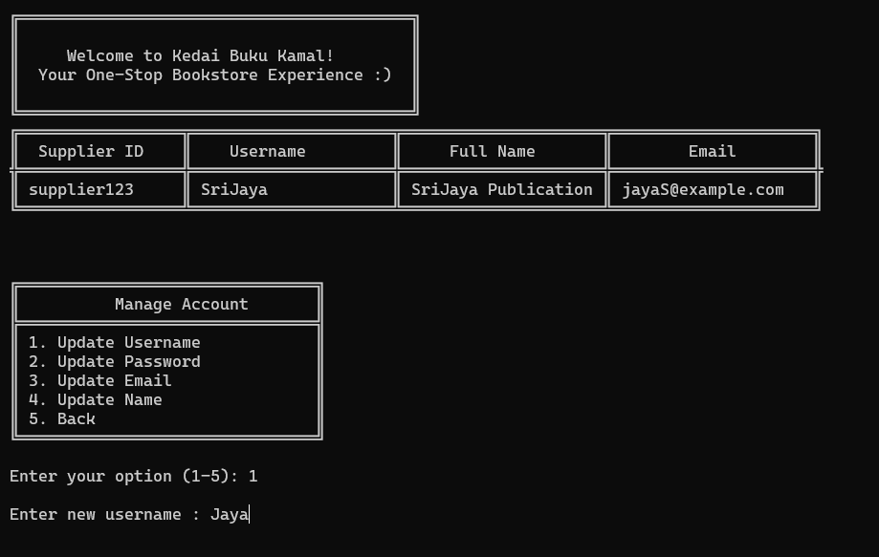

**Figure 3.37 : Update username**

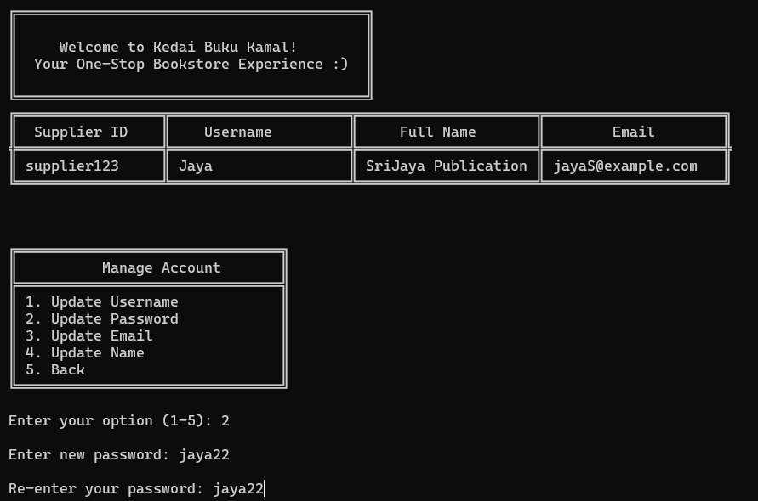

**Figure 3.38 : Update password**

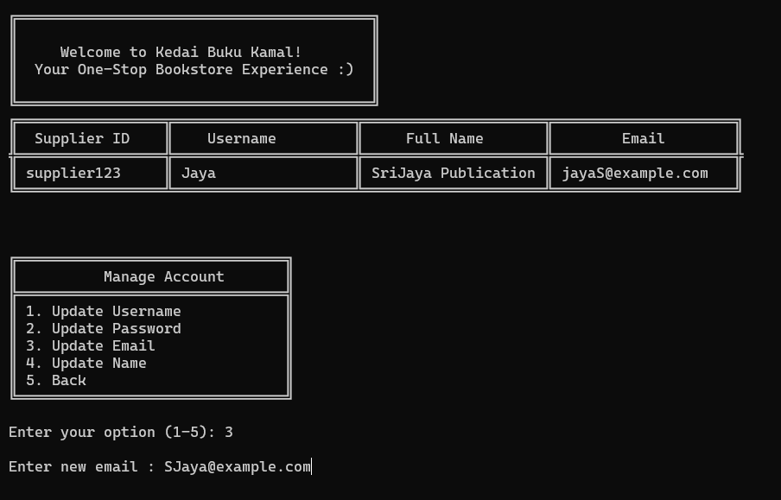

**Figure 3.39 : Update email**

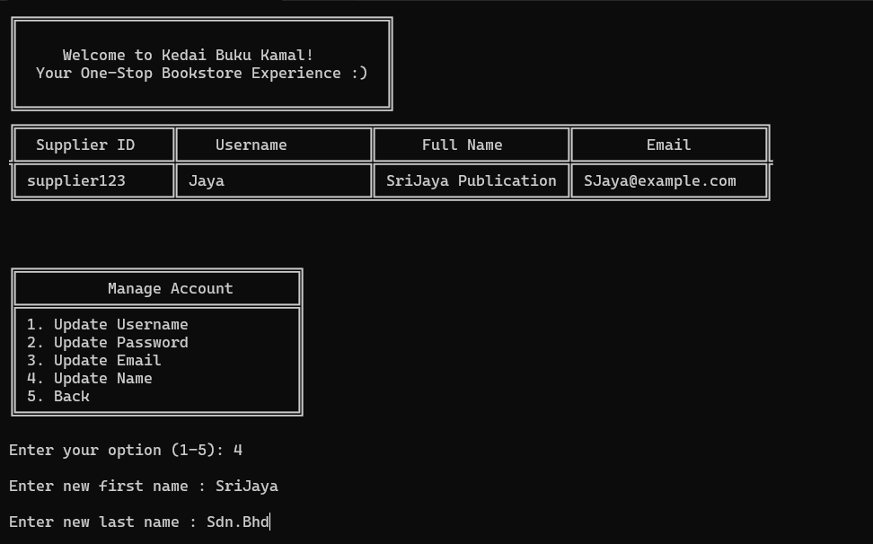

**Figure 3.40 : Update name**

## Source Code

Admin.java

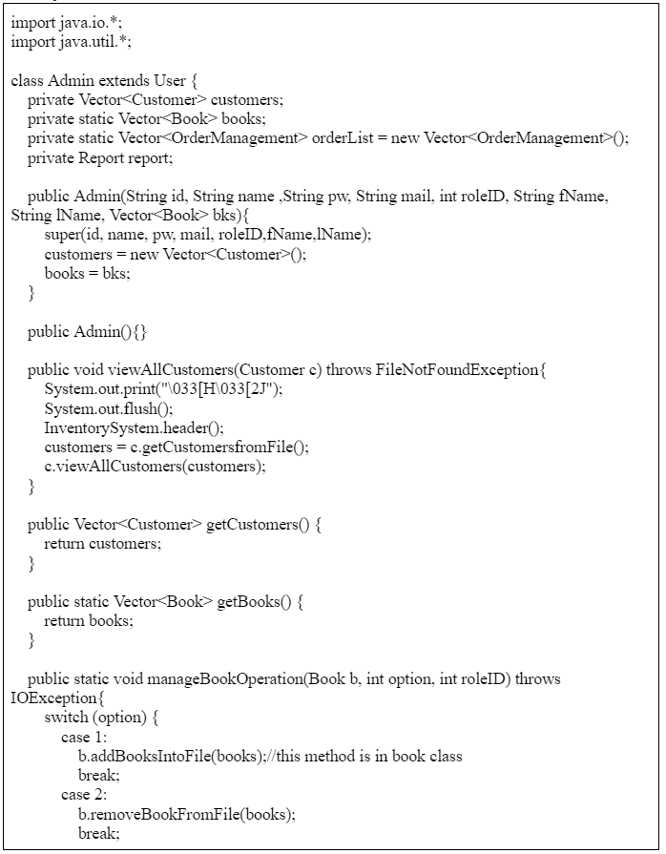

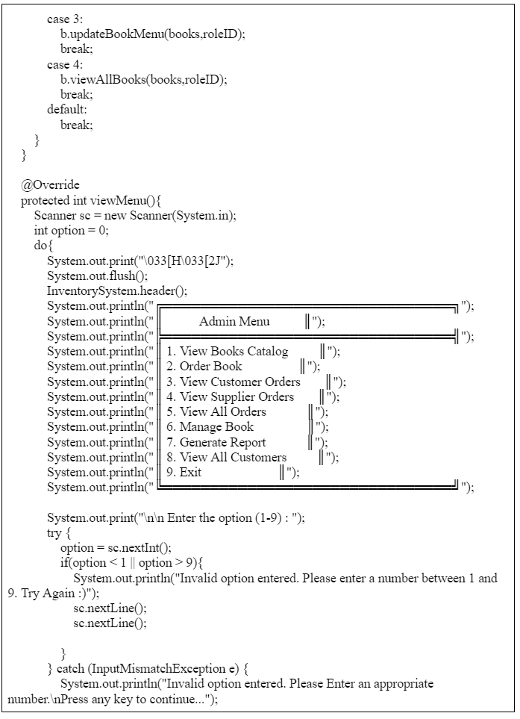

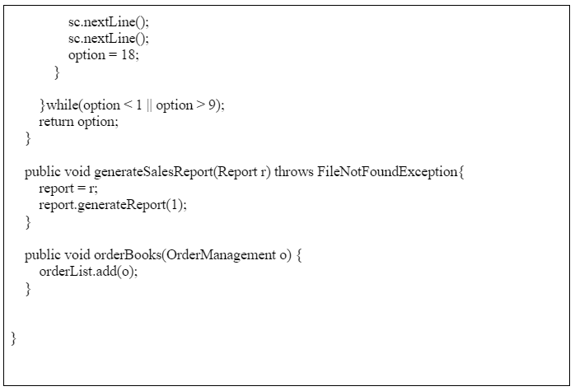

Book.java

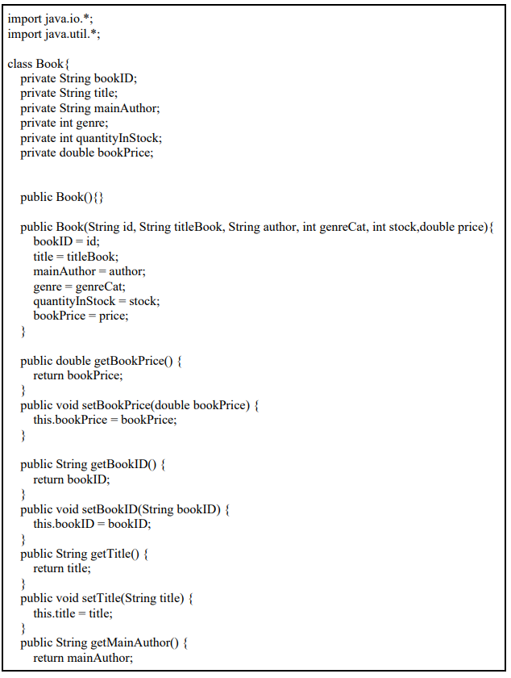

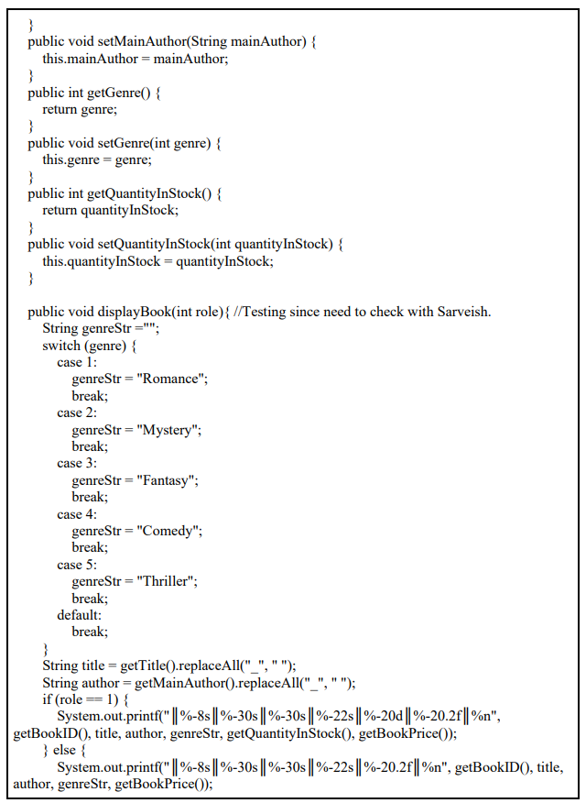

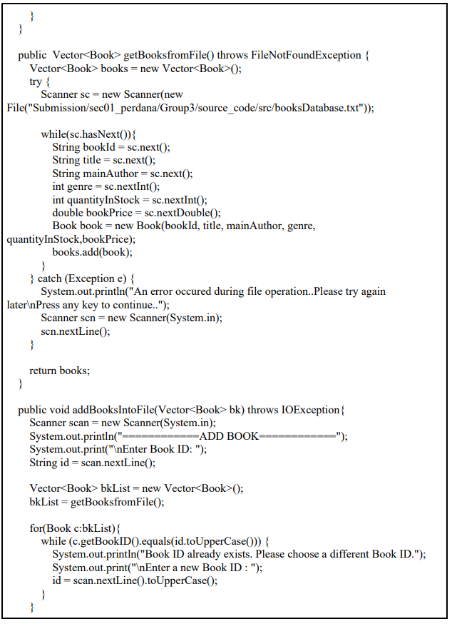

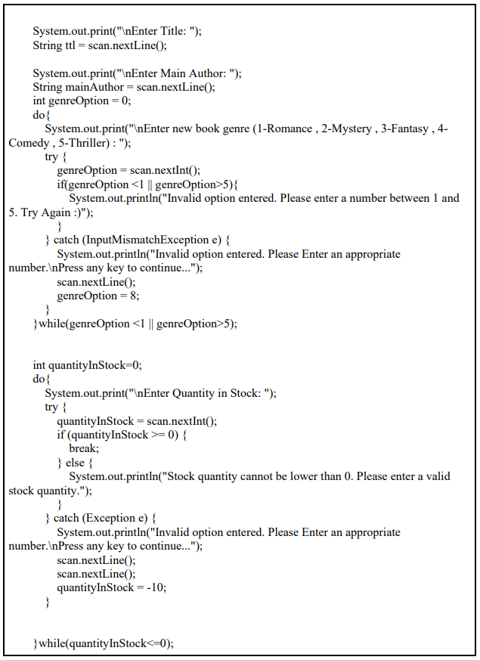

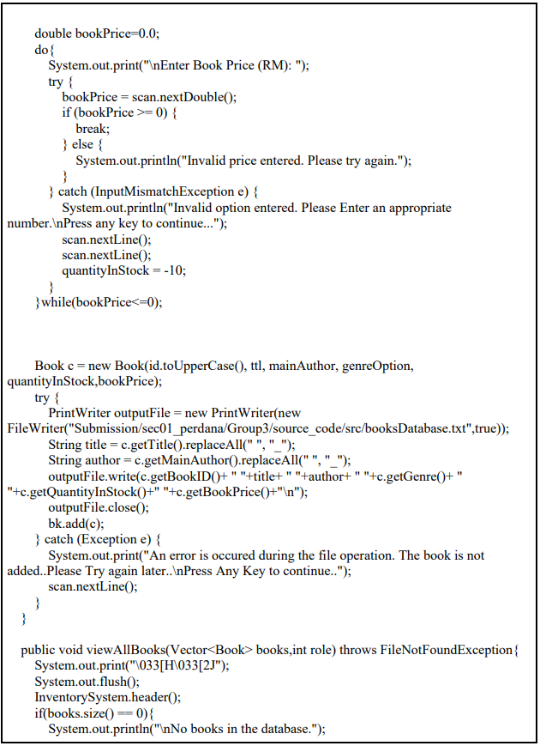

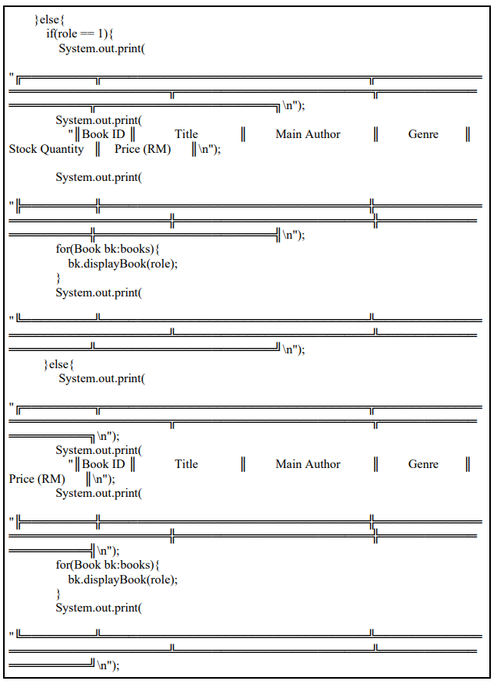

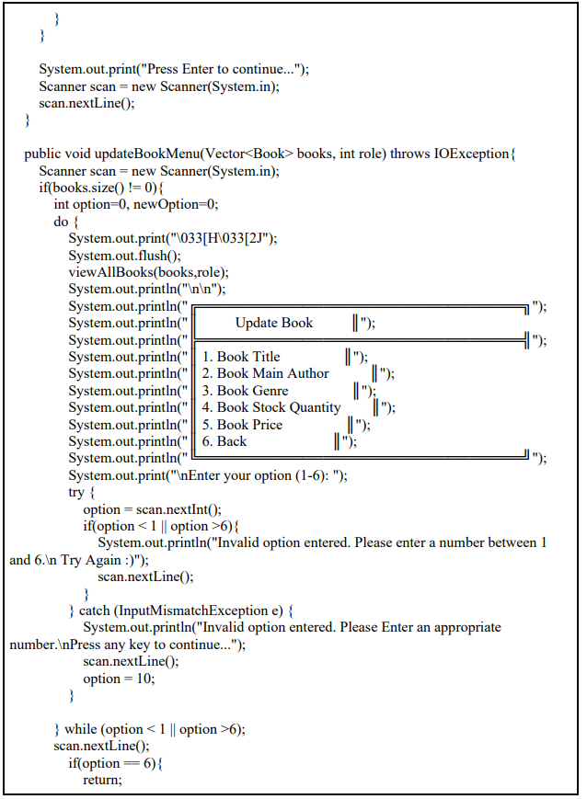

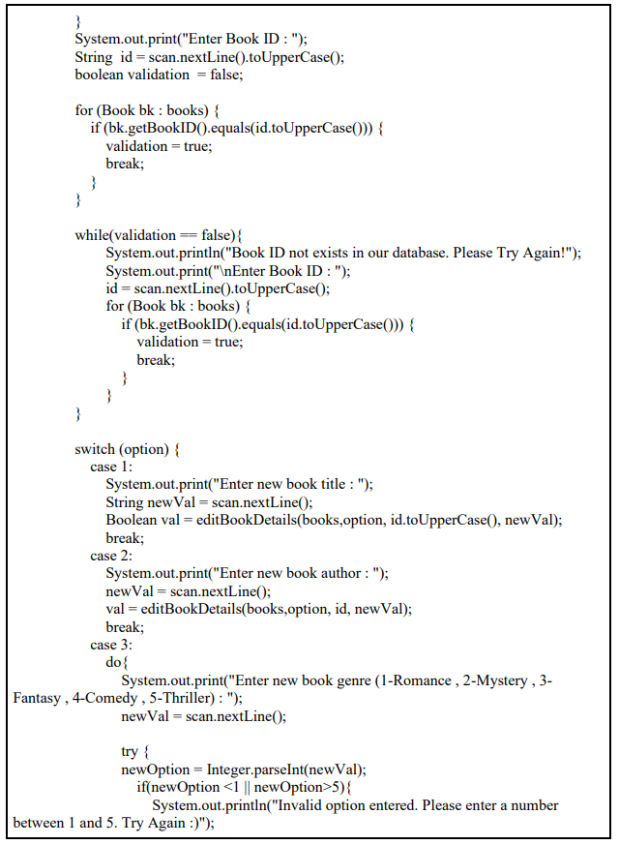

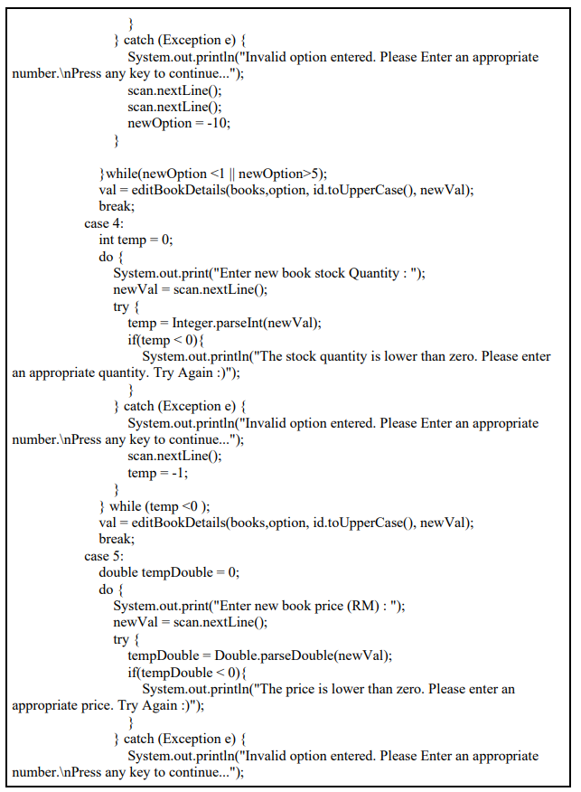

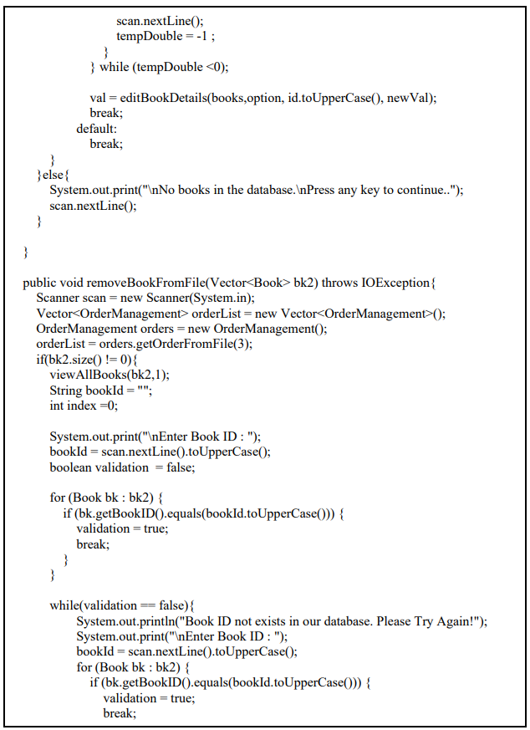

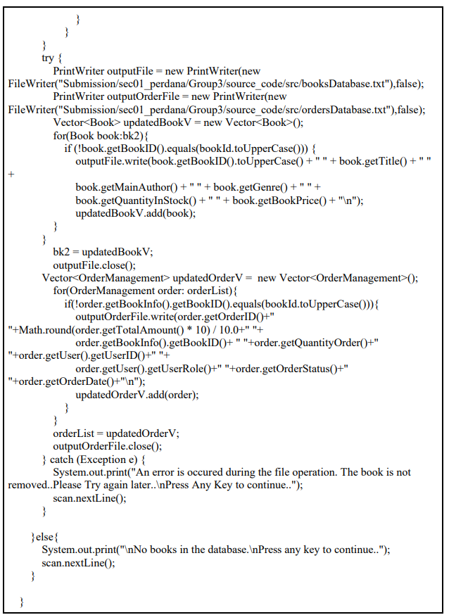

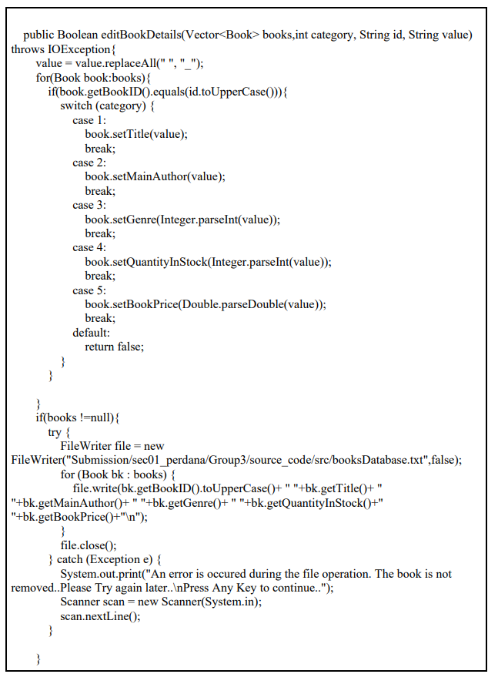

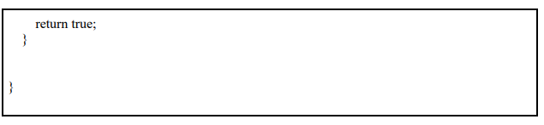

BookSupplier.java:

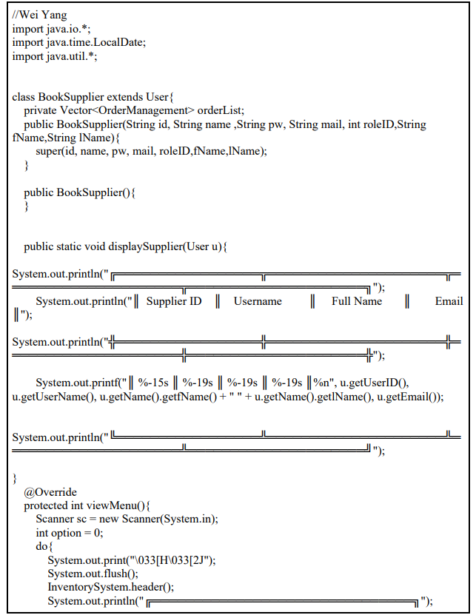

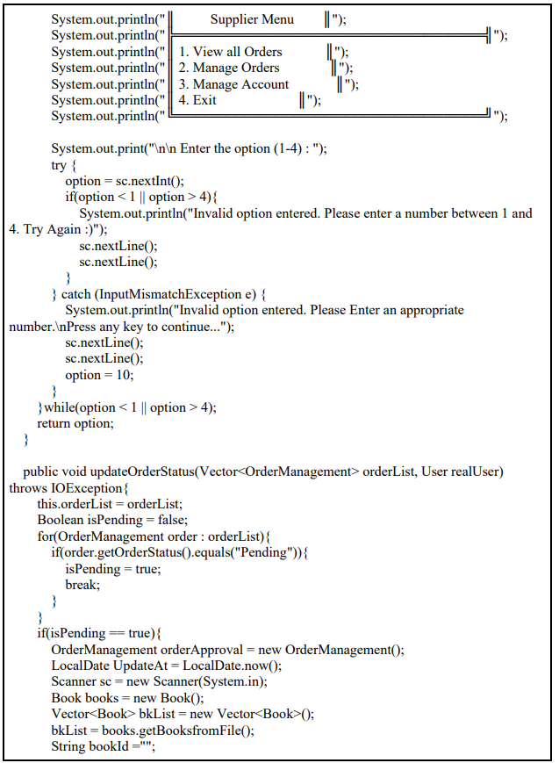

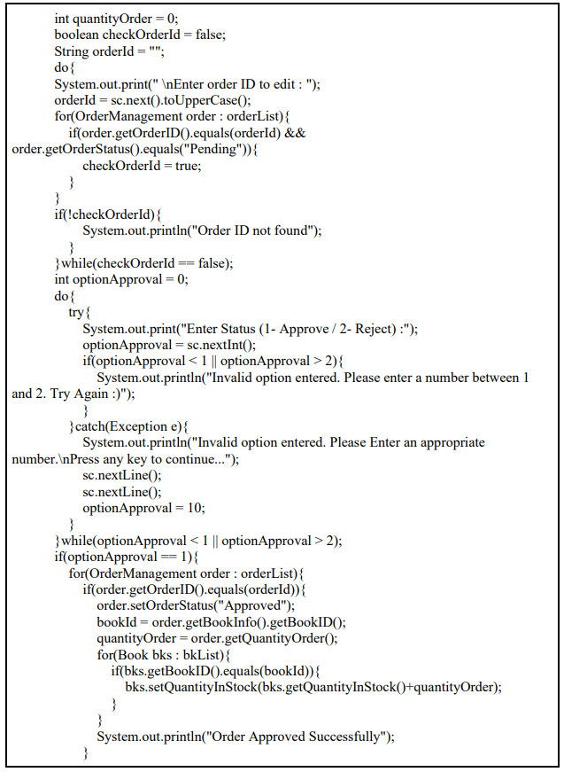

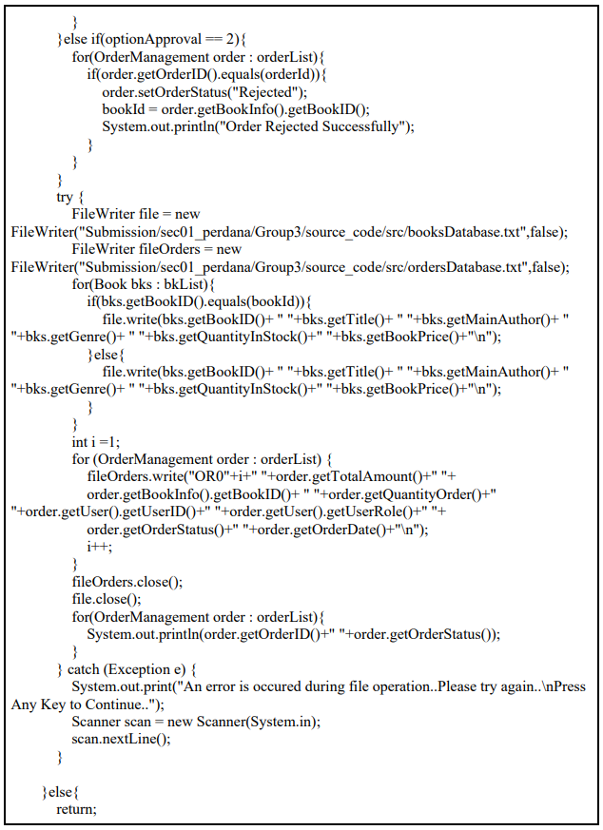

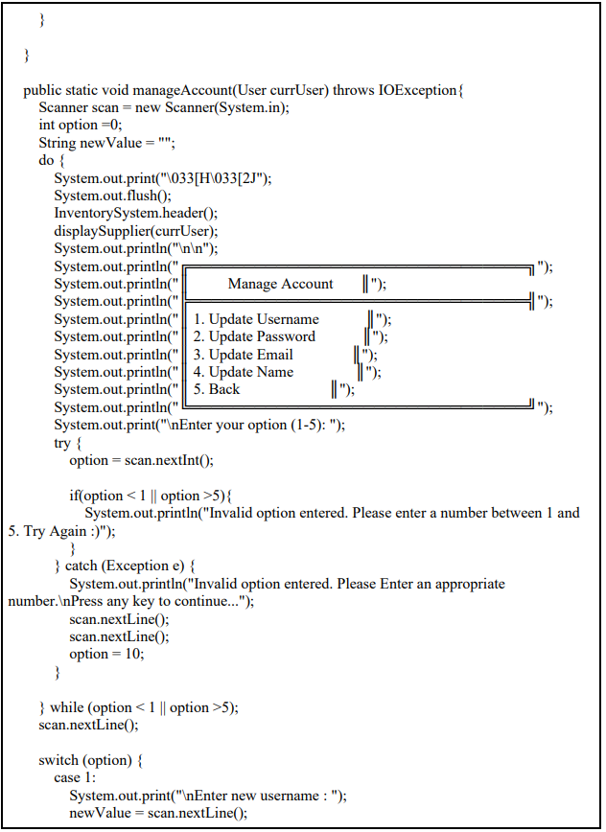

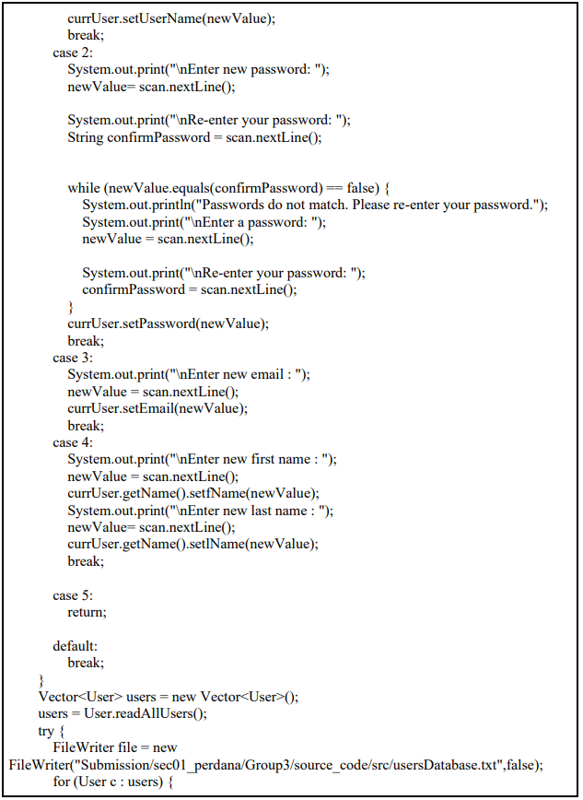

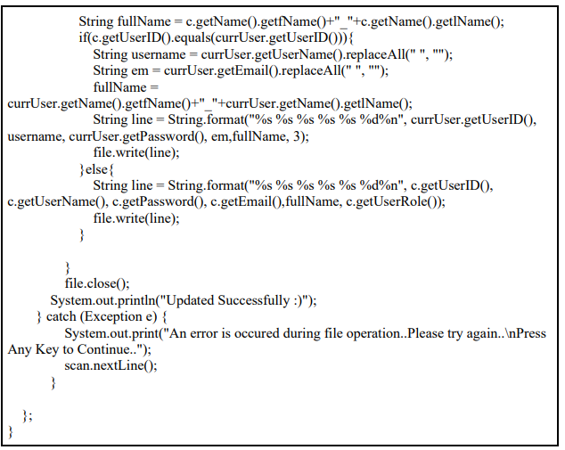

Customer.java:

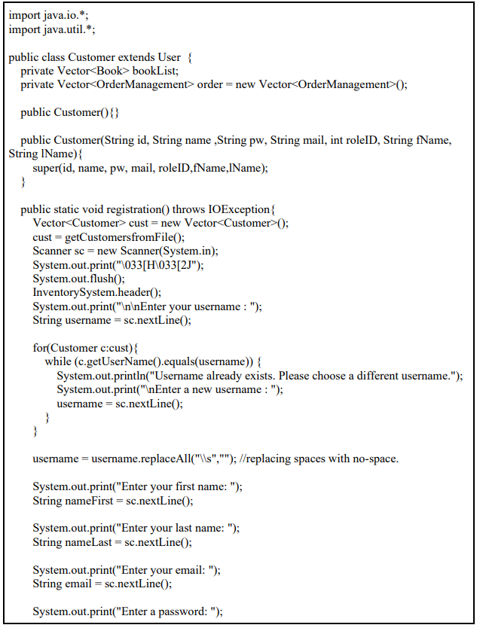

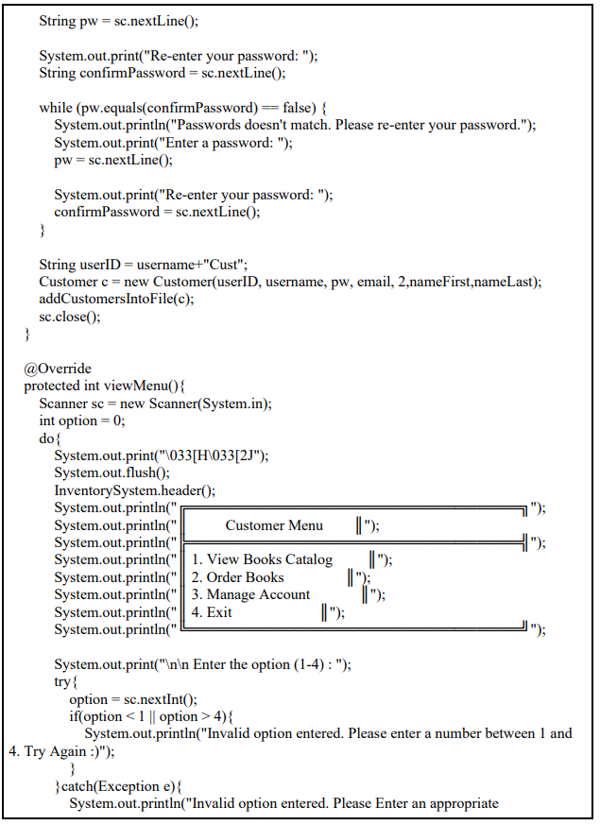

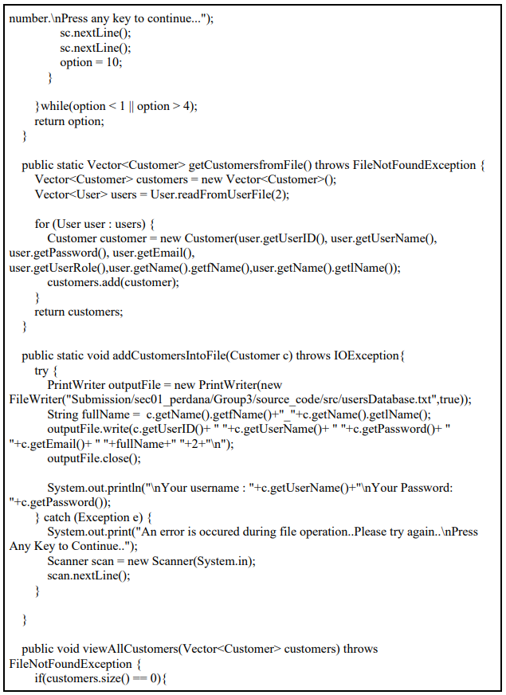

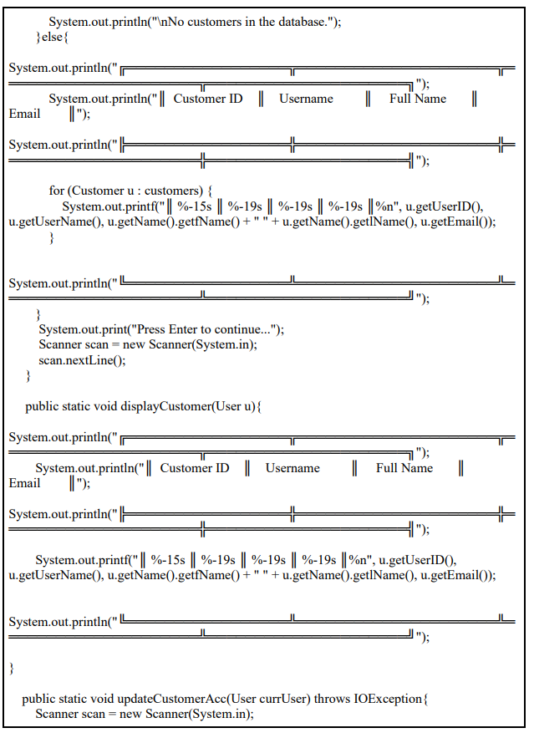

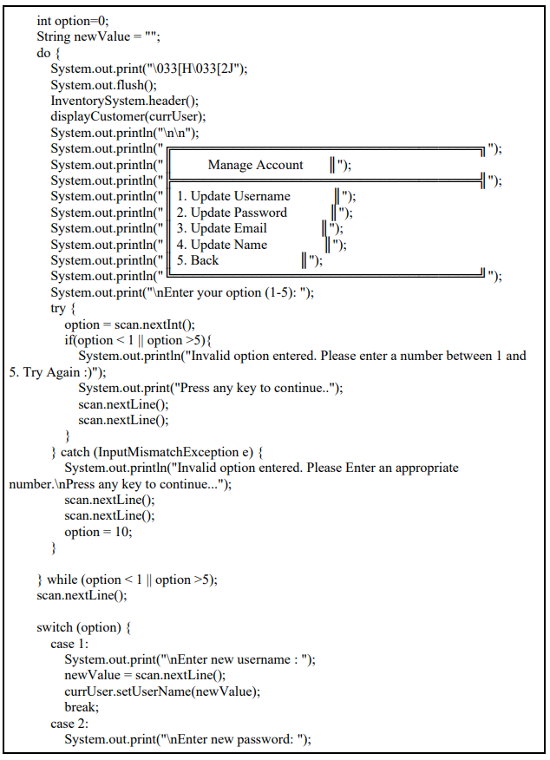

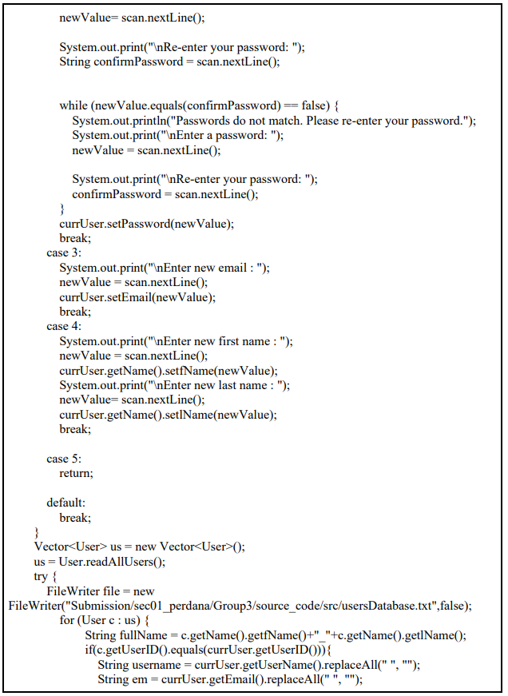

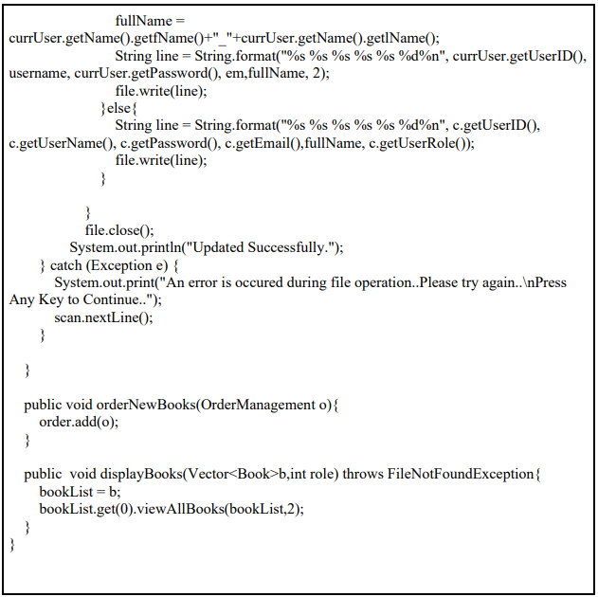

InventorySystem.java:

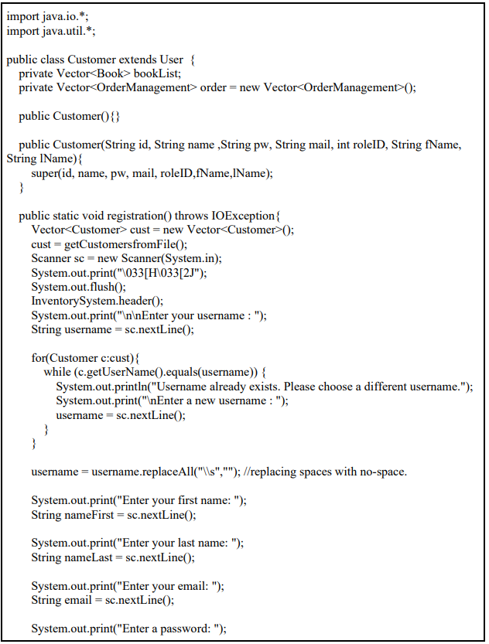

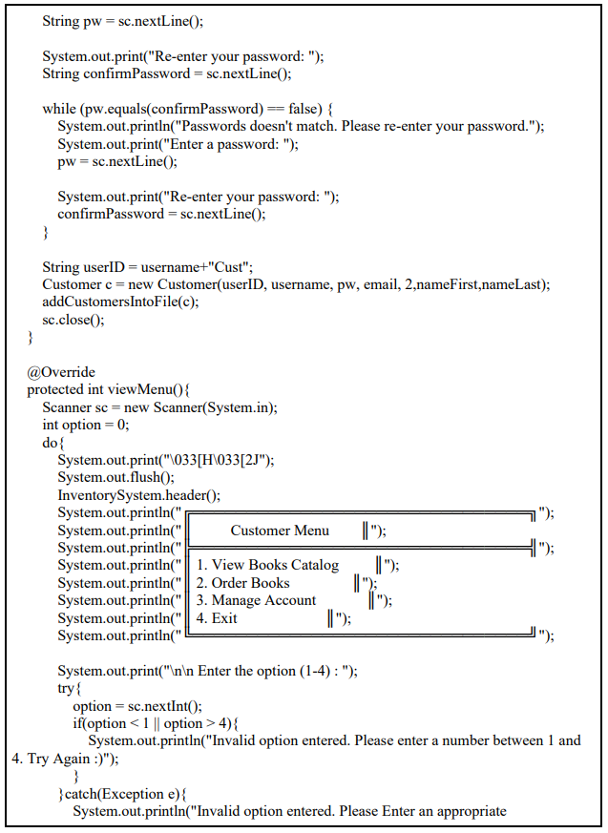

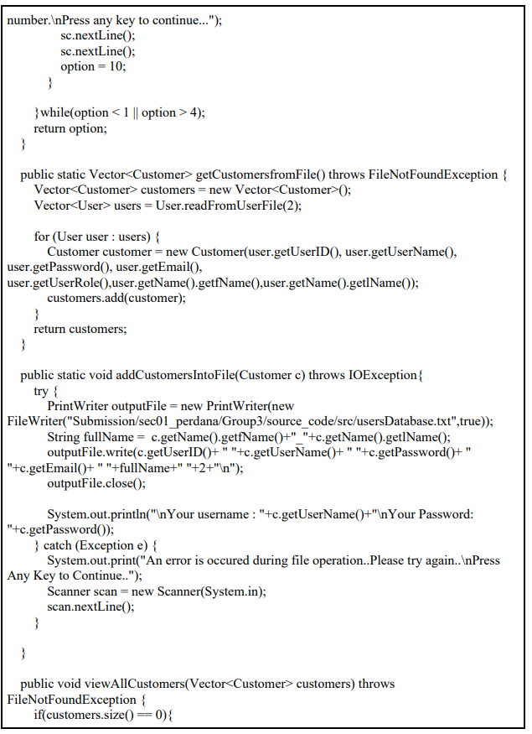

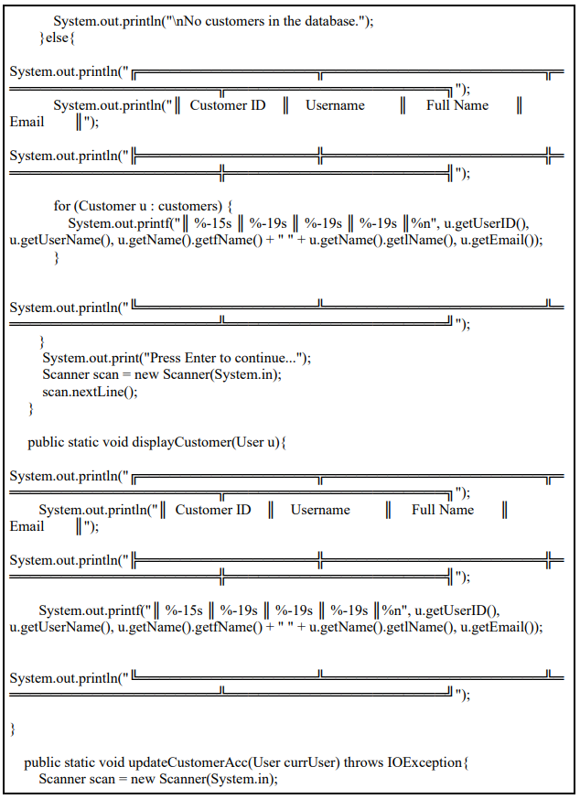

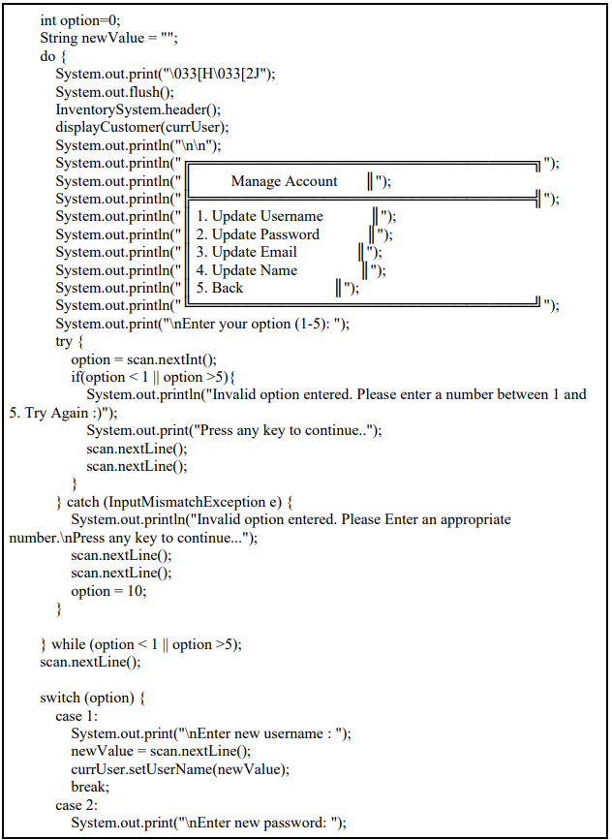

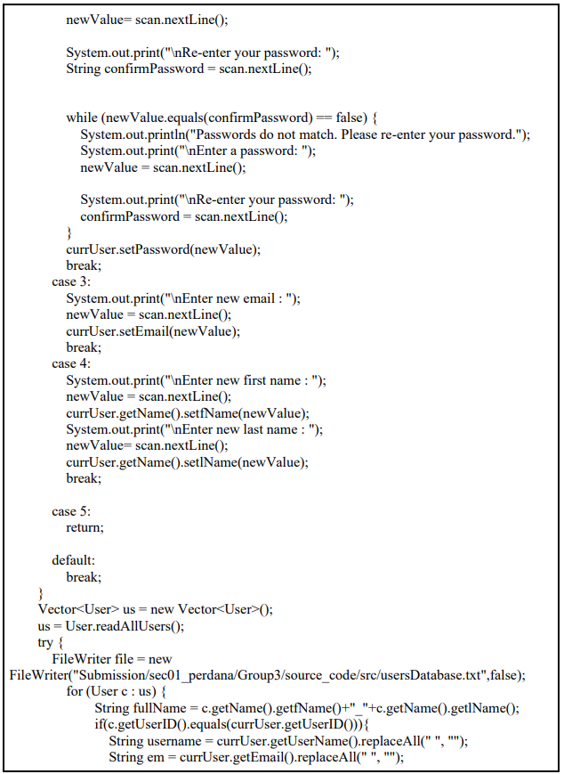

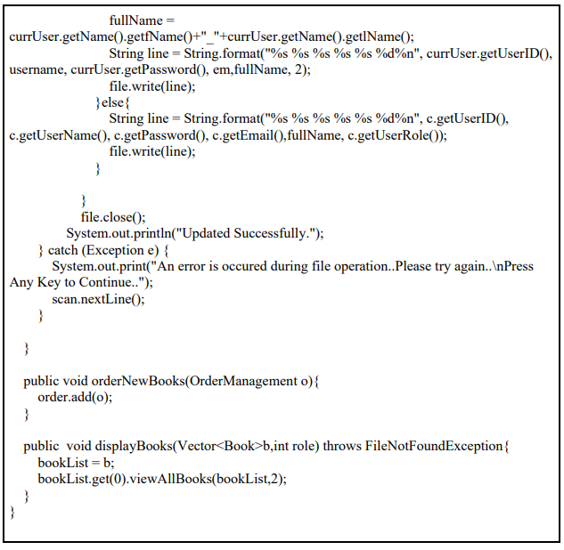

Menu.java:

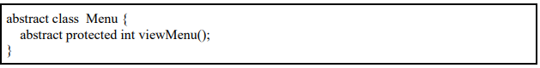

Name.java:

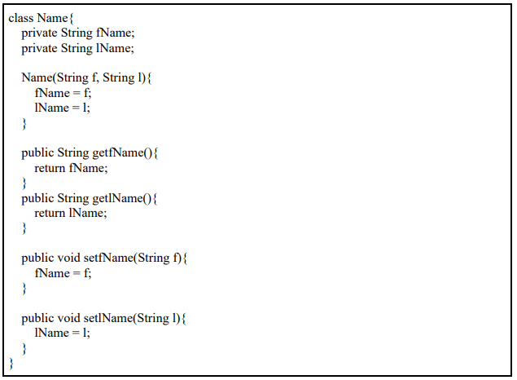

OrderManagement.java:

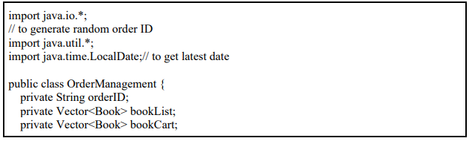

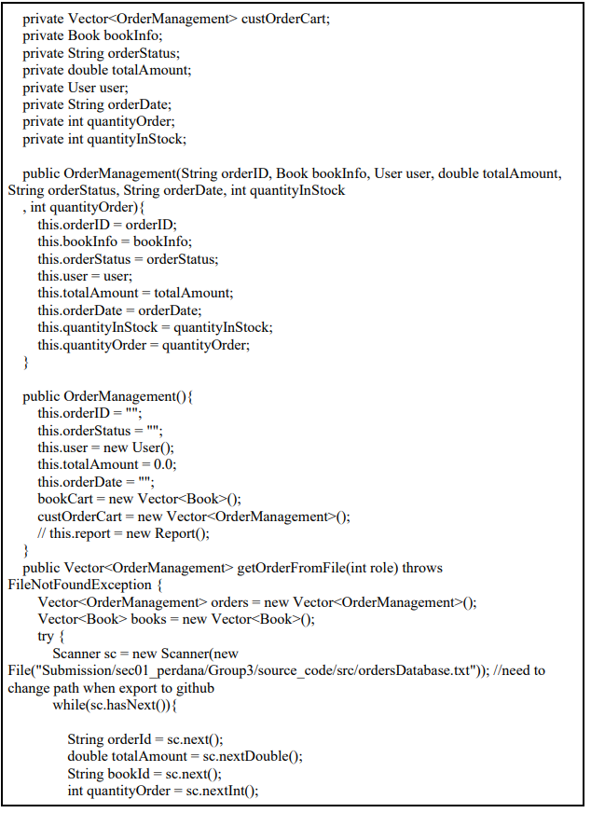

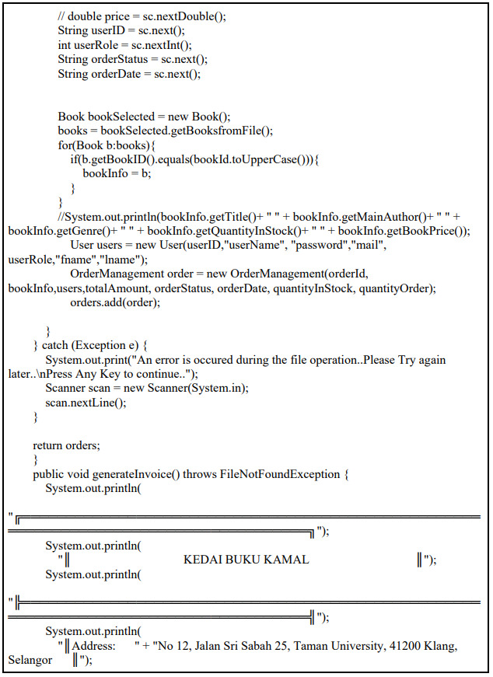

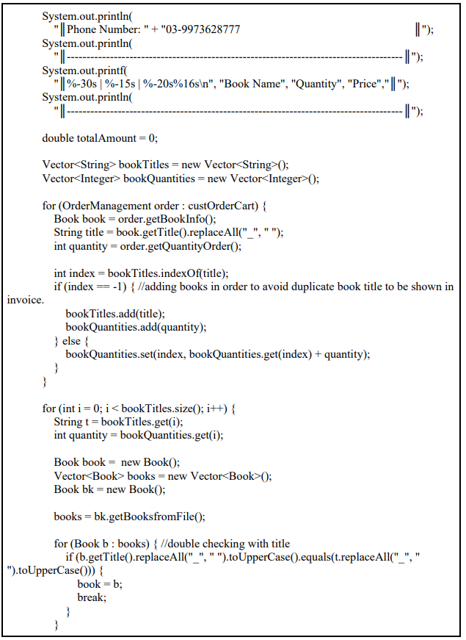

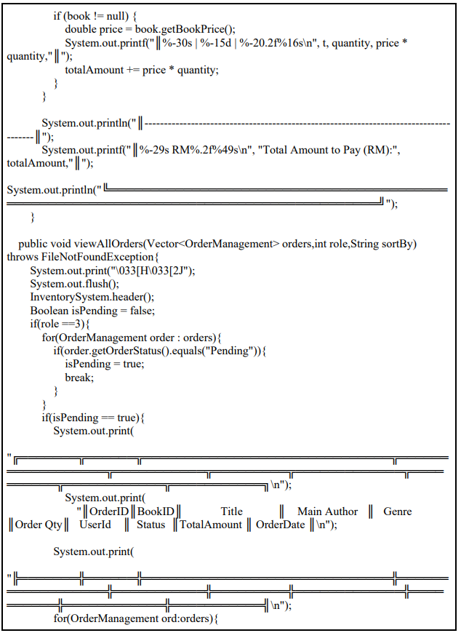

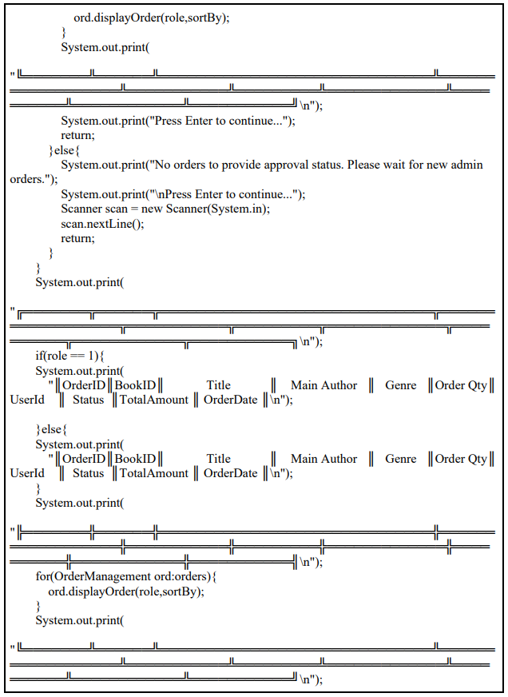

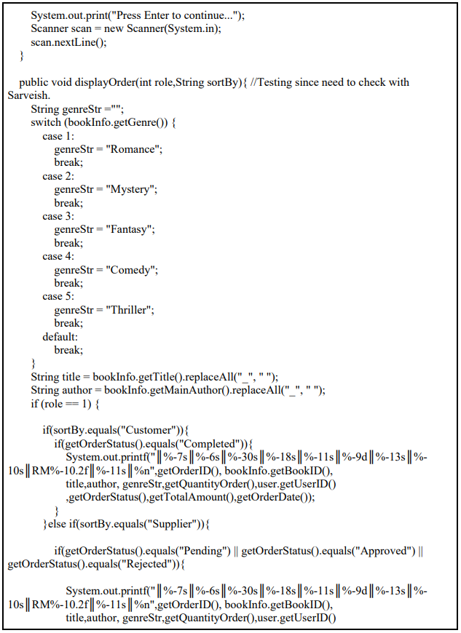

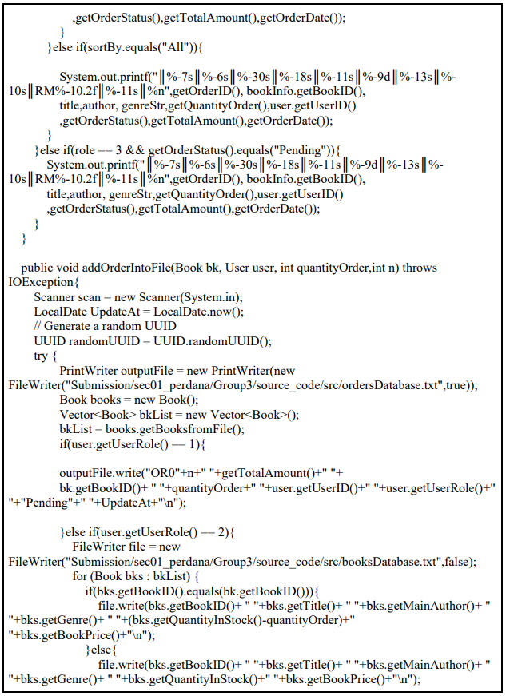

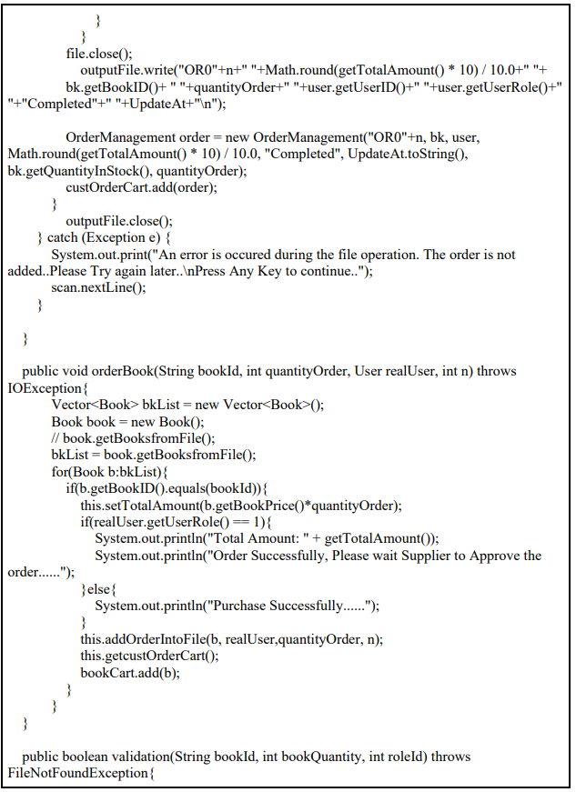

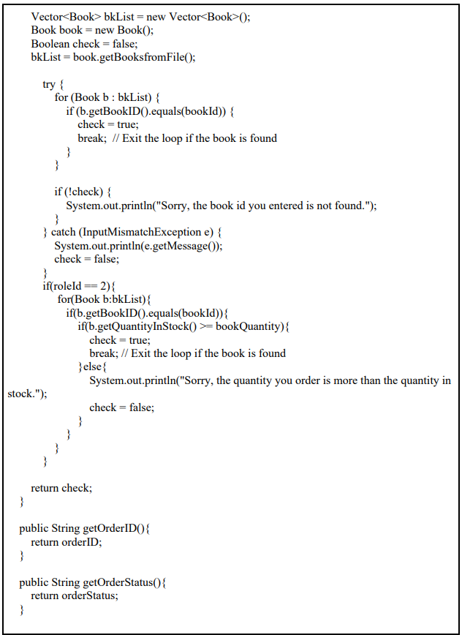

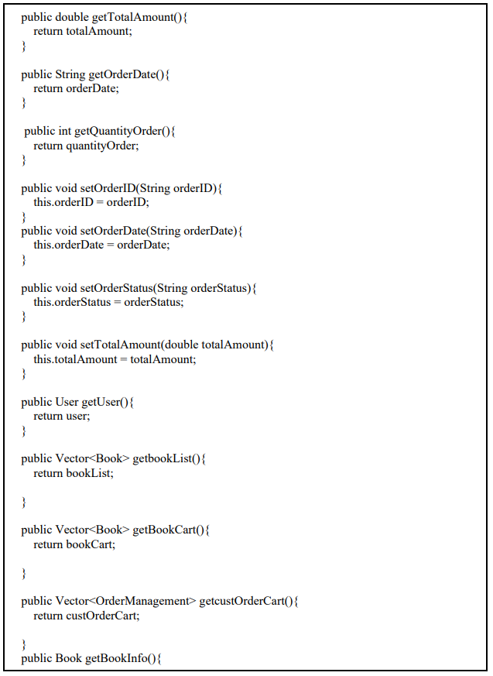

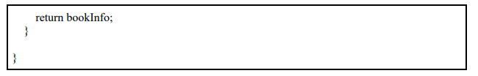

Report.java:



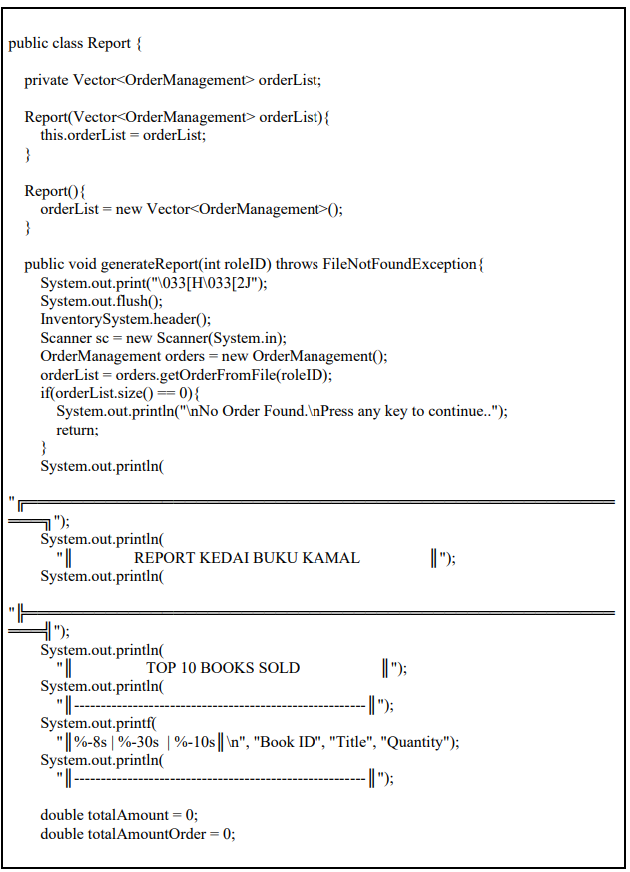

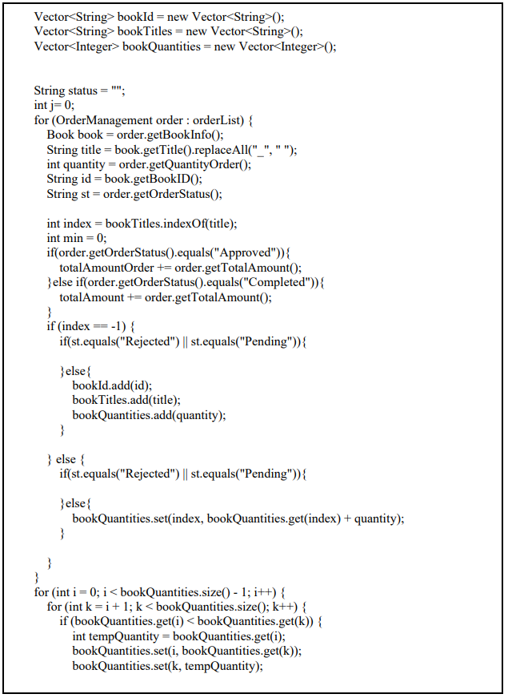

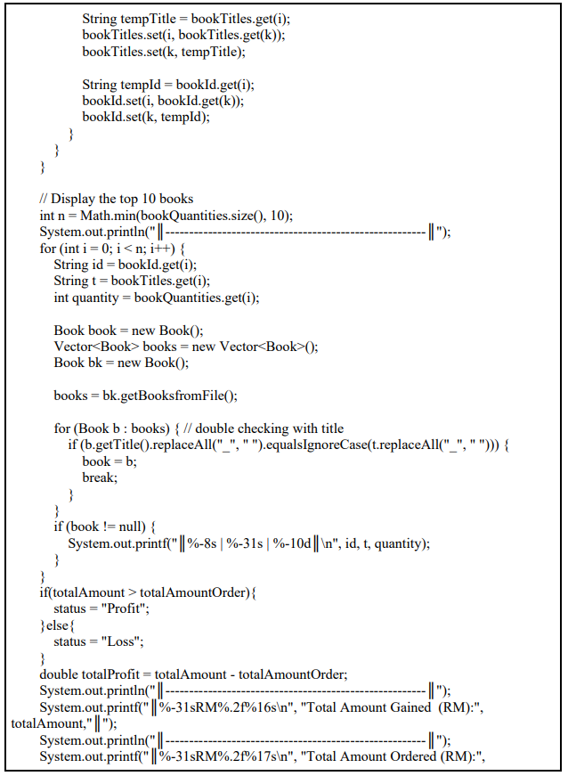

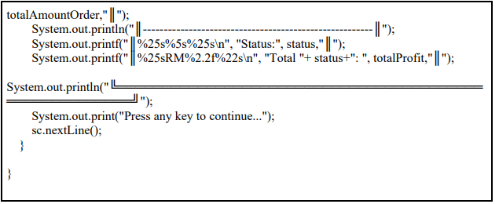

User.java:



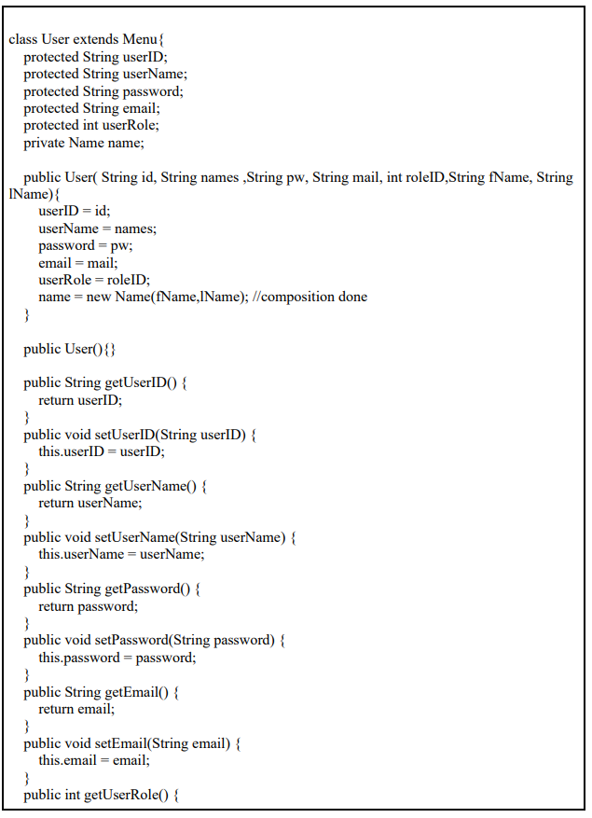

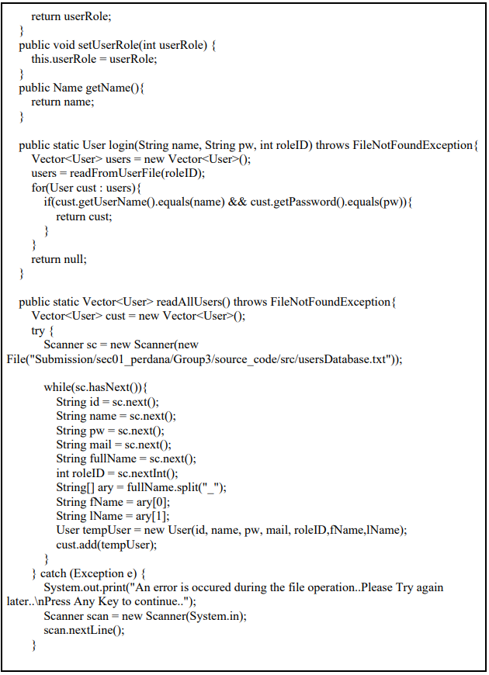

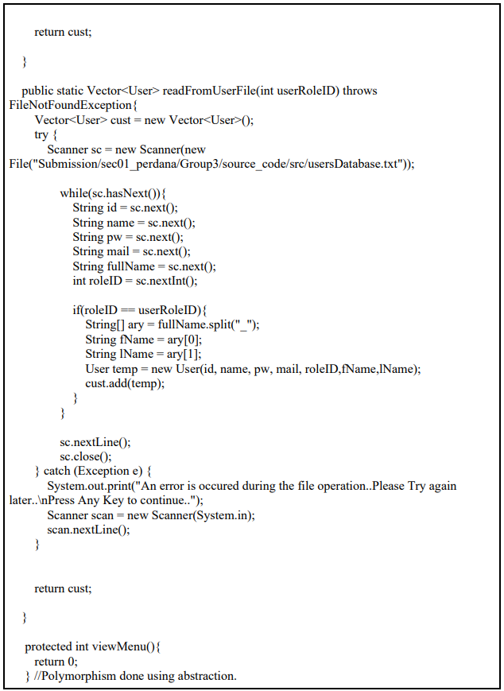

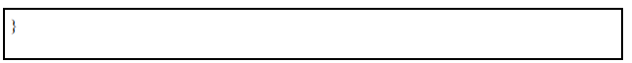

**SECTION D: TASK DISTRIBUTION**

| **Category** | **Task** | **Person-In-Charge** |
| --- | --- | --- |
| **Coding Implementation** | Class InventorySystem | LIEW YONG ZHENG |
| Class User | SARVEISH |
| Class Admin | SARVEISH |
| Class Customer | SARVEISH |
| Class BookSupplier | CHONG WEI YANG |
| Class Book | CHONG WEI YANG |
| Class Report | LIEW YONG ZHENG & TAN CHEE SEN |
| Class OrderManagement | TAN CHEE SEN |
| Class Name | SARVEISH |
| Class Menu | SARVEISH |
| **Others (Diagrams, Reports and Slides)** | Introduction | LIEW YONG ZHENG |
| Class Diagram | CHONG WEI YANG & TAN CHEE SEN |
| Flowchart Workflow | LIEW YONG ZHENG & SARVEISH |
| OO Concept Explanation | LIEW YONG ZHENG |
| User Manual | CHONG WEI YANG |
| Presentation Slide | ALL |

**SECTION E: CONCLUSION**

In summary, by using JAVA to create the system, we were able to gain some understanding of OOP concepts. We can implement the OOP concepts covered in the Object-Oriented Programming course in creating relationships between all the classes and that make up the entire system.